Pickup and Delivery Portal
RADM-102
Department Owner: Process Engineering  FedEx U.S., FedEx Canada | Last Update: 10 May 2024 DRAFT

Overview
This publication serves as a demonstration of the Pickup & Delivery Portal application (referred to as the P&D Portal throughout this document). It takes the user through the process of requesting access, logging in to the P&D Portal, verifying, editing, and adding service provider SCANNER user information, and resolving issues.

Transition from EASE to P&D Portal
The P&D Portal is a web-based application that will replace the existing EASE application. It contains the same functionality that exists in EASE with a different look and feel, using a more modern technology platform.
The existing EASE functionality is moving to the P&D Portal in phases. As each phase is enabled in the P&D Portal, the functionality will be turned off in EASE. Until all functionality is moved from EASE to the P&D Portal, station users will need to perform work in both applications. In the short-term, CDAS will continue to receive activity information for payment from EASE. Any updates made to SCANNER user information in the P&D Portal will be systematically sent back to EASE to keep the two applications in sync and ensure accurate CSP compensation.
The planned P&D Portal phases include:
- Phase 1: SCANNER User Information (called Header in EASE)
- Phase 1 rollout complete for all stations in the U.S.
- Currently being rolled out to stations in Canada as they transition to Express.
- Phase 2: Pickup Information (development is in progress)
- Read only view available to all stations in the U.S.
- Currently being rolled out to stations in Canada as they transition to Express.
- Phase 3: Delivery Information

What does the P&D Portal Do?
The P&D Portal receives scanner data that is uploaded by a service provider employee driver. The P&D Portal examines the data, flags any potential issues, and allows station personnel to edit data as necessary. Some issues are required to be changed based on business rules, while other potential issues are informational.
Important: The P&D Portal application should be reviewed on a daily basis to ensure issues are resolved timely.
This Book Explains
- Requesting P&D Portal access
- Accessing the P&D Portal
- SCANNER User Information Issue Review and Resolution
- Editing SCANNER User Information
- Adding a Manual Route
Important: This procedure will be updated as additional functionality is moved from EASE into the P&D Portal.

Table of Contents
Overview 1
What does the P&D Portal Do? 2
P&D Portal SharePoint Site 4
Purpose 4
Layout and Functionality 4
P&D Portal Home 4
LOGIN to P&D Portal 5
P&D Portal Training Documents 5
Legacy Applications 5
FXG Applications/Projects 5
Requesting Access to the P&D Portal 5
Logging into the P&D Portal 10
Summary Tab 14
Layout and Functionality 14
Waffle Menu 14
Today’s Open Issues Summary 16
Week to Date Total Issues Summary 16
Consolidated Summary Tab 17
Layout and Functionality 17
Station Consolidated Summary Tab 17
District Consolidated Summary Tab 18
PGH Consolidated Summary Tab 18
Issues Tab 19
Layout and Functionality 20
SCANNER USER ISSUES Card 20
Open Tab 20
RESOLVED Tab 21
SCANNER User Issue Details 22
Steps to Resolve 22
CSA Information 23
User Information 24
Email Icon 25
Print Icon 26
Actions Taken Link 27
Process Button 28
Refresh Issue Button 28
Resolving SCANNER User Issues on the Issues Tab 37
Service Providers Tab 41
Purpose 41
Layout and Functionality 42
CSA List 42
CSA Details (to the right of the CSA list) 43
P&D Summary 44
Work Area Detail Tab 45
Calendar Tool 46
Email Icon 47
Print Icon 48
Actions Taken Link 49
Editing a Route on the Service Provider Tab 50
Adding a Manual Route on the Service Providers Tab 54
Read Only View of Pickup Activity 57
Layout and Functionality 58
Work Area Detail Tab – Pickup & Delivery Stop Table 58
Pickup Details Pop-up 58
Pickup Details Pop-up: Planned Shipper Section 59
Pickup Details Pop-up: Actual Package Section by Shipper Number 59
Scanned Tracking ID Information Pop-up 61
P&D Portal Snack Bar Messages 62
Facility Search Pop-Up 62
Summary Tab 63
Issues Tab 63
Service Providers Tab 66
Edit Pop-Up 67
Add Route Pop-Up 68
Related Documents 70

P&D Portal SharePoint Site
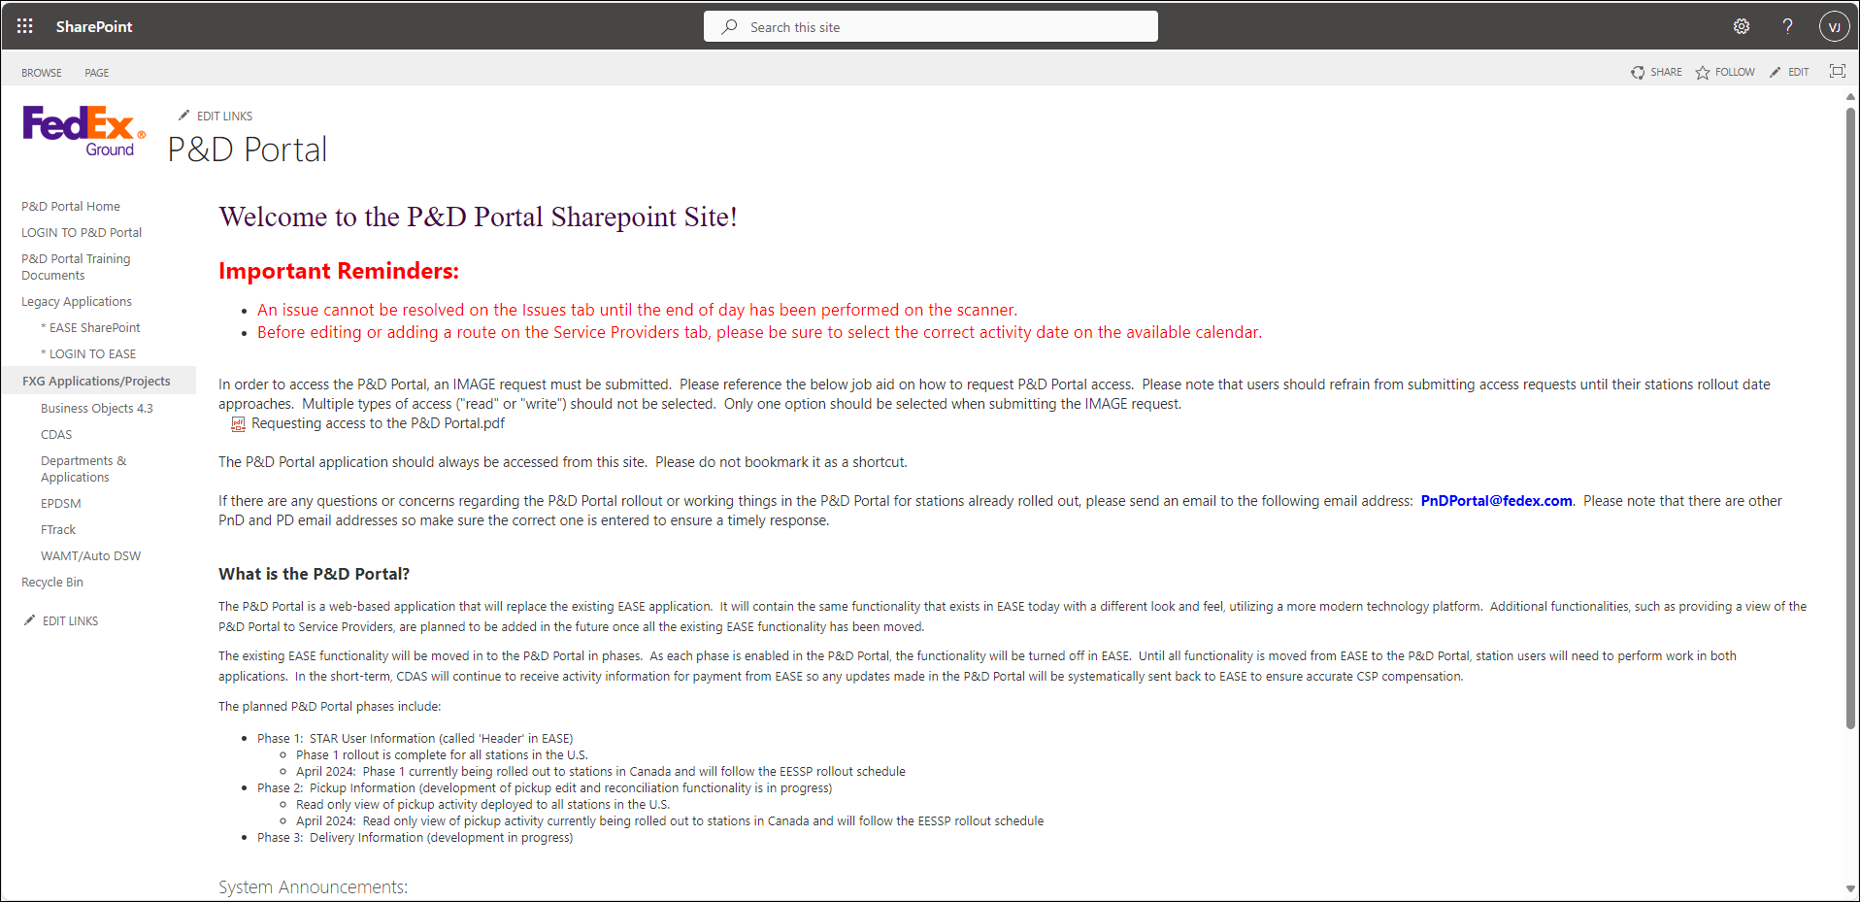

Purpose
The P&D Portal SharePoint site is the starting point for P&D Portal access. Postings on this page include the log in link to access the application, system maintenance messages, and access to training materials.

Layout and Functionality

P&D Portal Home
Returns the user to the main P&D Portal SharePoint page.

LOGIN to P&D Portal
The application should always be accessed from the link on the P&D Portal SharePoint site. This ensures that the most up to date version of the application is used. Do not save it as a bookmark or shortcut.

P&D Portal Training Documents
Provides access to training job aids broken out by subject/topic.

Legacy Applications
Provides access links to the EASE SharePoint site along with an EASE log-in link.

FXG Applications/Projects
Provides links to commonly used applications such as Business Objects, CDAS, FTRACK, WAMT/DSW etc.

Requesting Access to the P&D Portal
For a user to have access to the P&D Portal, an IMAGE request must be submitted. Follow the below steps to submit an IMAGE request.
- Log into IMAGE (use keyword search IMAGE). https://image.prod.fedex.com/identityiq
- Once logged in, select Manage User Access.
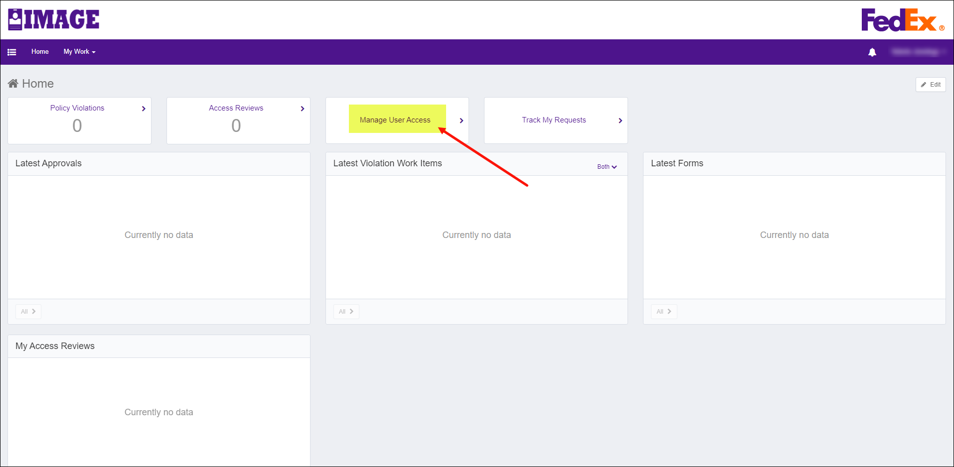
- Enter your employee ID in the Search for users by FedEx ID# field and select Enter.
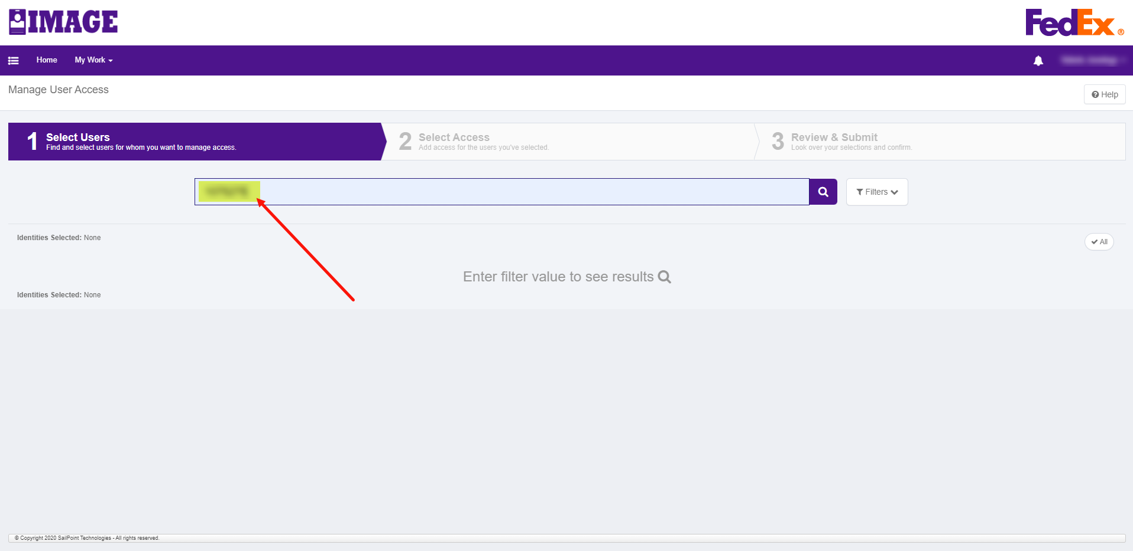
- The name corresponding to the Employee ID displays along with the name of the employee’s manager.
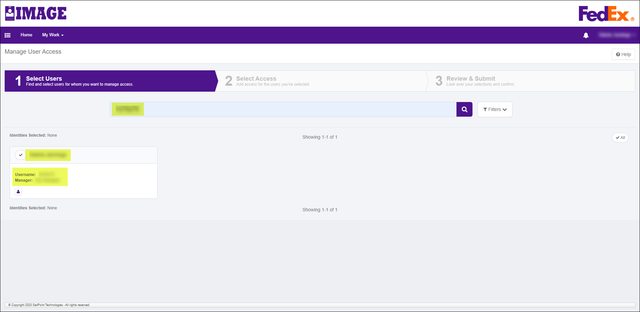
- Click the checkmark next to the employee’s name and select Next.
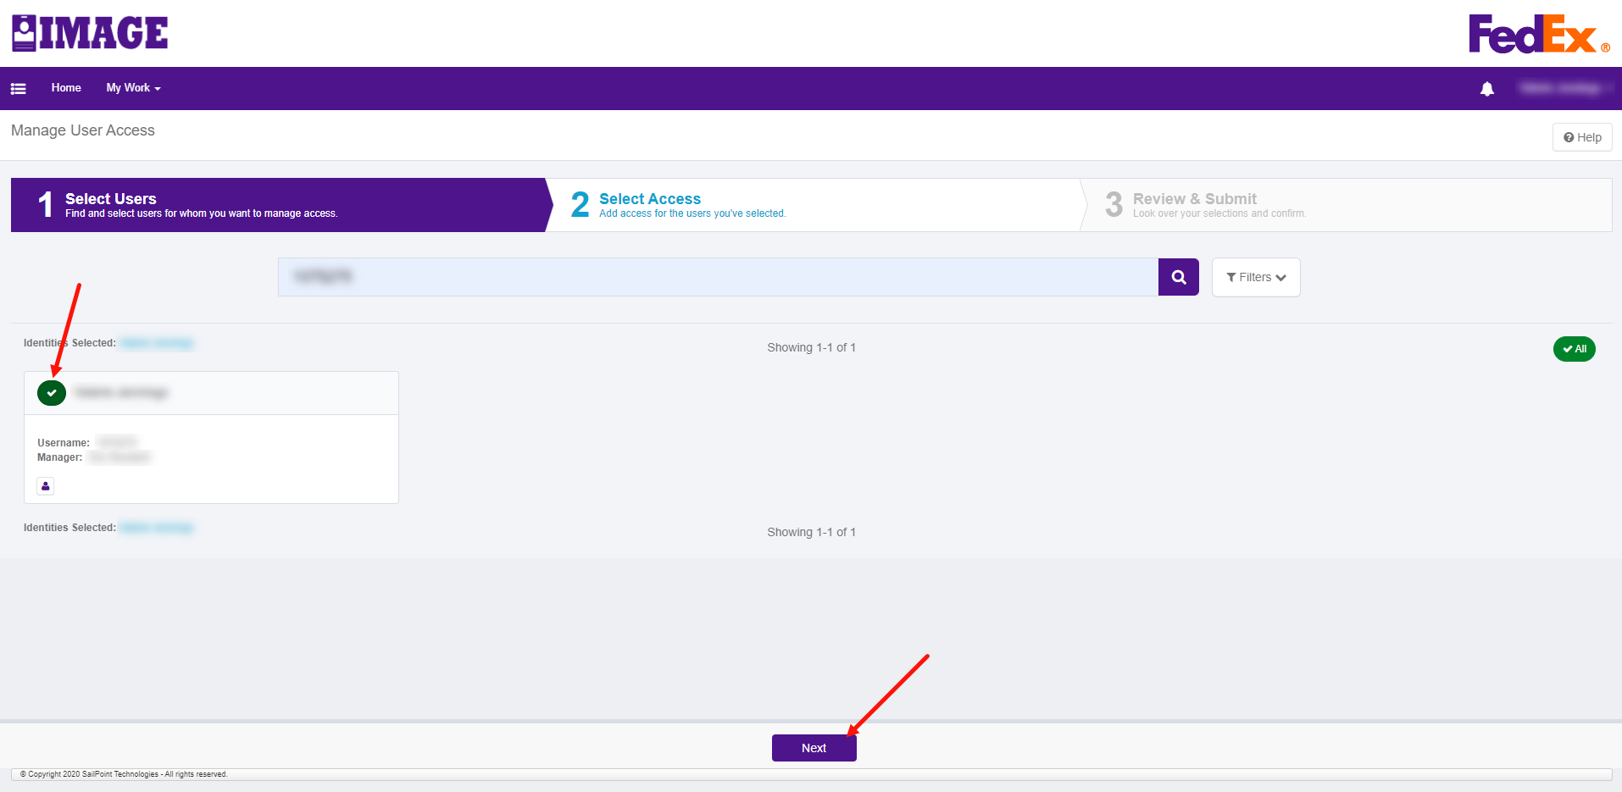
- Type P&D Portal in the Search by Keywords box and press Enter.
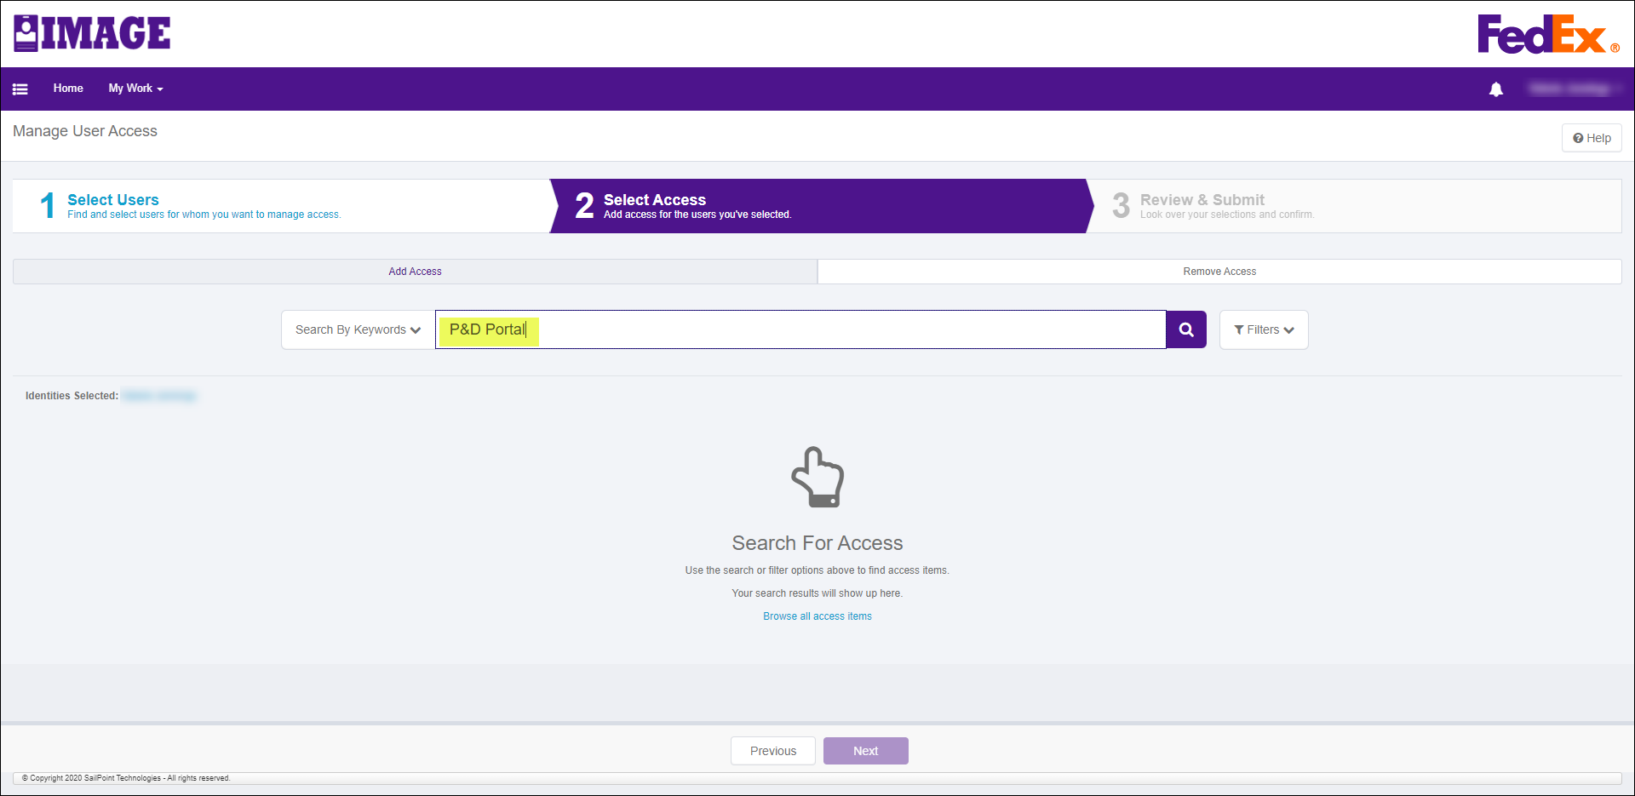
- A list of available access levels displays for the P&D Portal. There are different levels of access to the P&D Portal and each level has both a read and a write option.
- pnd-portal_app_station_read_access_app3536703
- pnd-portal_app_station_write_access_app3536703
- pnd-portal_app_district_read_access_app3536703
- pnd-portal_app_district_write_access_app3536703
- pnd-portal_app_all_read_access_app3536703
- pnd-portal_app_all_write_access_app3536703
- pnd-portal_app_admin_access_app3536703
Which level of access should I select?
- Station users should request Station level access.
- District users should request District level access.
- PGH domiciled users should request All level access.
Important (Express employees): Station personnel assigned to Express must select the 'All' level of access.
Important: The admin access is limited to specific PGH and IT users only. Any request submitted for admin access will be denied.
Should I select read or write access?
- If a station user’s job responsibilities include working activity in EASE, request Station Write access.
- If a district user (i.e., Quality Process Specialists) has backup responsibilities that include working activity in EASE when station personnel are not able to, request District Write access.
- All others should request Read access for their appropriate level.
Note: Users with read access will not be able to work activity in the P&D Portal.
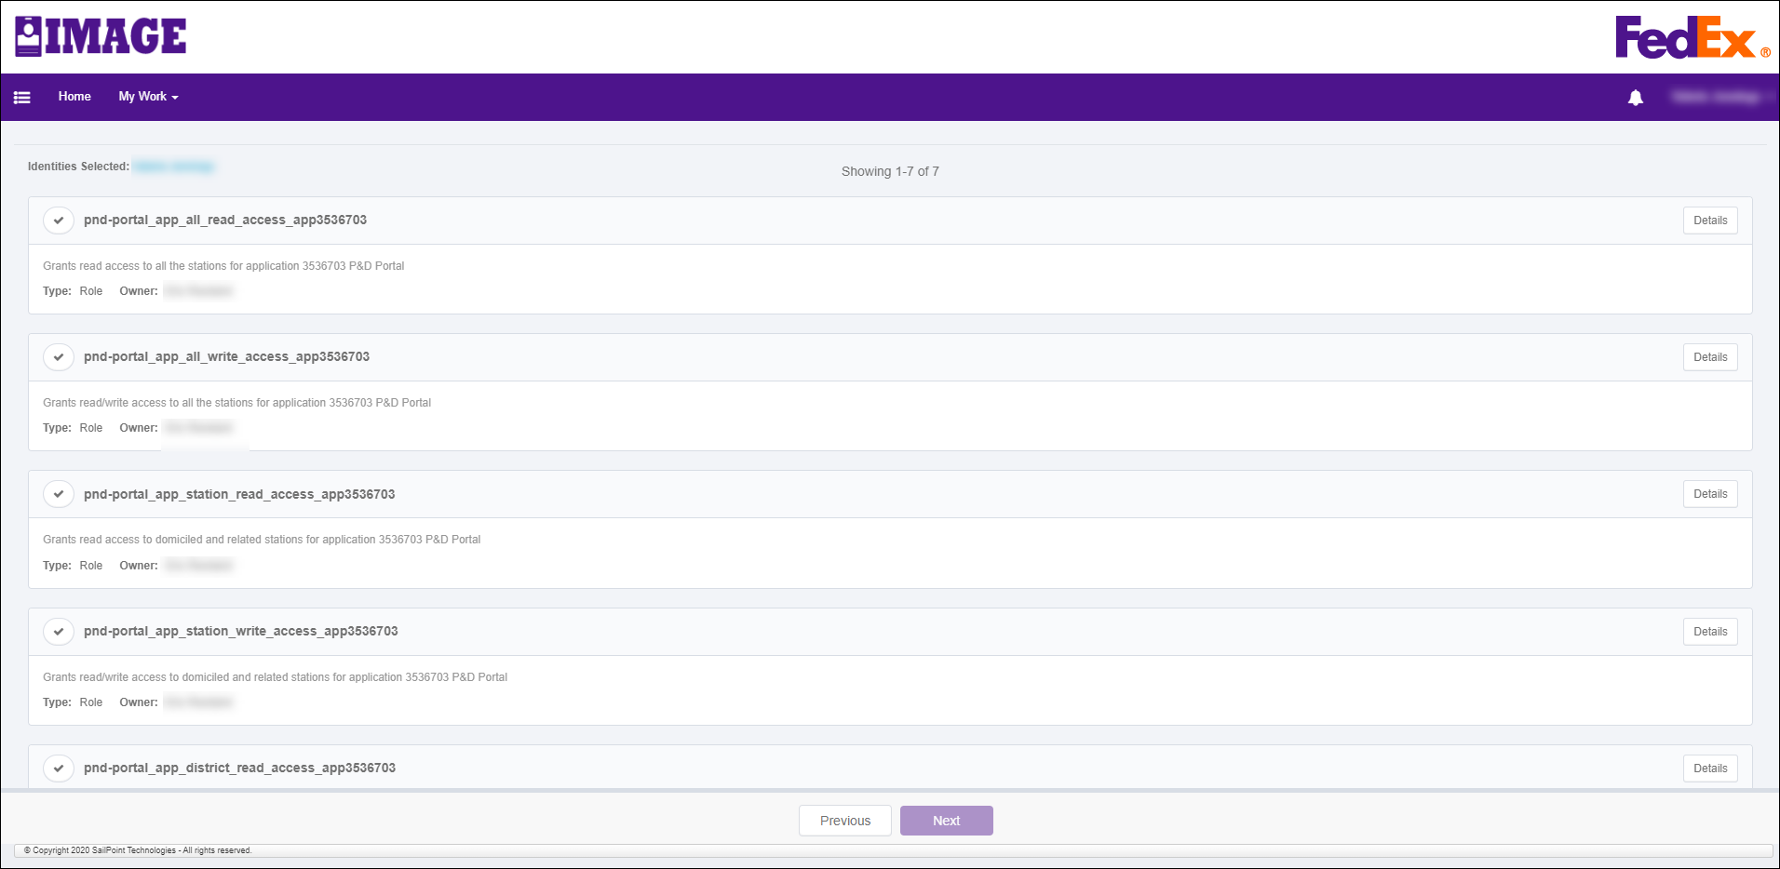
- Click the checkmark next to the appropriate level and type of access and select Next.
Important: Only select one option. If multiple options are selected, it could delay getting access to the application.
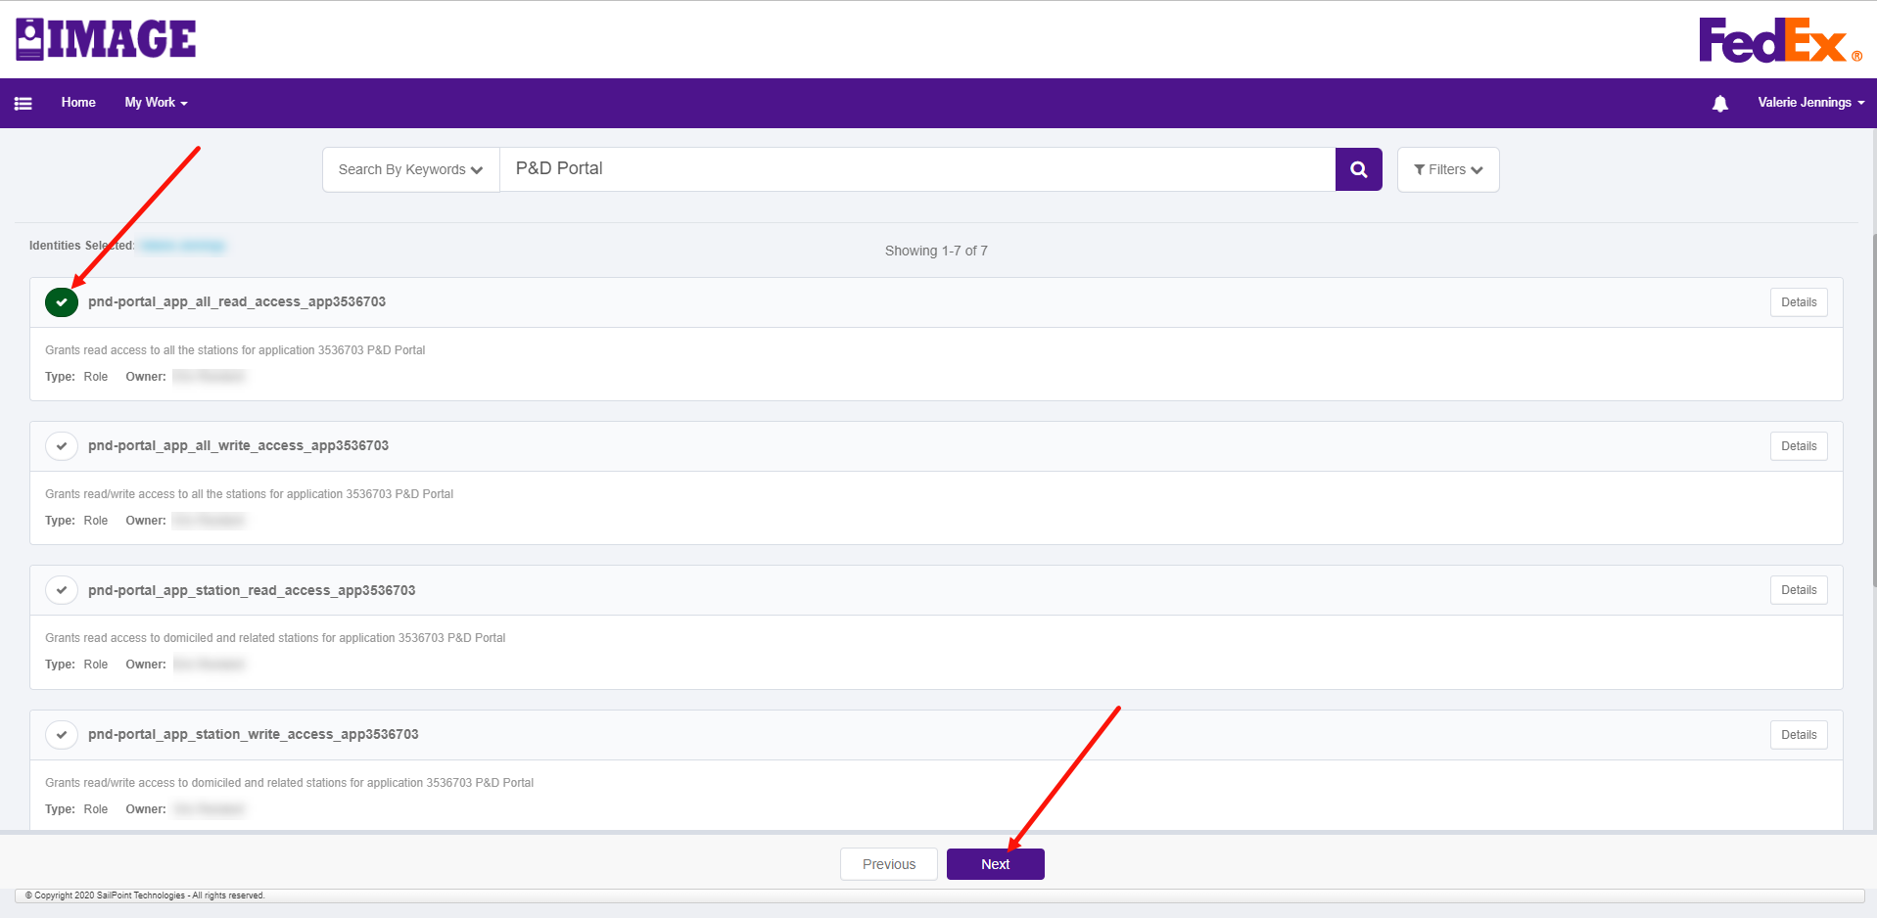
- If a selection is made for a level and type of access already assigned, a message displays that the level is already assigned. Simply select the X to close the message.
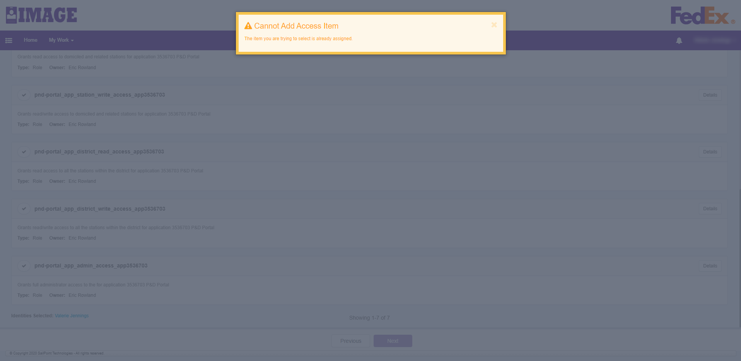
- On the IMAGE Review and Submit screen, review the level and type of access selected and if it’s correct, select Submit. If the option selected is not correct, select Previous to return to the previous screen and select the correct level and type of access (see Step 7).
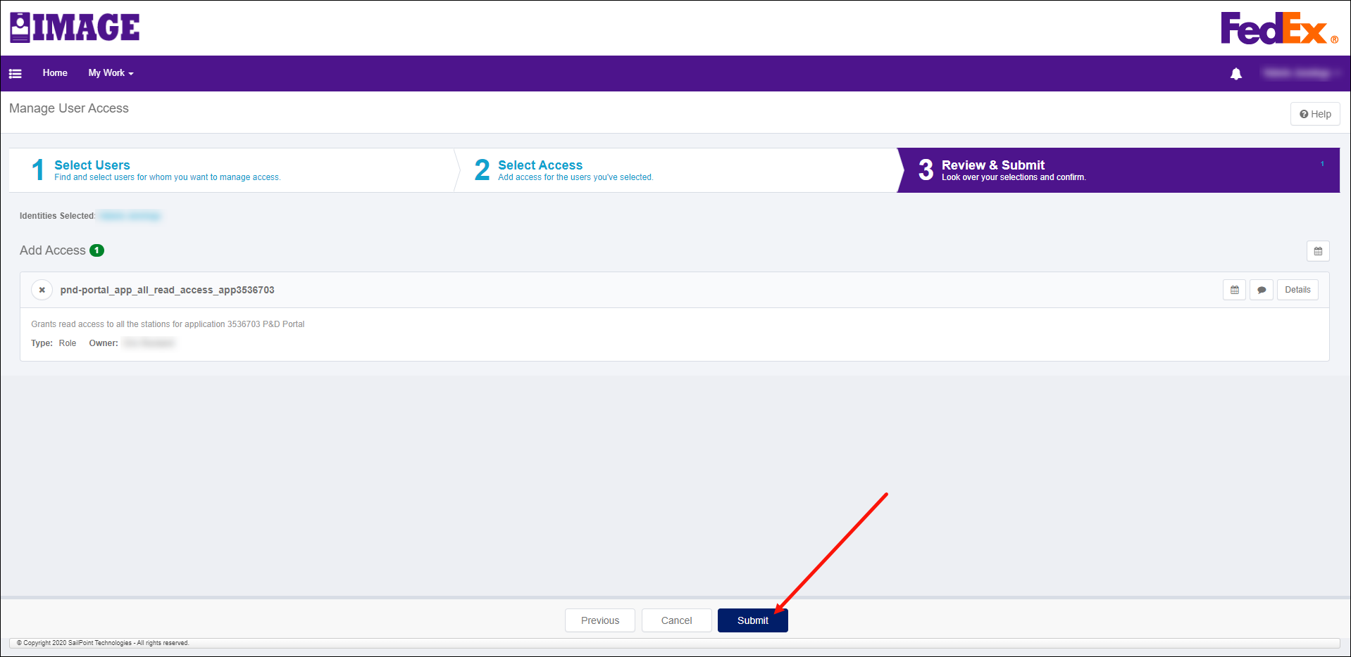
- Once the request is submitted, the user’s manager receives the request for approval. The manager should review the request to ensure the correct level and type of access is requested.
- Once the user’s manager approves the request, the application business owners receive and review the request.
- Once all approvals are received, the user receives notification that their request was approved. Access the P&D Portal using the log-in link on the P&D Portal Sharepoint - Home, see the Logging in to the P&D Portal section in this procedure.

Logging into the P&D Portal
The P&D Portal uses OKTA/PurpleID sign on to verify the user’s level of access and for what stations. Follow the below steps to log in to the P&D Portal:
- Once access is approved via IMAGE (see Requesting access to the P&D Portal section of this procedure), select the P&D Portal link on the FXG Departments& Applications site to access the P&D Portal SharePoint site.
- On the P&D Portal SharePoint site, select the LOGIN TO P&D Portal link on the left side of the page.
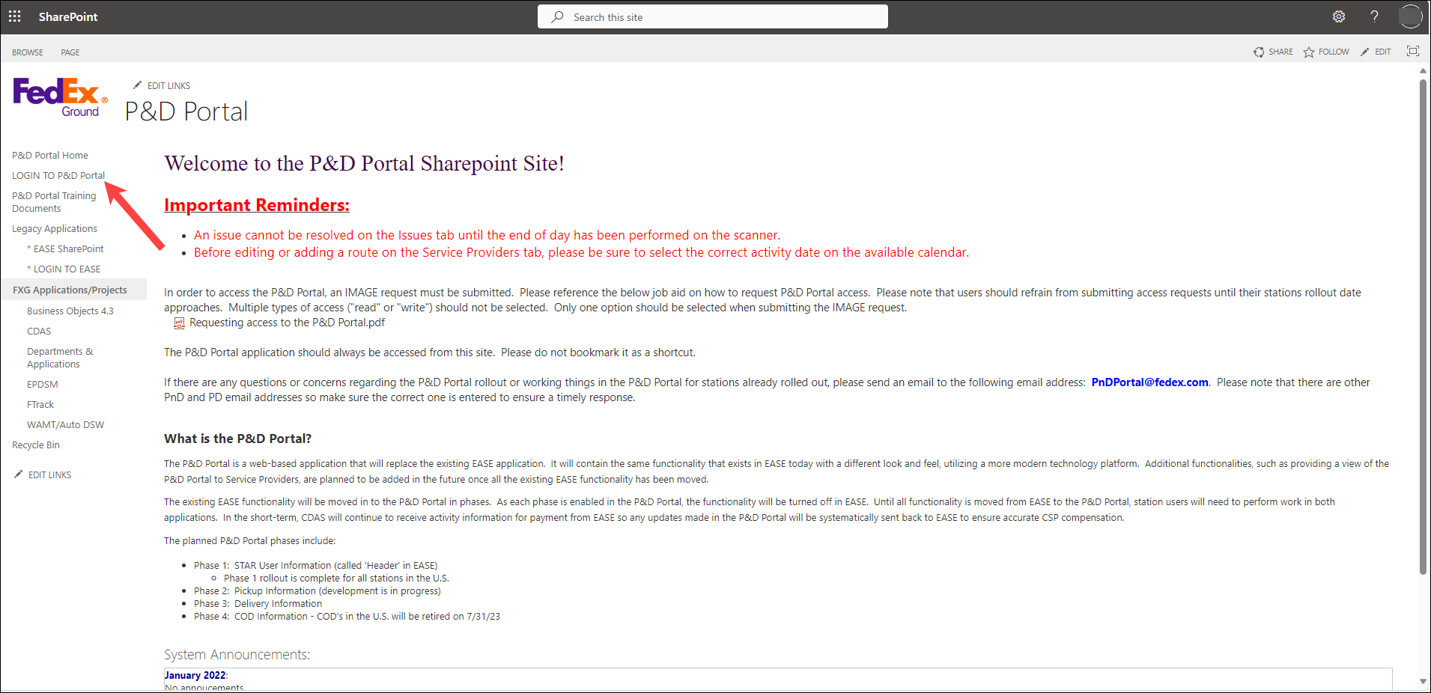
- A PurpleID sign on page displays.
- Enter your employee ID and password. Select the Sign In
- If user has access, the application opens the Facility Search page. Place cursor in the Facility Id/Abbreviation field to open the dropdown list.
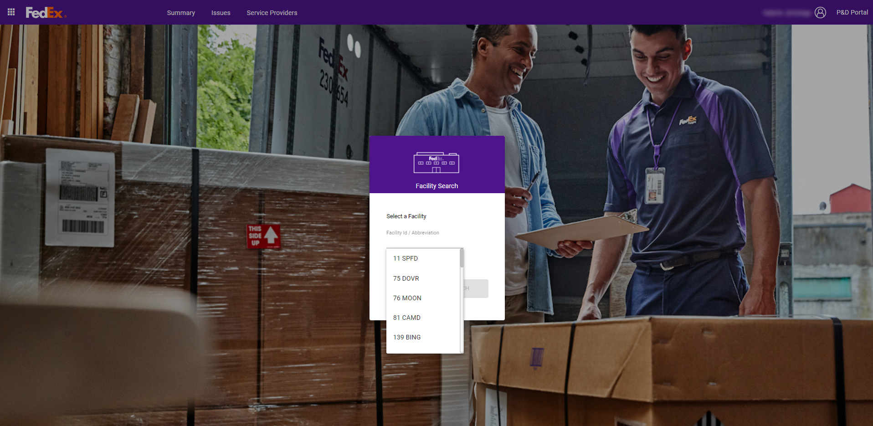
- The users related stations display in the dropdown. Select the desired facility from the provided list or key the facility number in the field to filter the list. Click on the desired station. If information was keyed into the field, delete the information keyed in to reset the dropdown list.
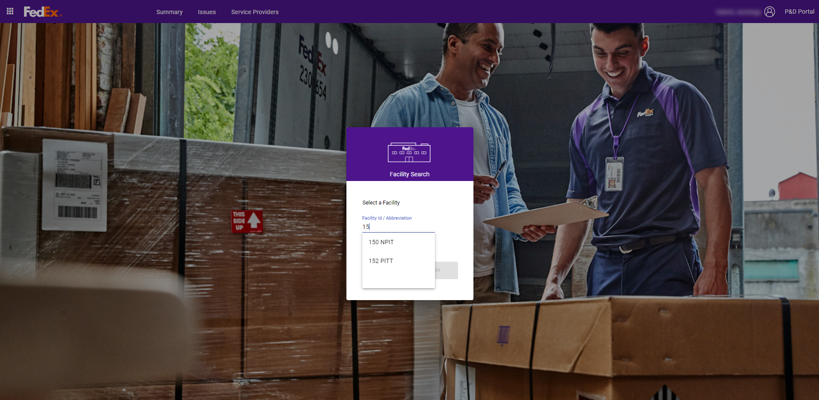
- Once a facility is selected, select Search.
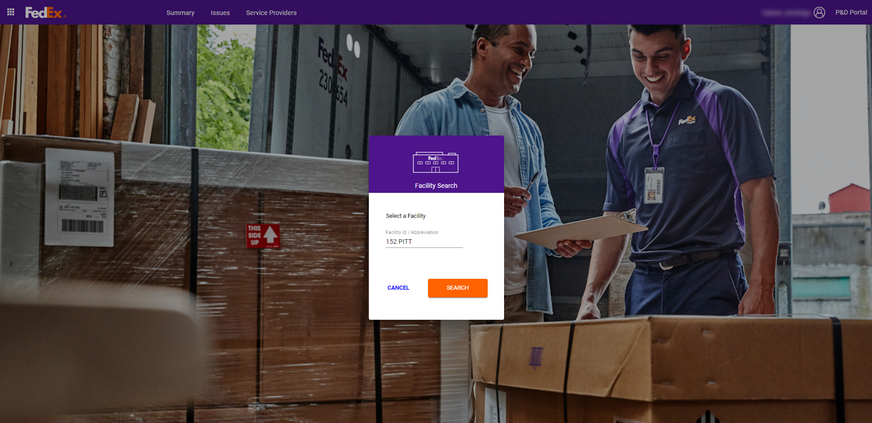
- The P&D Portal UI loads with the Summary tab displayed. For additional information on the Summary tab, see the Summary Tab section in this procedure.

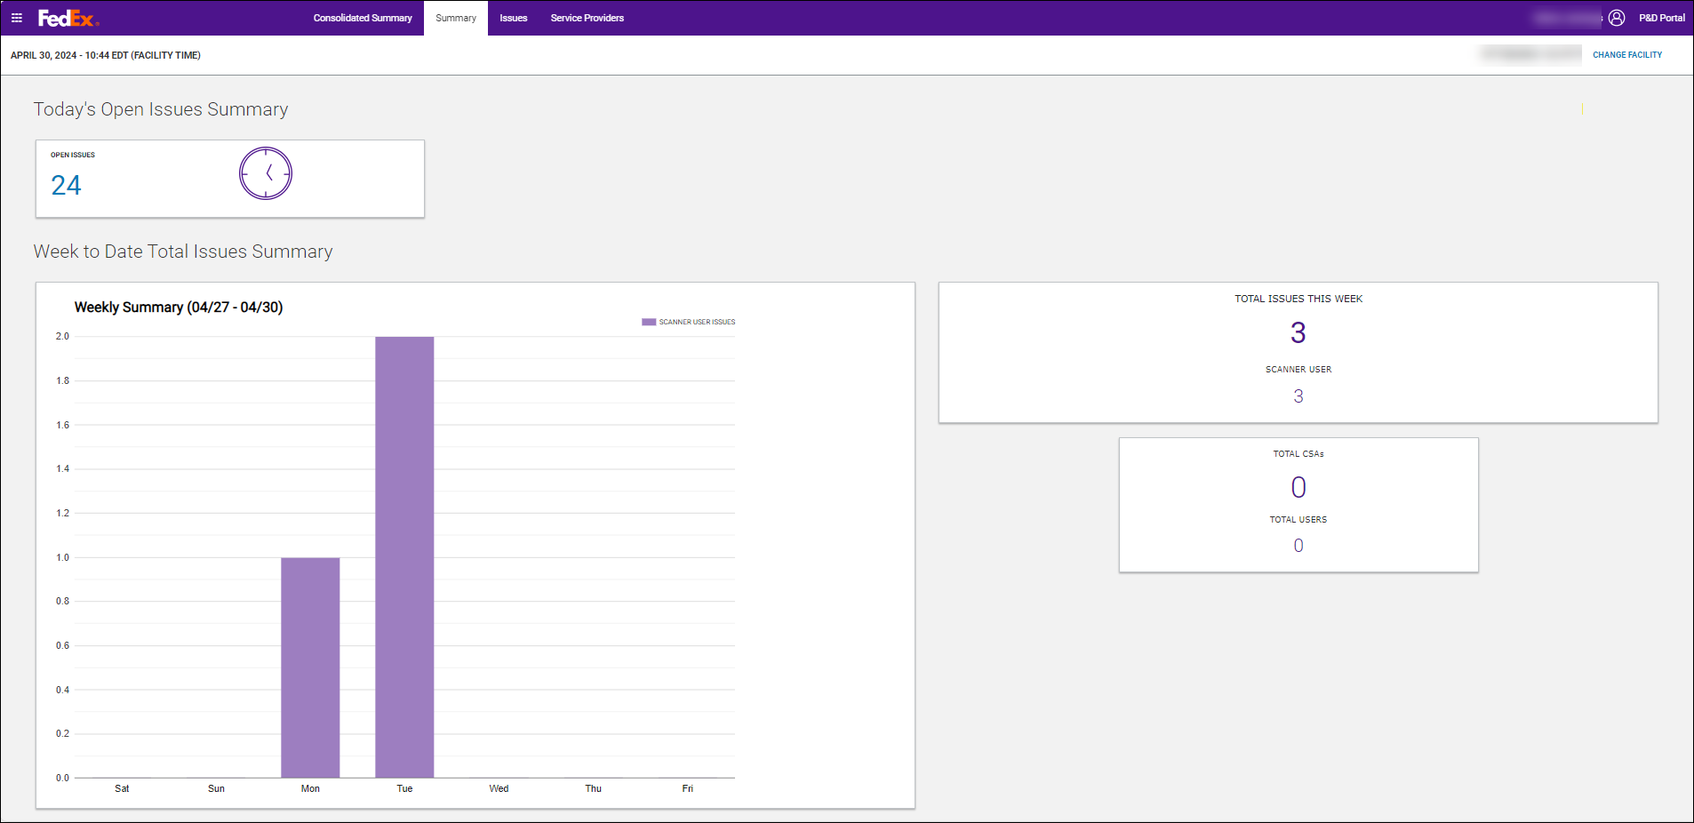
- If a user has access to multiple facilities, change the facility number by selecting the Change Facility link.

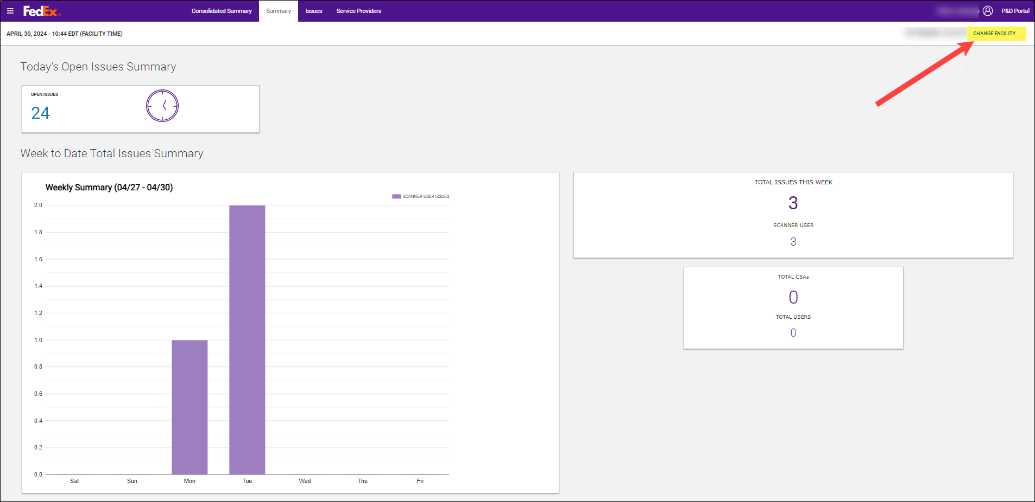
- Select Change Facility to open the Facility Search pop-up to select or key another facility.

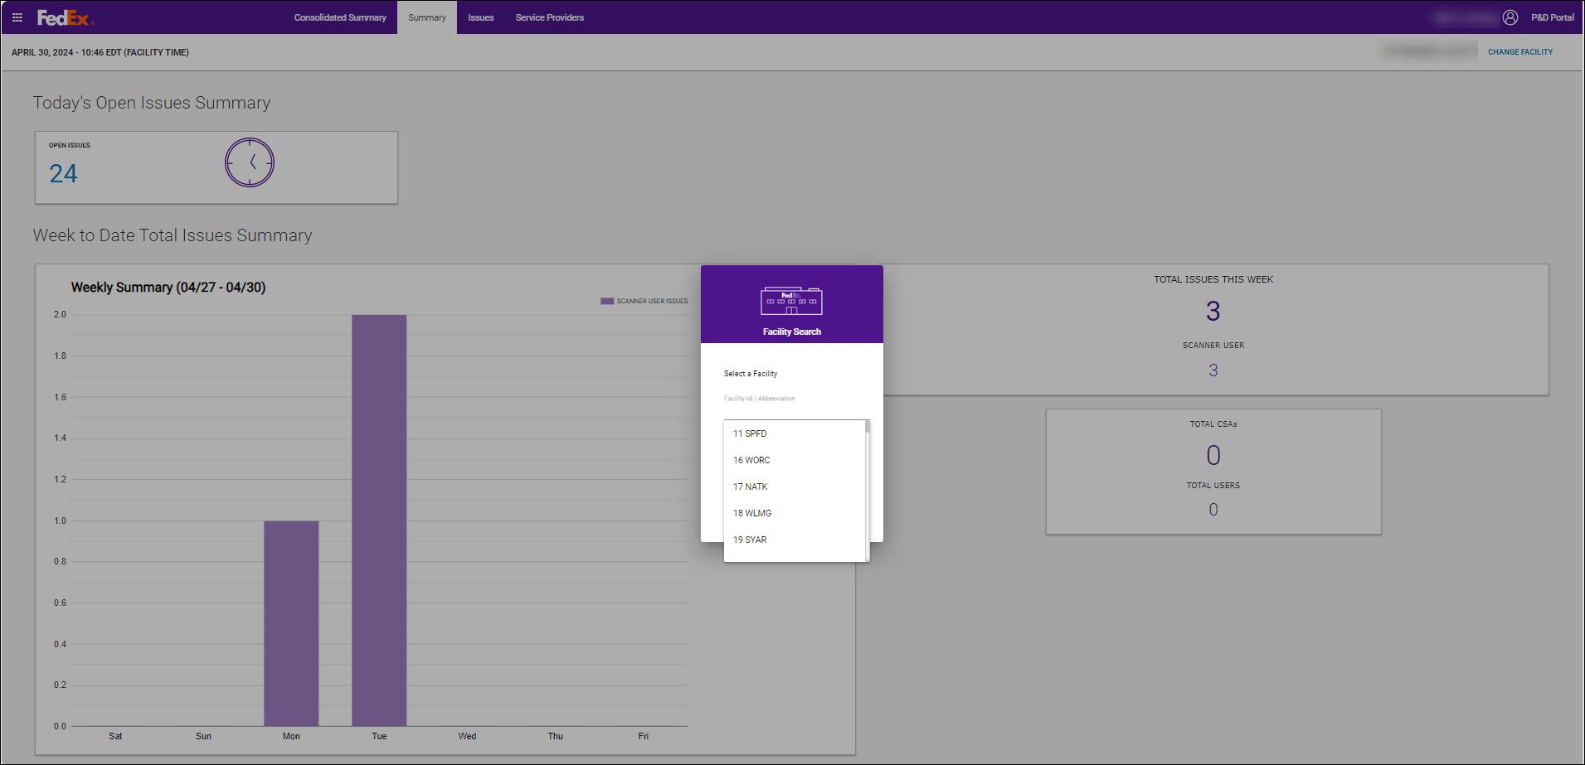
- Select a different facility from the dropdown or key the facility number in the field to filter the list and select Search. The selected facility’s information loads in the P&D Portal.

Summary Tab
The Summary tab provides high level information regarding the number of issues for the selected station. This tab is similar to the EASE home page.
The top bar provides links to different tabs within the application, along with displaying the logged in user’s name, the current date and time, and the station selected on the Facility Search screen.

Layout and Functionality

Waffle Menu

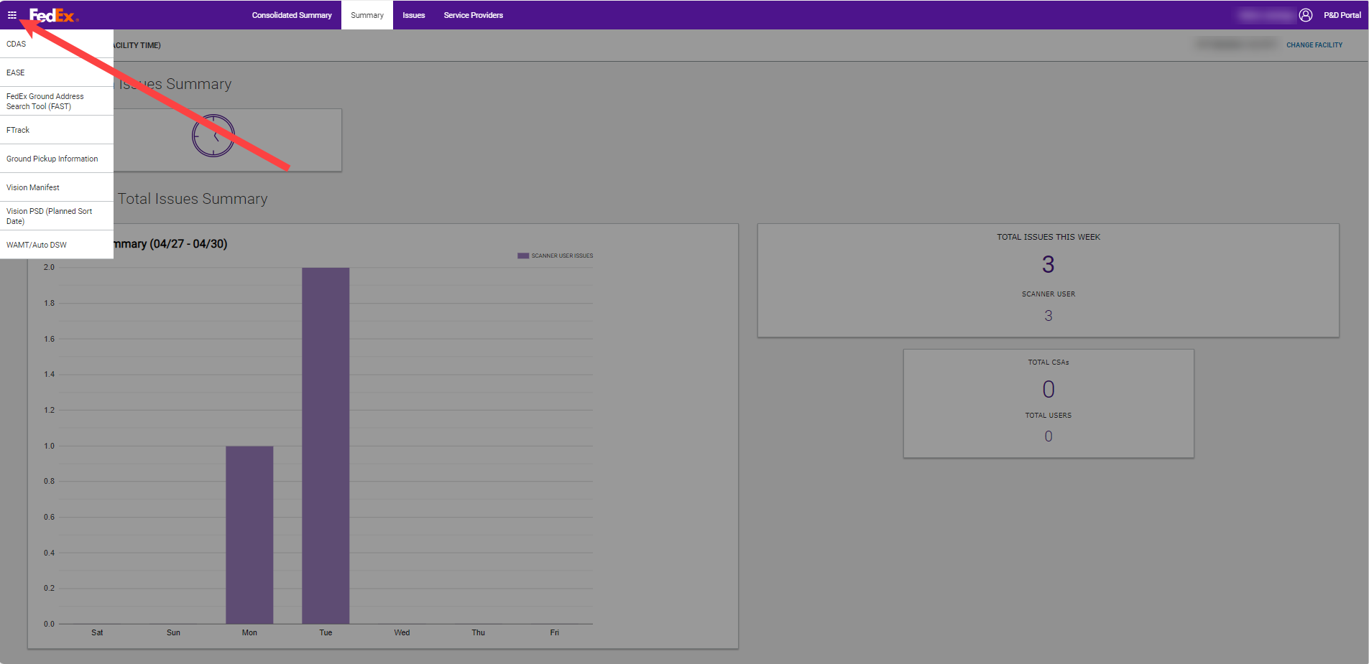
- The Waffle menu is located in the upper left-hand corner of the P&D Portal.
- When selected, a dropdown opens with links to the following applications:
- CDAS
- EASE
- FedEx Ground Address Search Tool (FAST)
- FTrack
- Ground Pickup Information
- Vision Manifest
- Vision PSD (Planned Sort Date)
- WAMT/Auto DSW
- When an application is selected from the Waffle menu dropdown, it opens in a new tab.
- The P&D Portal tab remains open.

Today’s Open Issues Summary
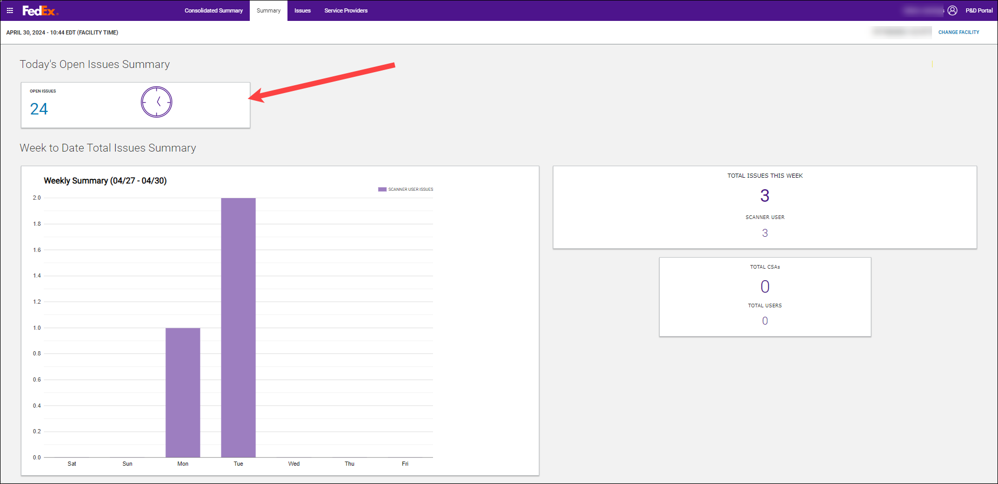
- The Open Issues card displays the total number of open issues that need resolved on the Issues tab.
- Click on this card to navigate to the Issues tab.

Week to Date Total Issues Summary

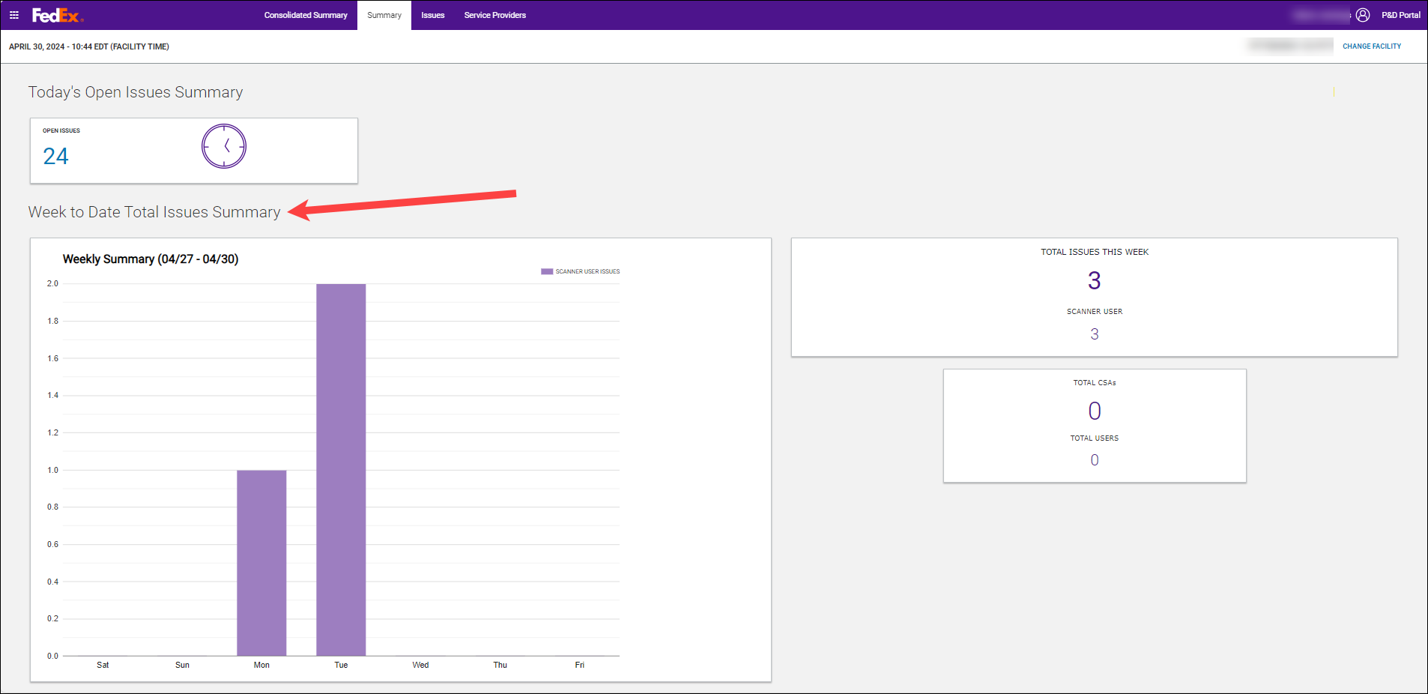
- The large Weekly Summary (date range) card on the left displays the total number of issues that generated each day within the settlement week (Saturday – Friday). This card resets every Saturday for the current week’s activity.
- The current day’s total issue count increases as issues are generated throughout the day.
- The small Total Issues This Week card on the right displays the total number of issues that generated within the settlement week. The total number of SCANNER User issues displays below the total and for now, that total matches the Total Issues This Week until other issue types such as pickup and delivery issues are added to the P&D Portal.
- The small Total CSAs and Total Users card displays the total number of CSAs and Users that had activity for the week.

Consolidated Summary Tab
The consolidated summary tab displays high level open issue totals by category for a user’s related stations regardless of the station number selected during log in.

Layout and Functionality
There are three levels of Consolidated Summary tab views: Station, District, and PGH. The view provided on the Consolidated Summary tab is dependent on the level of access provisioned in the P&D Portal IMAGE request.

Station Consolidated Summary Tab
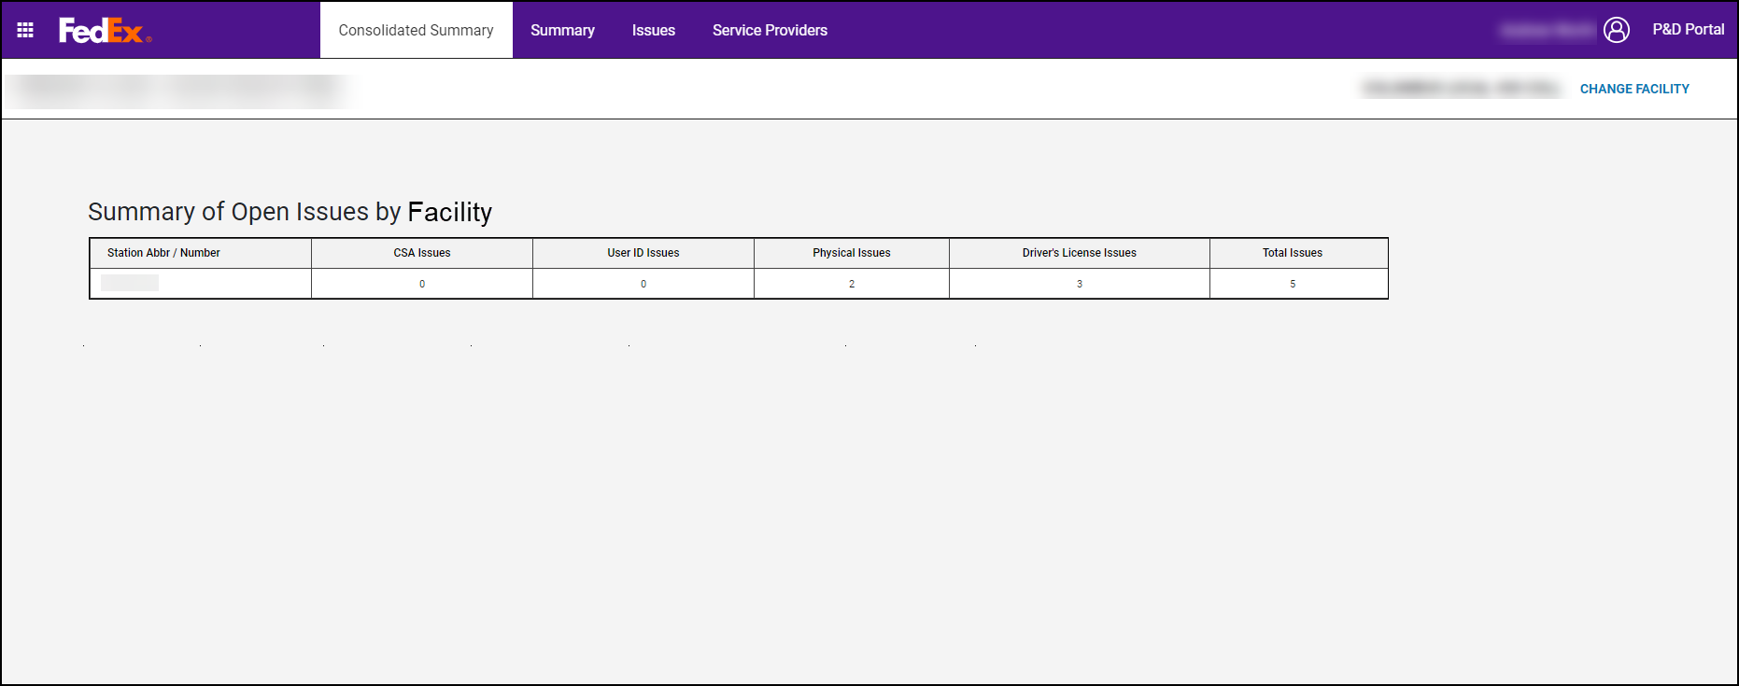
- Displays the number of open issues for a user’s related stations.
- The open issue information displays in the following categories:
- CSA Issues
- User ID Issues
- Physical Issues
- Driver’s License Issues
- If a different station needs attention, select the Change Facility link to change the facility.
- If a user sits on the tab for a while, a tab refresh is required to pull in updated information. To refresh the tab:
- Select a different tab and navigate back to the Consolidated Summary tab.
- Select the orange REFRESH button on the Consolidated Summary tab.

District Consolidated Summary Tab
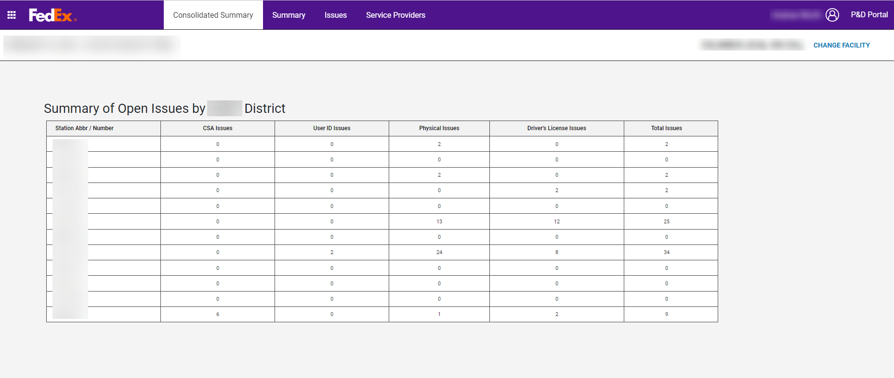
- Displays the number of open issues for all stations in the district.
- The open issue information displays in the following categories:
- CSA Issues
- User ID Issues
- Physical Issues
- Driver’s License Issues

PGH Consolidated Summary Tab
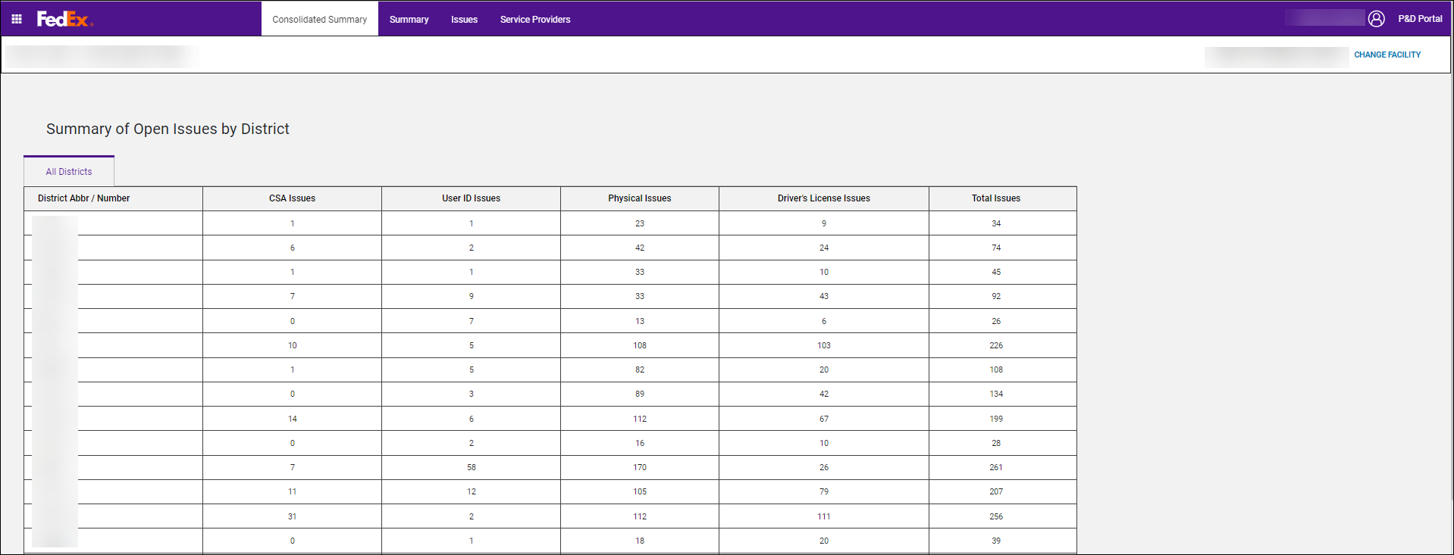

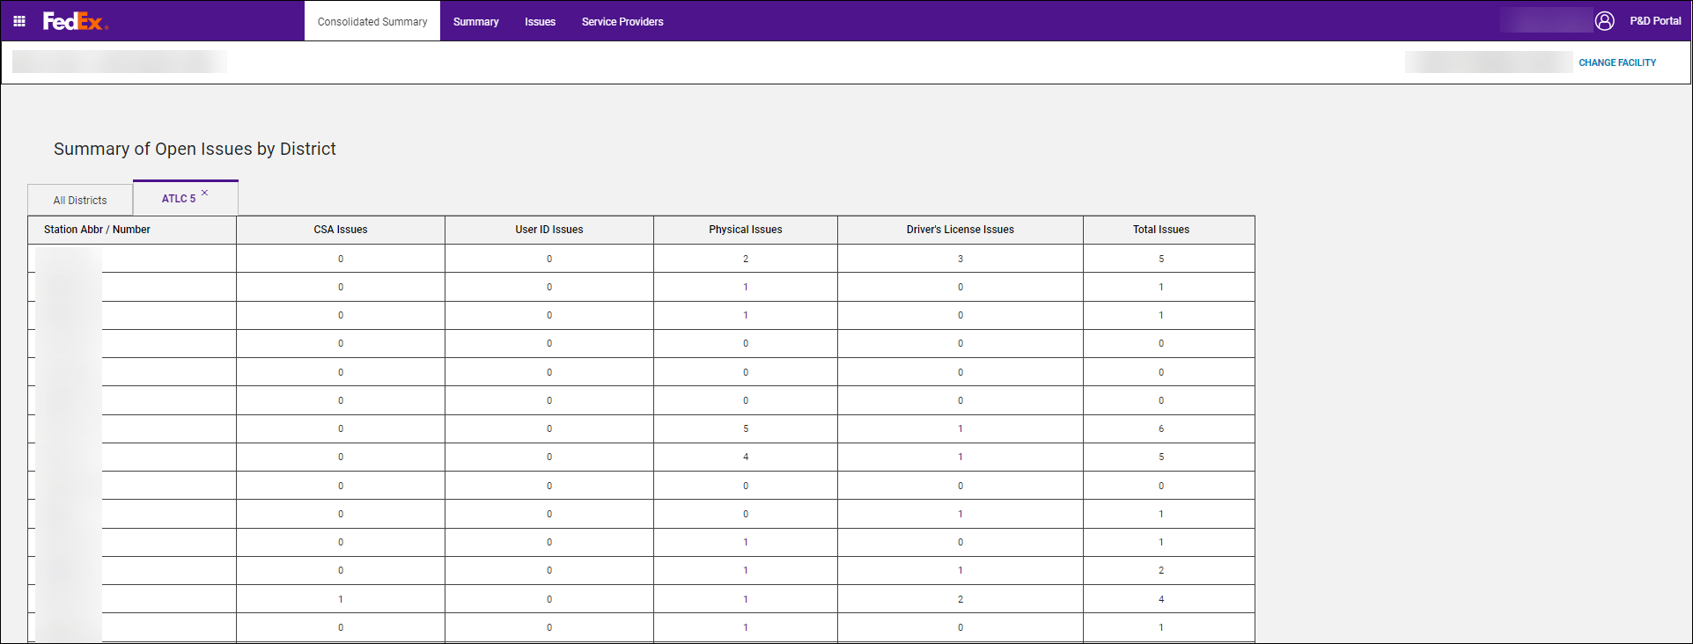
- Displays the number of open issues for each district in the U.S.
- If more districts exist than what are displayed, the list scrolls vertically.
- When a district is selected, a new tab opens to display the total number of open issues for all stations in the selected district.
- Multiple district tabs can be opened at the same time.
- If more districts are open than what are displayed, the Districts tab scrolls horizontally.
- The open issue information displays in the following categories:
- CSA Issues
- User ID Issues
- Physical Issues
- Driver’s License Issues

Issues Tab
As scanner data is received or manual routes are created in the P&D Portal, validations are being performed on the SCANNER user information received.
If any issues are identified (i.e., expired driver’s license, expired physical, PSA/CSA issues, User ID issues, etc.), the P&D Portal creates SCANNER User issues (formerly called Header issues in EASE) and displays them on the Issues tab as soon as the issues are generated.
Station personnel are expected to review and resolve issues on a daily basis.
An issue displays in read only format until the end of the day is performed on the scanner. Once an end of the day is received, the issue can be resolved.
Note: There is no calendar concept on the Issues tab. Issues display on the tab for all issues generated regardless of the date, CSA, or SCANNER user.

Layout and Functionality

SCANNER USER ISSUES Card
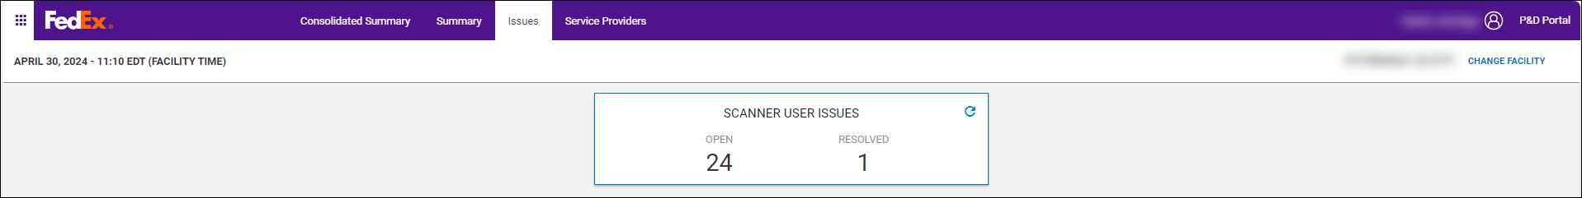
- Displays the number of OPEN and RESOLVED SCANNER user issues.
- Select the SCANNER USER ISSUES card to refresh the Issues tab and pull in any new issues that were created since the tab was accessed.

Open Tab
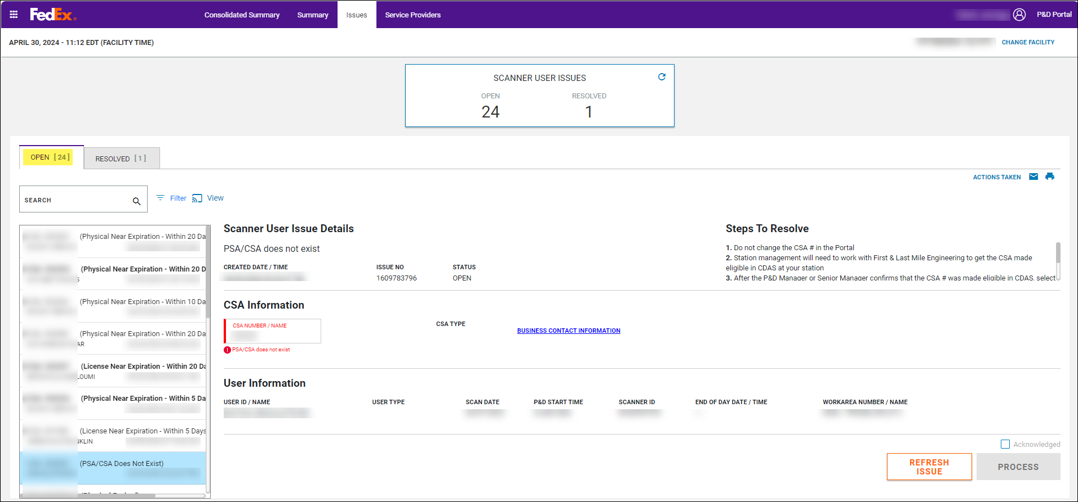
- The OPEN tab displays by default when the Issues tab loads.
- The tab is highlighted purple to indicate it’s the active tab being viewed.
- The tab displays the SCANNER User OPEN issues that need to be worked by station personnel.
- The total number of OPEN SCANNER User issues is displayed in parenthesis.
- The first open issue in the list is selected by default.
- The issue selected and being viewed is highlighted blue.
- The following information displays for each issue in the Open tab:
- CSA #: The CSA # entered in the scanner.
- Name of the Issue: The name of the issue (for example, Physical Expired, Driver’s License Expired, etc.).
- User Name: The name of the user that performed the activity on the scanner.
- Created date and time: The date and time the issue was created.
- If there are more issues than what is visible on the screen, the OPEN issue scrolls horizontally and vertically.
- The issue details for the issue selected displays to the right of the OPEN issue list.

RESOLVED Tab
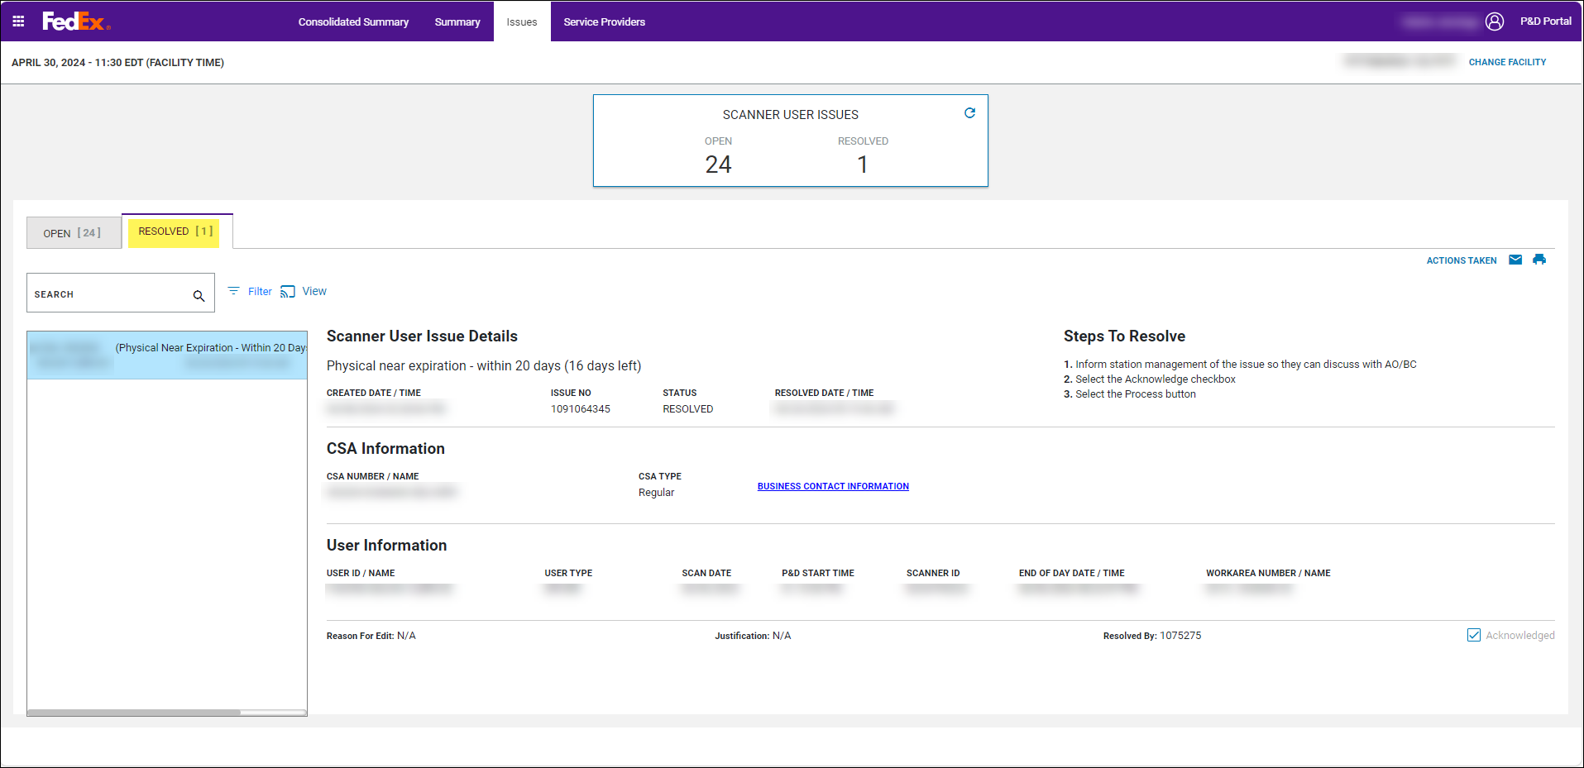
- The RESOLVED tab displays issues that were worked and successfully processed on the OPEN tab. For more information on how to resolve issues, see Resolving SCANNER User Issues section in this procedure.
- When selected, the RESOLVED tab is highlighted purple at the top of the tab to indicate it’s the active tab being viewed.
- The total number of RESOLVED SCANNER User issues is displayed in parenthesis.
- The most recently resolved issues display at the top of the list.
- The first resolved issue in the list is selected by default.
- The issue selected and being viewed is highlighted blue.
- The information displayed for issues in the RESOLVED tab is the same as the information displayed for issues in the OPEN tab with the following difference:
- The resolved date and time display instead of the created date and time.
- If there are more issues than what are visible on the screen, the RESOLVED issue list scrolls horizontally and vertically.
- The issue details for the issue selected displays to the right of the RESOLVED issue list.
- The Reason for Edit and Justification if entered display under the issue details along with the employee ID that resolved the issue.
Important: It is not possible to unresolve or re-open an issue after it is resolved. If additional changes are required for the route, make them on the Service Providers tab. For more information on the Service Providers tab, reference the following sections in this procedure: Service Providers tab and Editing a Route on the Service Providers tab.

SCANNER User Issue Details
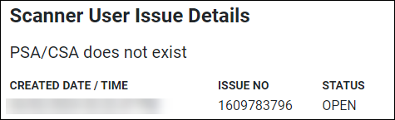
- The SCANNER User Issue Details section provides information regarding the issue selected in the list:
- Name of the issue: for example, PSA/CSA does not exist.
- Created Date and time: the created date and time.
- Issue number: System generated number.
- Status: OPEN or RESOLVED depending on the tab being viewed.

Steps to Resolve
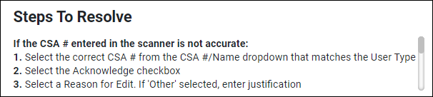
- The Steps to Resolve section identifies the steps to resolve the issue.
Note: Some steps contain multiple options if an issue can be resolved in different ways. It is important to review all the steps to ensure the correct resolution is taken. For more information on Steps to Resolve, see Resolving SCANNER User Issues section in this procedure.
- This section is scrollable if the Steps to Resolve section contains more information than what is visible on the screen.

CSA Information
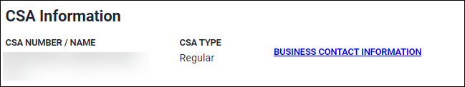
- The CSA Information section provides Contracted Service Area details retrieved from CDAS for the issue being viewed on the screen:
- CSA Number / Name:
- Displays the CSA # entered in either the scanner or in the P&D Portal for a manual route and the associated name retrieved from CDAS.
- This field is an available dropdown for any issue that involves the CSA # such as PSA/CSA is Inactive so that the correct CSA # can be selected, if applicable. For more information on how to resolve PSA/CSA issues, see the Resolving SCANNER User Issues section in this procedure.
- For PSA/CSA issues, this field is highlighted red, and the issue name displays in red under the dropdown box.
- CSA Type:
- Provides the description of the CSA # such as Regular, Agency, Management.
- Select the blue Business Contact Information text and a pop-up box displays the following CSA business contact information as listed in CDAS:
- Contact Name
- Phone Number
- Email Address
Note: If multiple business contacts display in the pop-up, the same phone number and email address may display for all contact names. This is not a system issue but rather a result of how the information has been updated and maintained by the service provider. If the information is not accurate, the service provider can correct it in MyGroundBizAccount.

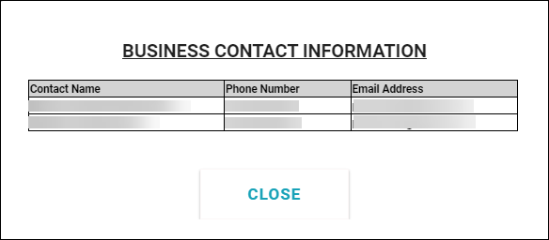

User Information
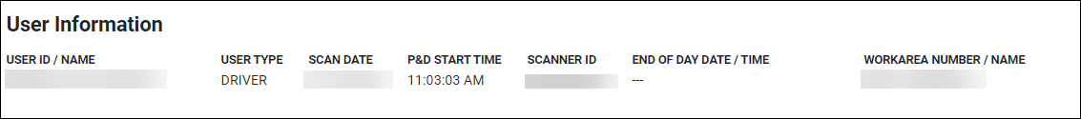
- The User Information section provides details regarding the user associated with the issue:
- User ID / Name:
- Displays the User number entered in either the scanner or in the P&D Portal for a manual route and the associated name.
- The field is an available dropdown for any issue that involves the User number such as User ID Not Active / Not Valid so that the correct User number can be selected, if applicable. For more information on how to resolve User ID issues, see Resolving SCANNER User Issues section in this procedure.
- For user ID issues, this field is highlighted red and the issue name displays in red under the dropdown box.
- User Type:
- Displays the user type entered in either the scanner or in the P&D Portal for a manual route.
- The field is an available drop down for any issue that involves the User Type such as User Type invalid for User ID so that the correct User Type can be selected, if applicable. For more information on how to resolve User Type issues, see Resolving SCANNER User Issues section in this procedure.
- For user type issues, this field is highlighted red and the issue name displays in red under the dropdown box.
- Scan Date: displays the scan date.
- P&D Start Time: displays the P&D start time.
- Scanner ID: displays the scanner serial number. If the issue is for a manual route created in the Portal, the scanner ID begins with *MAN.
- End of Day Date / Time:
  - Displays the end of day date and time.
  - Since issues are created as soon as the P&D Portal receives the information, this field is blank until the end of day is received.
Important: An issue cannot be worked/resolved until the end of day is received. This means that dropdown boxes and the Acknowledged checkbox is disabled until the end of day is performed on the scanner and populates in the system.
  - If the end of day is received after midnight on the activity date (late upload), the end of day displays in red.
- Work Area Number / Name: displays the work area information associated with the activity/issue.

Email Icon
- This icon provides users with the ability to email issue information being viewed on the screen.
- The email icon is in the upper right-hand corner near the Steps to Resolve tab.
- When the icon is selected, an “Are you sure” pop-up message displays notifying the user that the information is confidential to FedEx Ground and the service provider. The pop-up contains Ok and Cancel buttons.
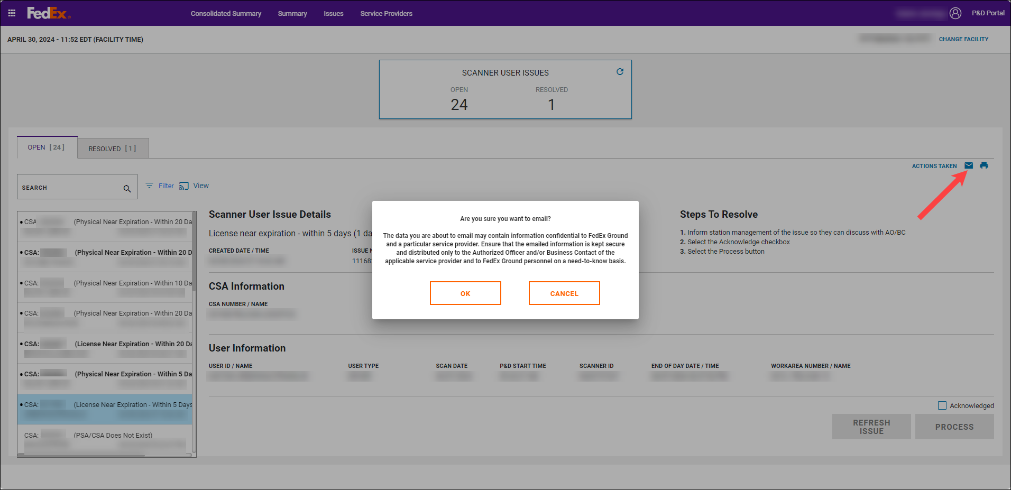
- If Cancel is selected, the confirmation pop-up closes.
- If Ok is selected:
- A “Select Business Contact” pop-up displays with a list of business contact names, phone numbers, and email addresses as maintained by the service provider on MyGroundBizAccount.
- Check the box in the Select column next to the desired contact.
- Select Send. The email goes to the selected business contact and the pop-up closes.
- Select Cancel to close the pop-up. An email does not send if Cancel is selected.
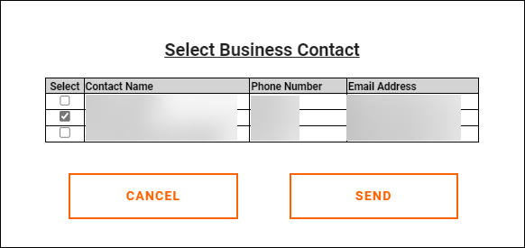

Print Icon
- This icon provides users with the ability to print the issue information being viewed on the screen.
- The print icon is located in the upper right-hand corner near the Steps to Resolve tab.
- When the icon is selected, an “Are you sure” pop-up message displays notifying the user that the information is confidential to FedEx Ground and the service provider. The pop-up contains OK and Cancel buttons.
- If Cancel is selected, the confirmation pop-up closes.
- If OK is selected, the print preview screen displays. The user has the option to print or save a copy locally. If print is selected, the information prints to the default laser printer.
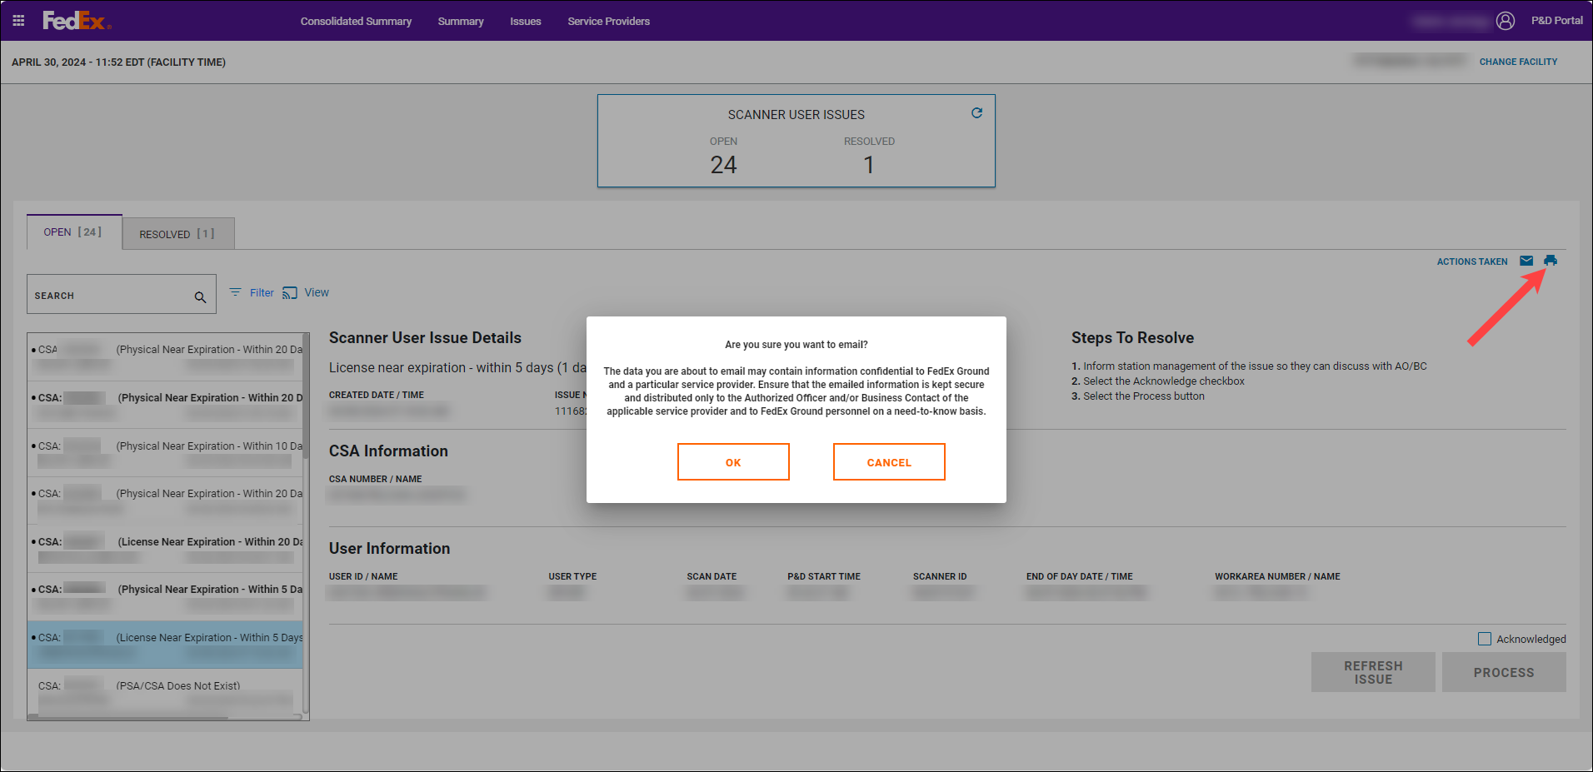
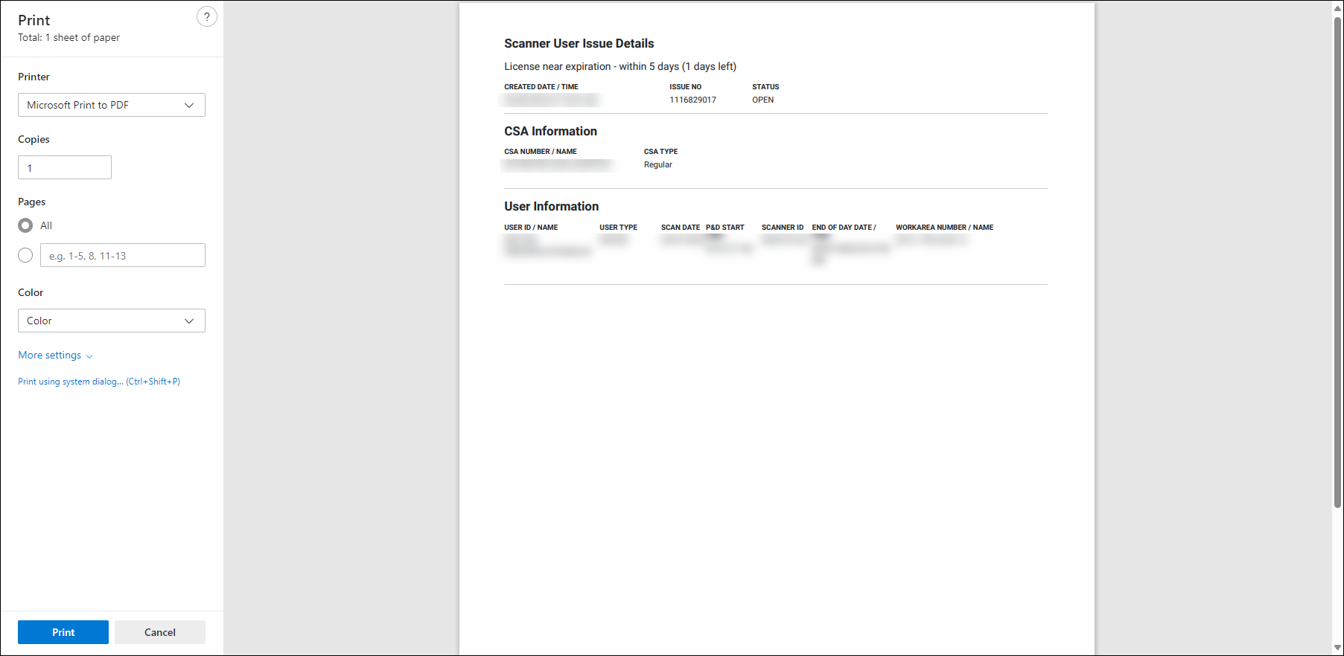

Actions Taken Link
- The Actions Taken link provides visibility to who may have printed or emailed issue information on the Issues tab.
- When selected, an Actions Taken pop-up displays and provides visibility to the following information:
- Action: displays either Print or Email.
- Date and Time: displays the date and time the action was taken.
- Employee ID: displays the employee ID who took the action.
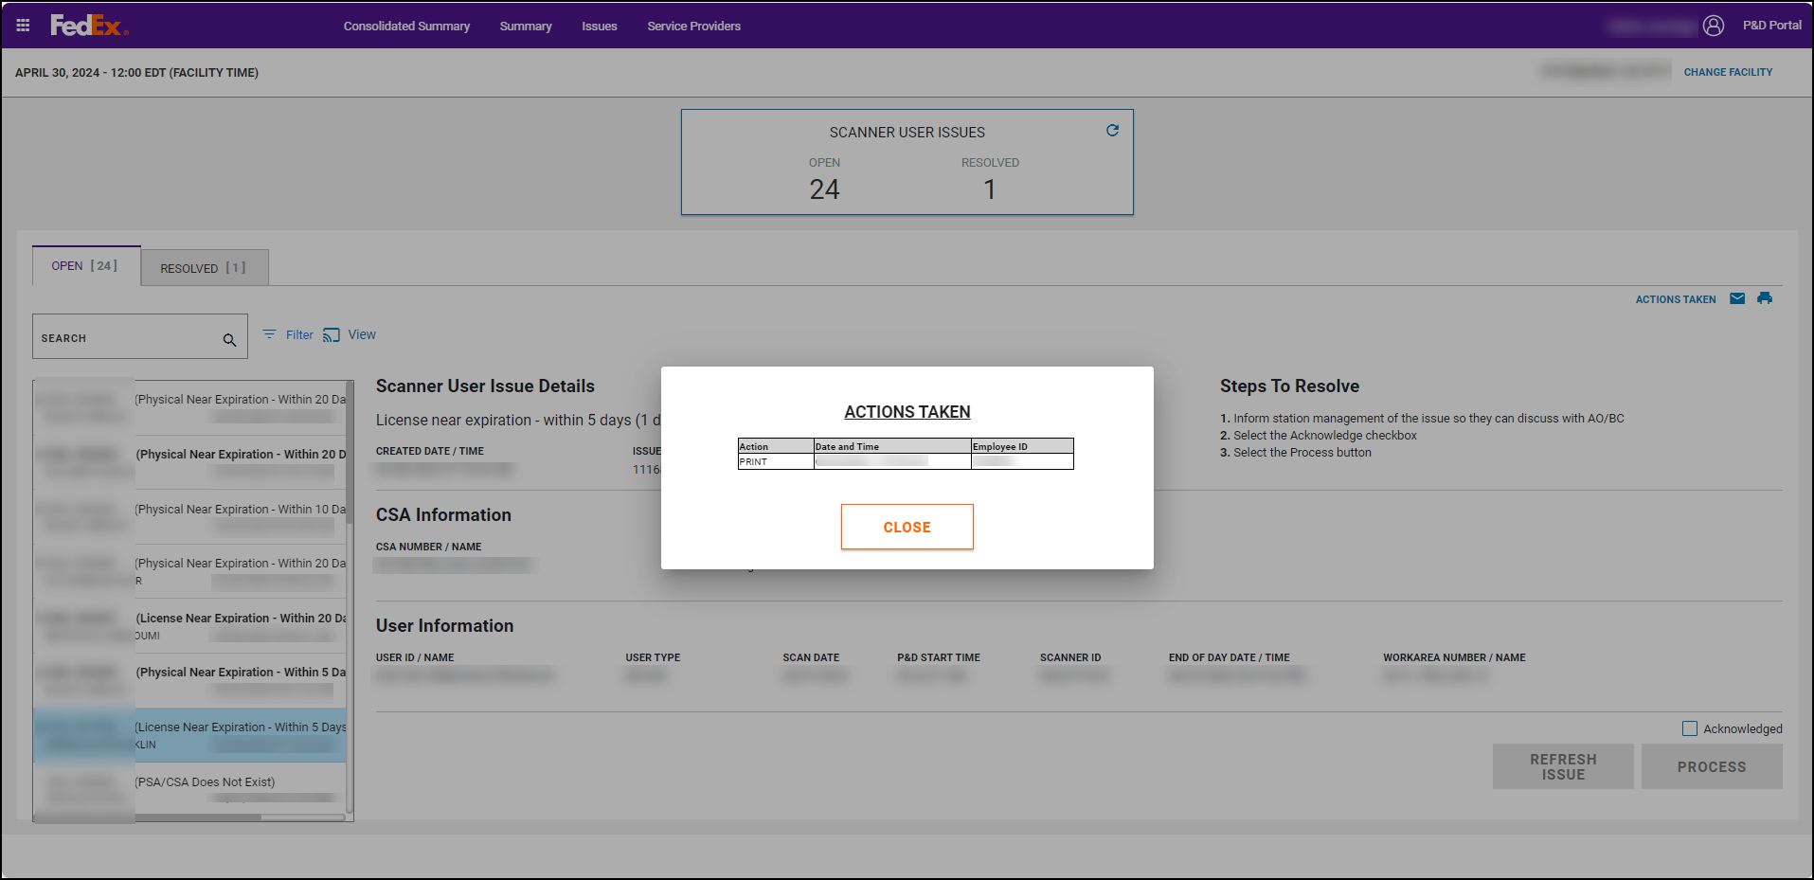
Acknowledged Checkbox
- To resolve an issue, users must select the acknowledge checkbox.
- If an issue was resolved by selecting a different value in any of the available dropdown boxes, a Reason for Edit pop-up displays when the acknowledged checkbox is selected:
- Users need to select from a list of available options to indicate the reason why the fields were changed.
- If Other is selected, justification must be entered in the available text box.
- Select Ok once entry is performed and the pop-up box closes.
- If Cancel is selected, the pop-up box closes and any changes made are lost.
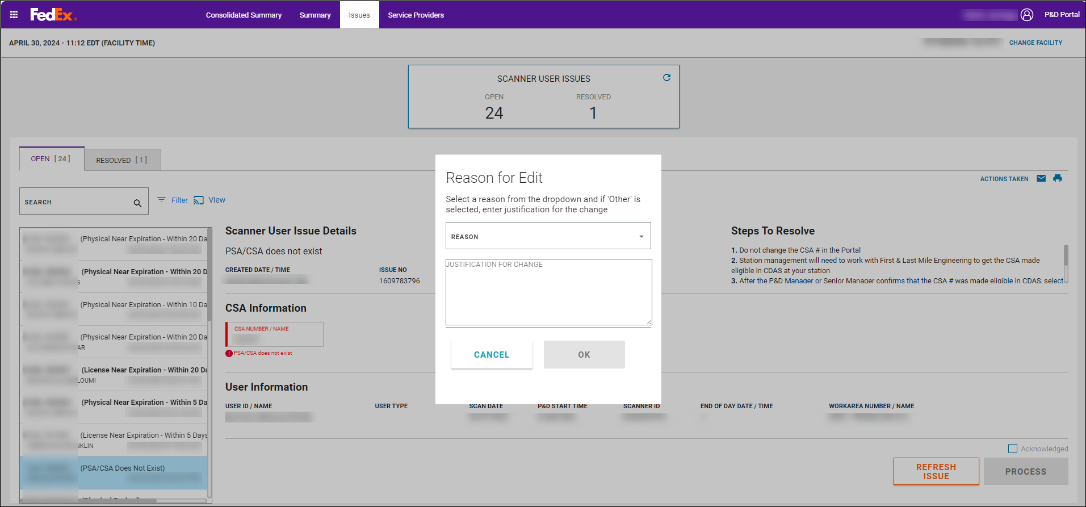

Process Button
- Once the issue is acknowledged and a Reason for Edit entered, if applicable, select Process to manage the issue.
- A green confirmation message displays at the top of the screen.
- The issue moves to the Resolved tab.
- The Open and Resolved counts update accordingly.

Refresh Issue Button
- Select Refresh Issue to refresh the issue being worked.
- For issues where CDAS updates were made, for example a CSA or User ID was made active in CDAS, selecting Refresh Issue triggers the checks to be performed again. If the issue no longer exists, a green message displays at the top of the screen indicating that the conditions that generated the issue no longer exist. For more information on how to resolve issues, see Resolving SCANNER User Issues section in this procedure.
- In this scenario, select the Acknowledge checkbox and then Process.
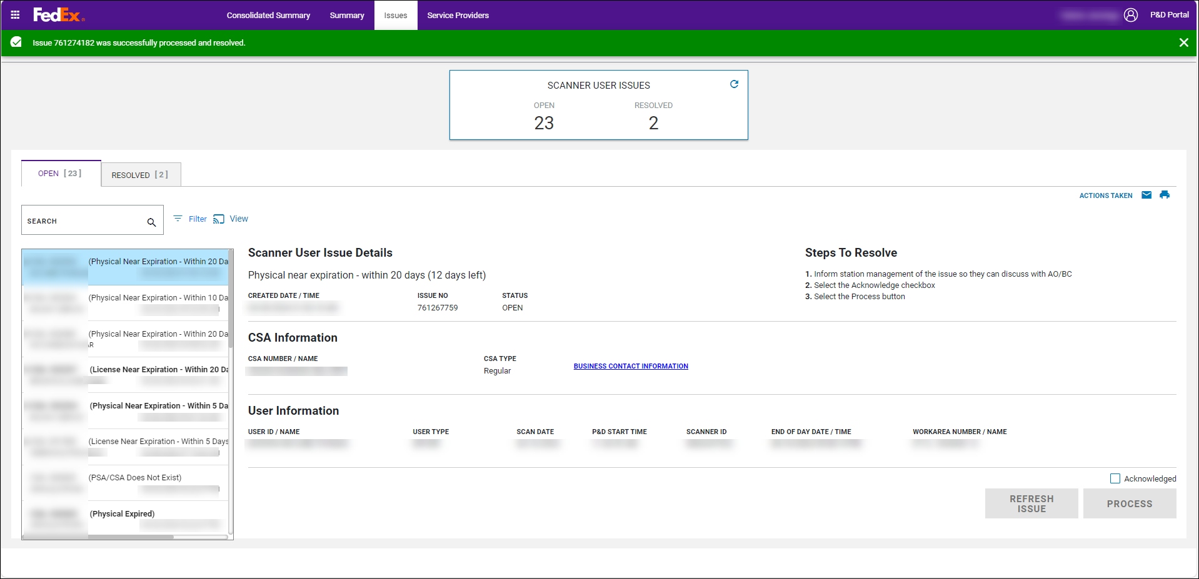
Search/Filter/View
Search:
A simple Search box is located above the Open and Resolved lists to filter the list.
- As text is entered into the Search box, the list of issues dynamically filters based on the text entered.
- The filter criteria entered in the Search box applies to both the Open and resolved tabs when navigating from one to another.
- If no issues exist for the criteria entered, both the issue list and the issue details are blank (a blank white page displays).
- To clear the filter, simply delete the text in the search box and a full list of issues displays.
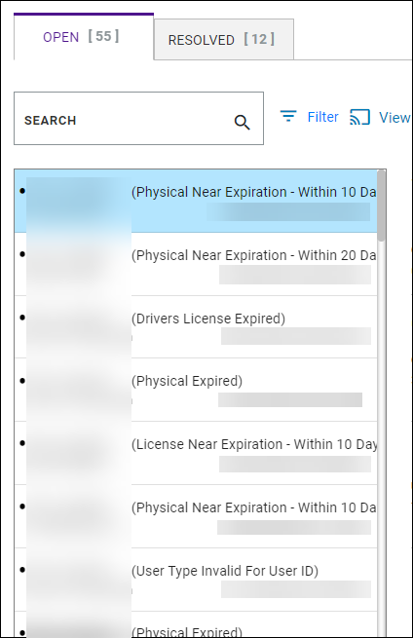

Filter/View:
The Open and Resolved issue lists can be filtered on the Issues tab and a view of that filter can be created/saved for reference later. For example, if a person only wants to see issues for certain CSA numbers, a view can be created to only show issues for those CSA’s. Follow the below steps to filter issues on the Issues tab and save a filtered view.
- On the Issues tab, select Filter next to the Search box to filter the Open and Resolved issue lists.
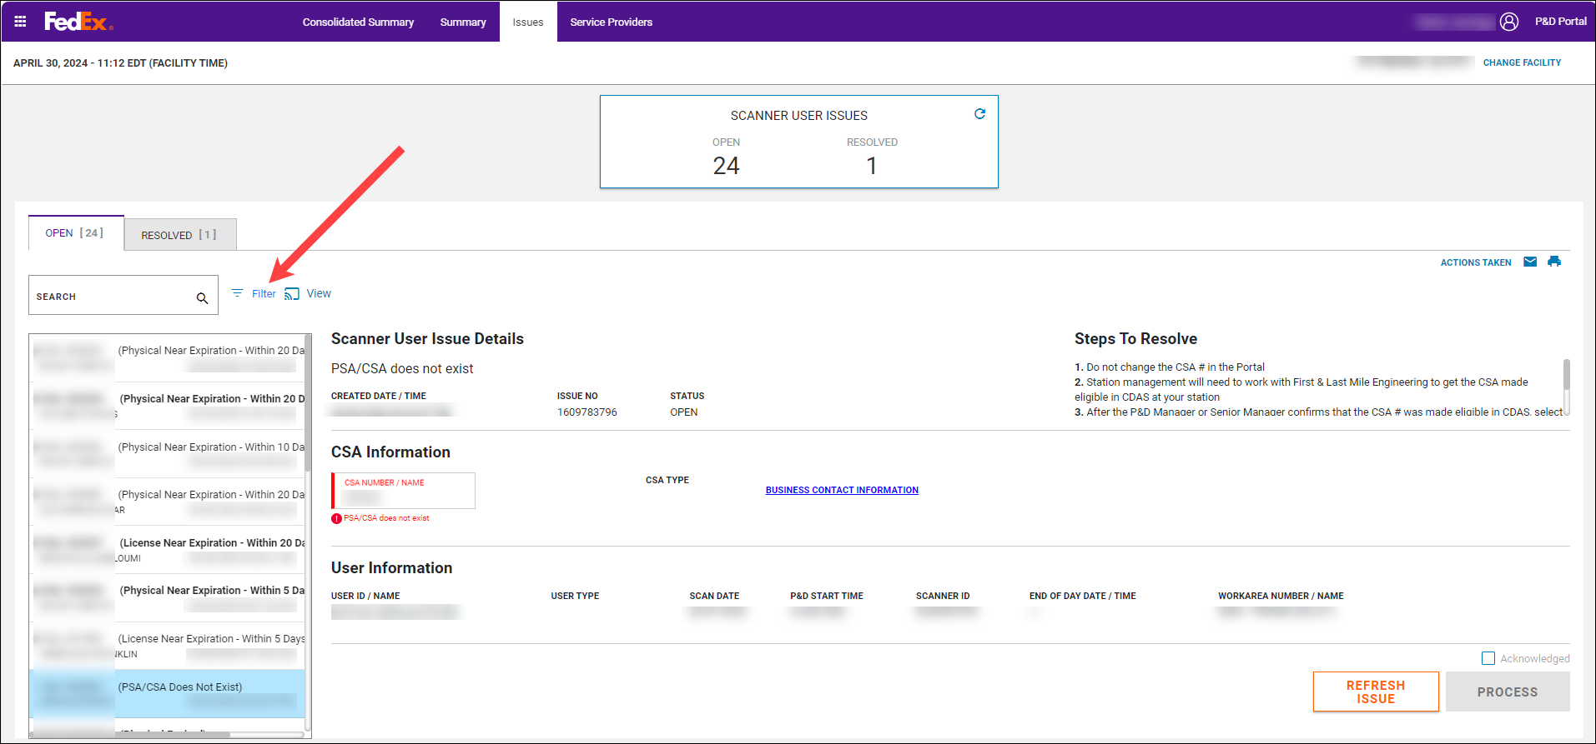
- A Filter Options panel opens on the right-side of the screen with the following categories to filter by:
- CSA Number / Name
- User ID / Name
- Issue Description
- Work Area Number / Name
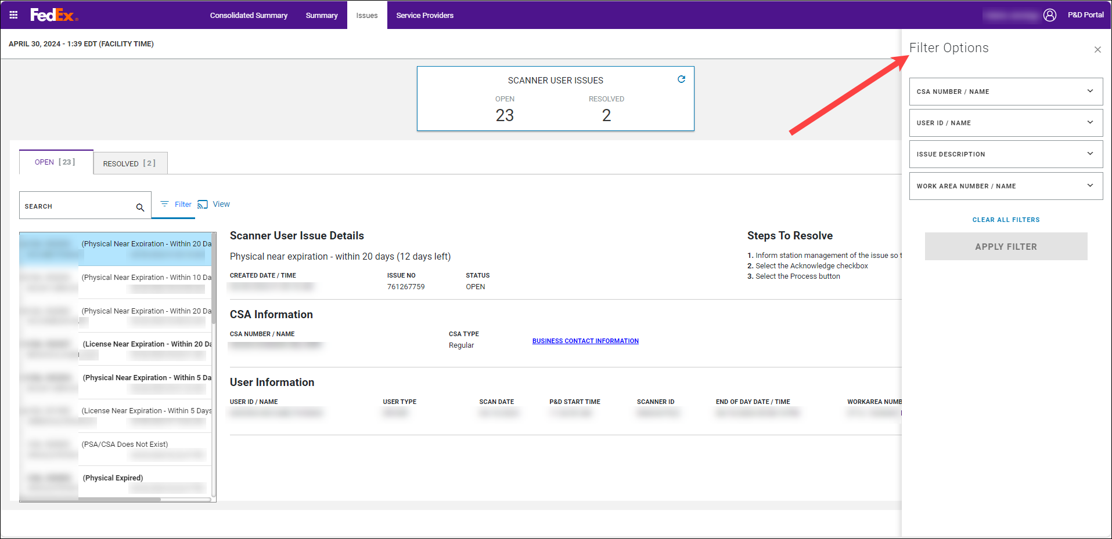
- Select the dropdown arrow for the desired category and a list of options for that category displays. Select the desired option(s) and then click outside of the dropdown box to close it.
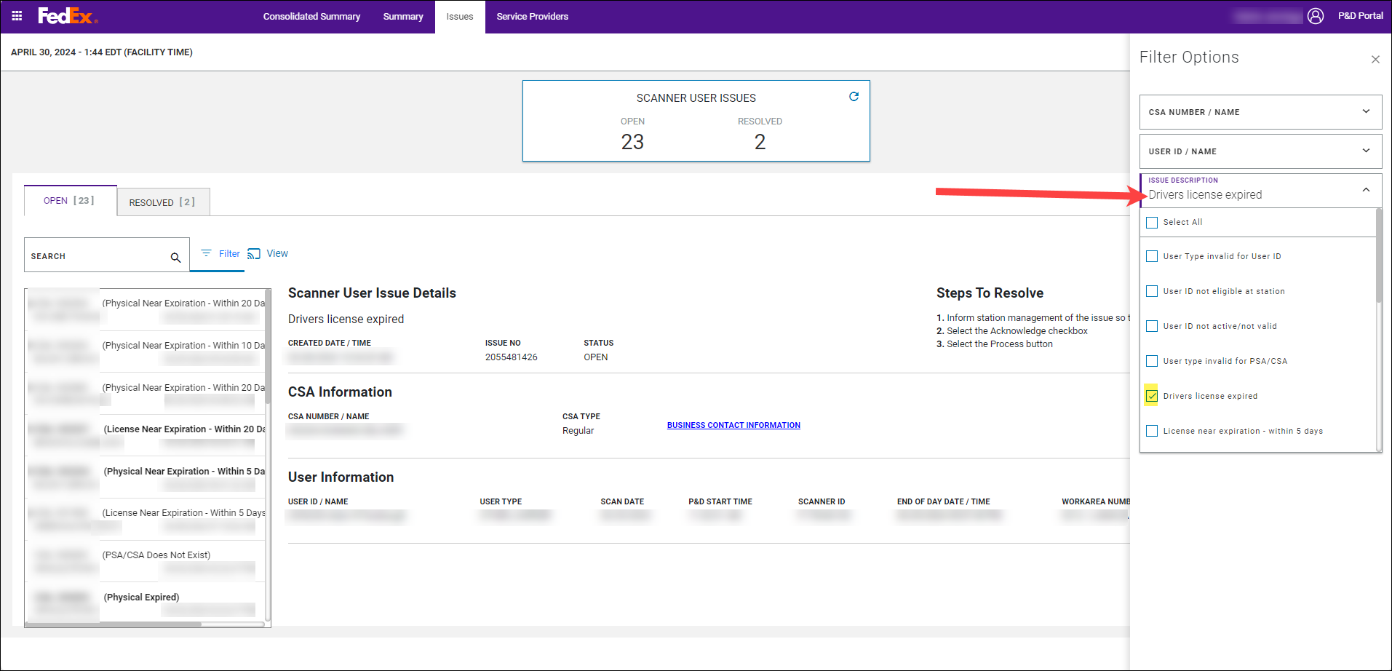
- The options selected display in the box. Select Apply Filter to apply the selected filters.
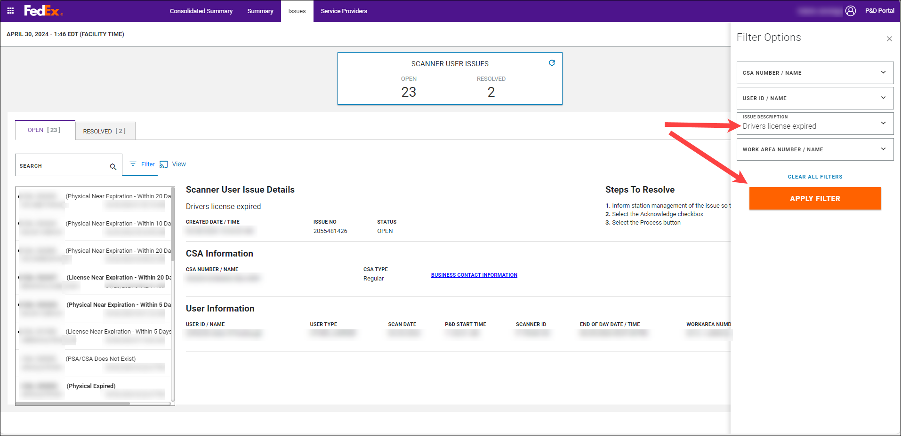
- The Open and Resolved lists update to display the issues for the filter applied. A filter pill displays showing the category being filtered. If multiple categories are selected, multiple pills display.
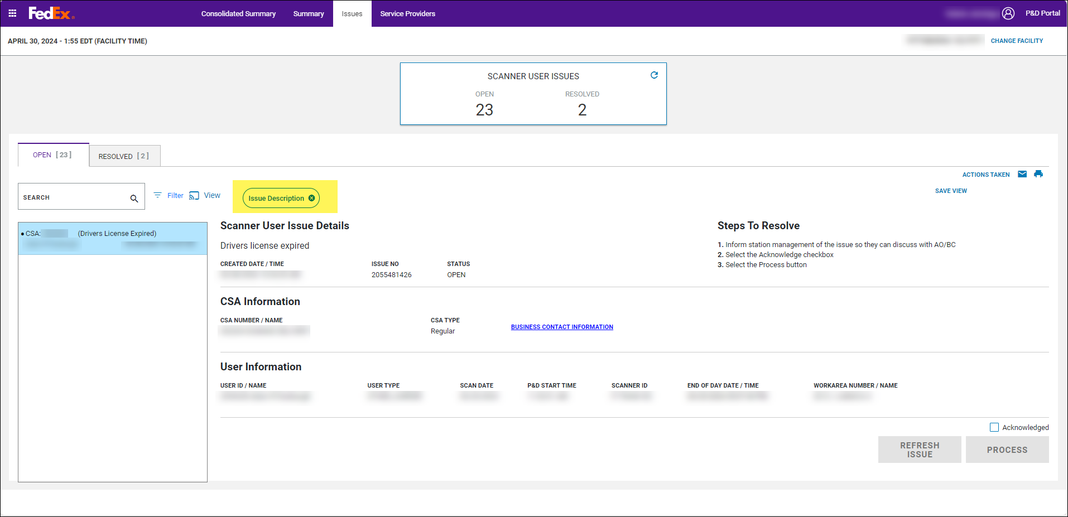
- To clear the filters and bring back a full list of issues:
- Click on the X in the pill to remove the filter category.
- Select Clear All Filters in the Filter Options panel.
- Navigate to a different tab and re-select the Issues tab.
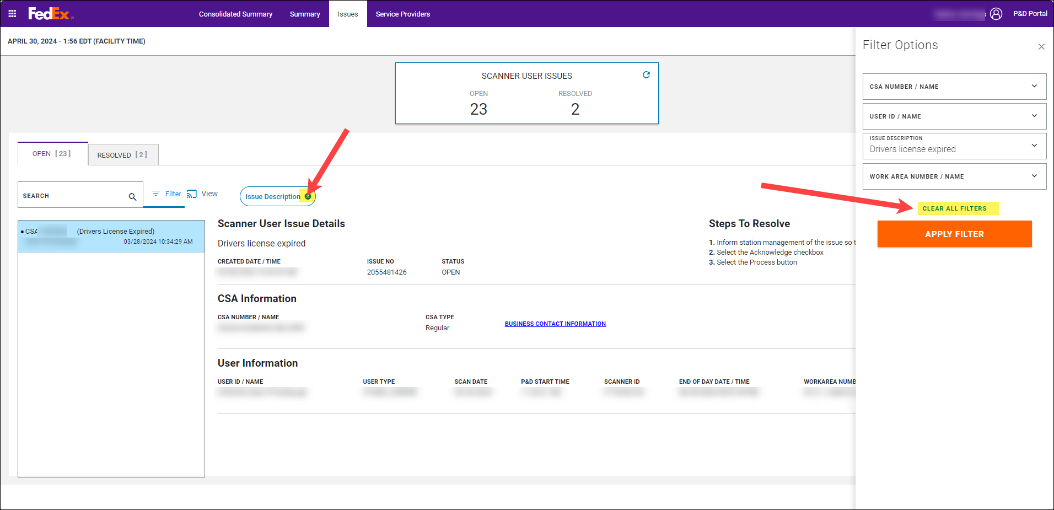
- Once a filter is applied, the view can be saved for easy reference later. Select Save View.
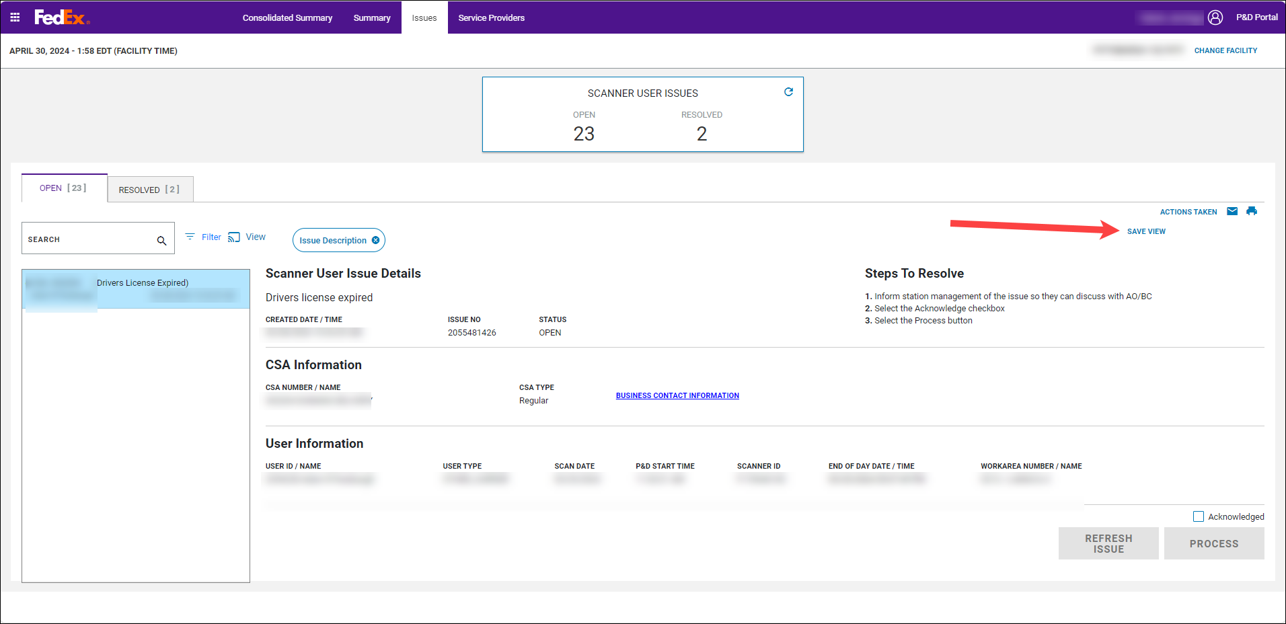
- A Save Filter View pop-up displays to enter a view name. Key in the desired view name and select Save View. To close the pop-up without saving a view, select Cancel.
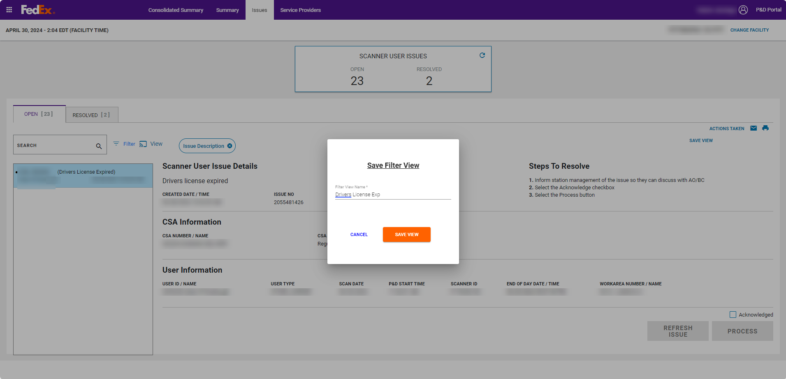
- A green snack bar message displays indicating the view was successfully saved. Select Close to close the Save Filter View pop-up.
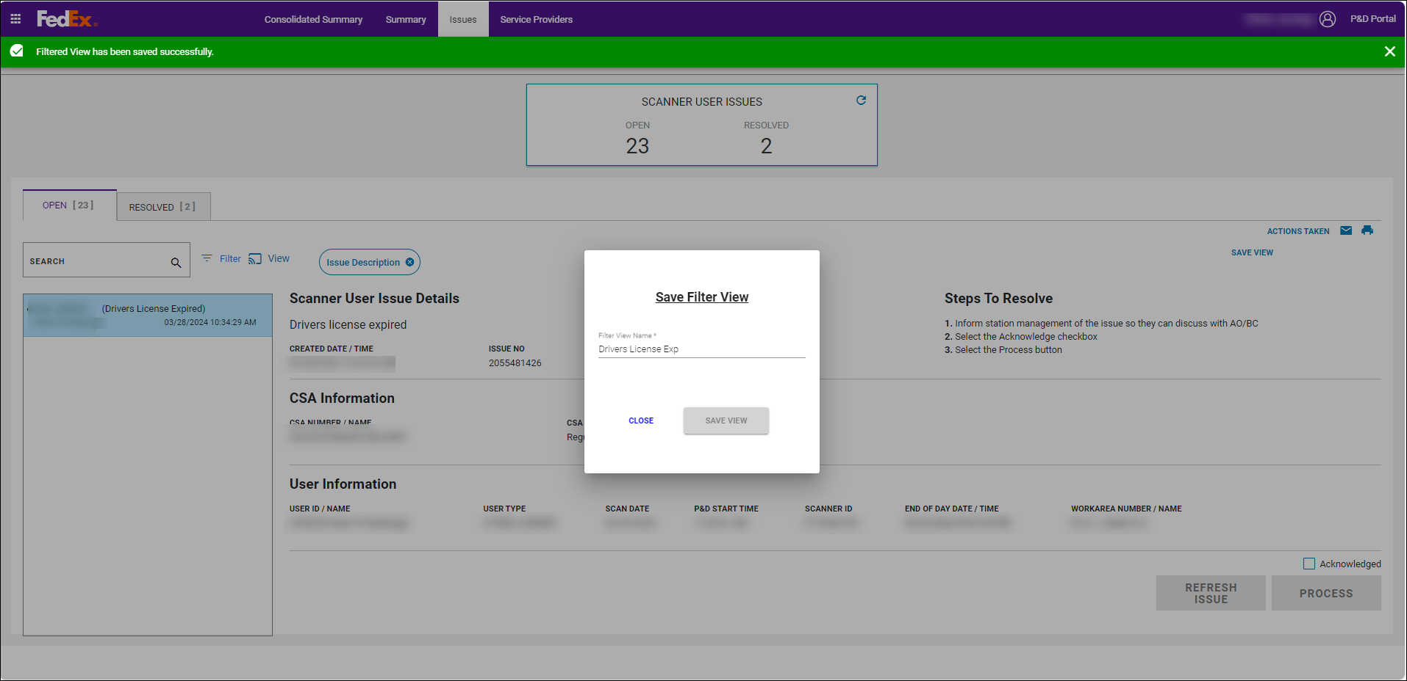
- The view name entered in the pop-up displays to the right of the screen.
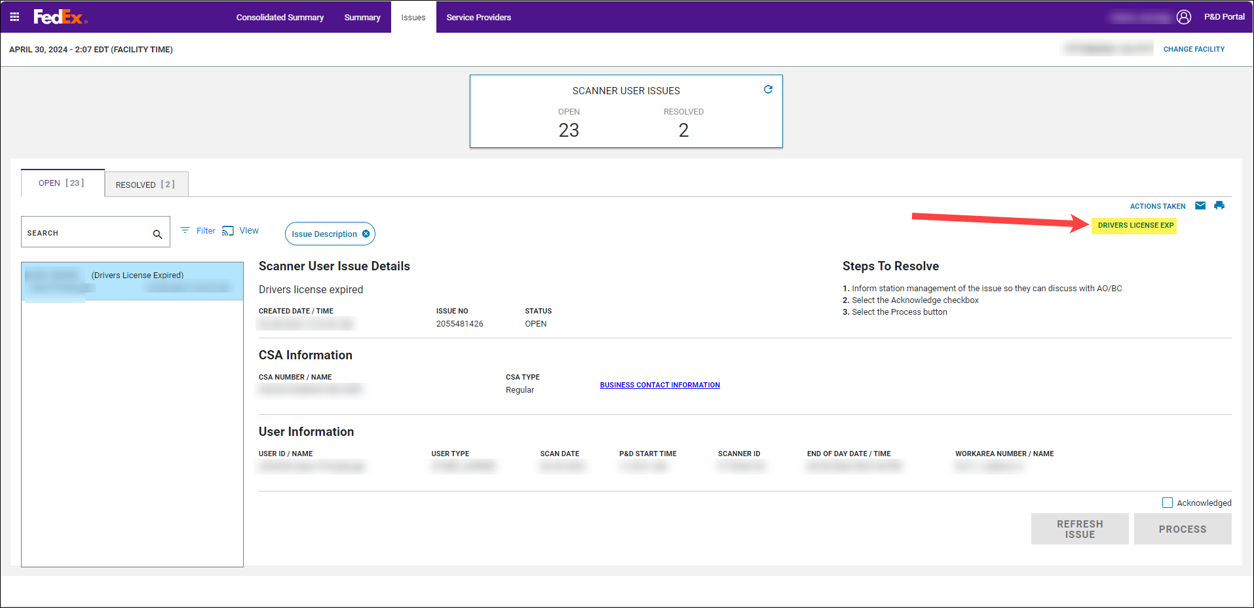
- To see a list of saved views, select View. A ‘SELECT A FILTER VIEW TO APPLY’ pop-up displays. The following information displays in the pop-up:
- View Name
- Created Date and Time
- Delete Column
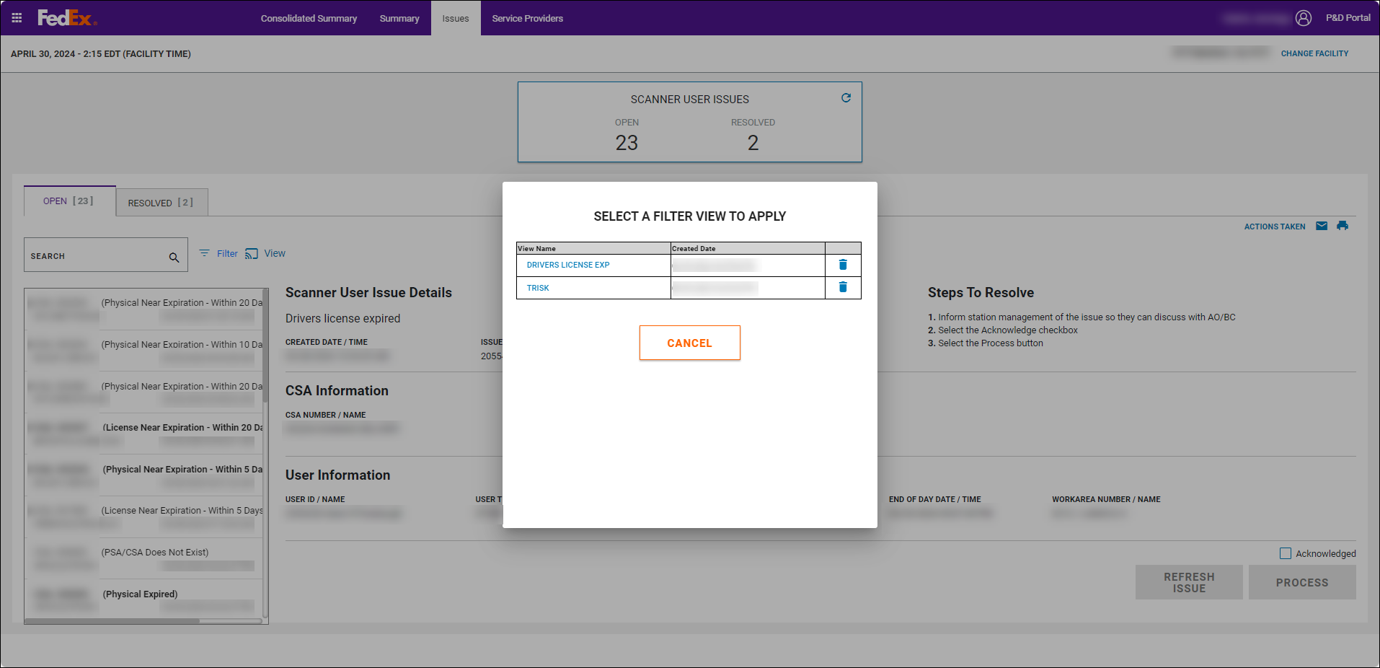
- Click on the blue view name in the ‘SELECT A FILTER VIEW TO APPLY’ pop-up to easily filter the open and resolved lists based on the selected views filter criteria. When the view is selected:
- The pop-up closes.
- The filter is applied.
- The filter pills display.
- The view name displays to the right of the screen.
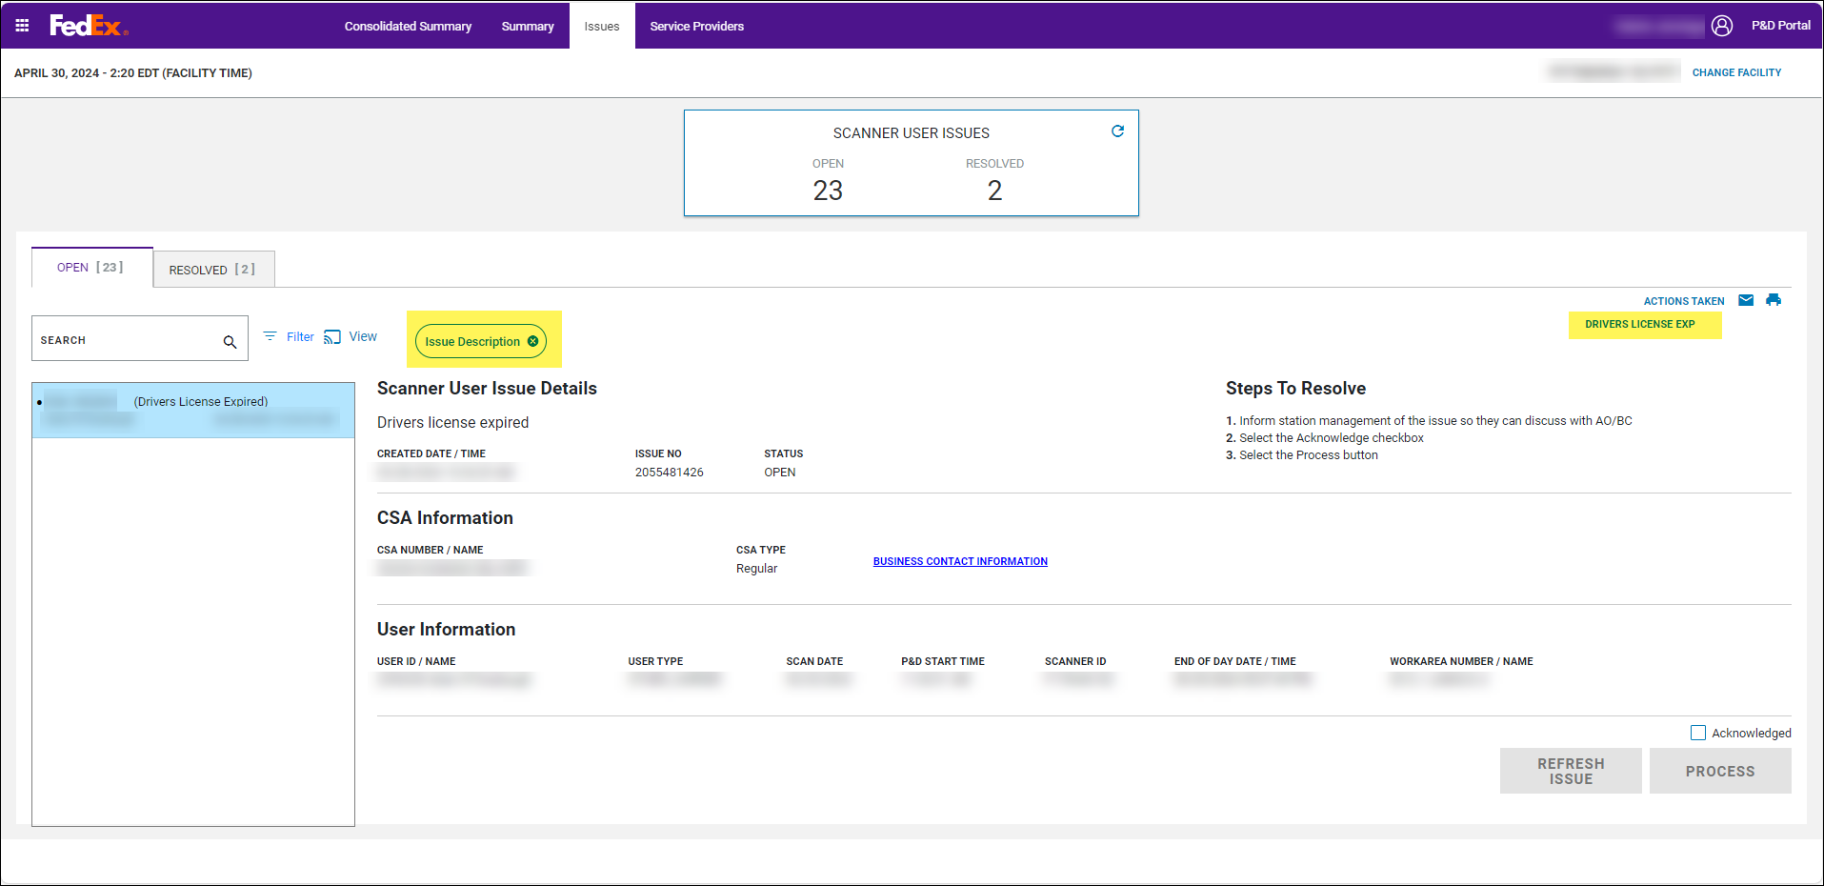
- To delete a saved view:
- Click View.
- In the ‘SELECT A FILTER VIEW TO APPLY’ pop-up, select the blue trash can.
- A green snack bar displays indicating that the view was successfully deleted.
- The view name no longer displays in the pop-up.
- Select Close to close the pop-up.
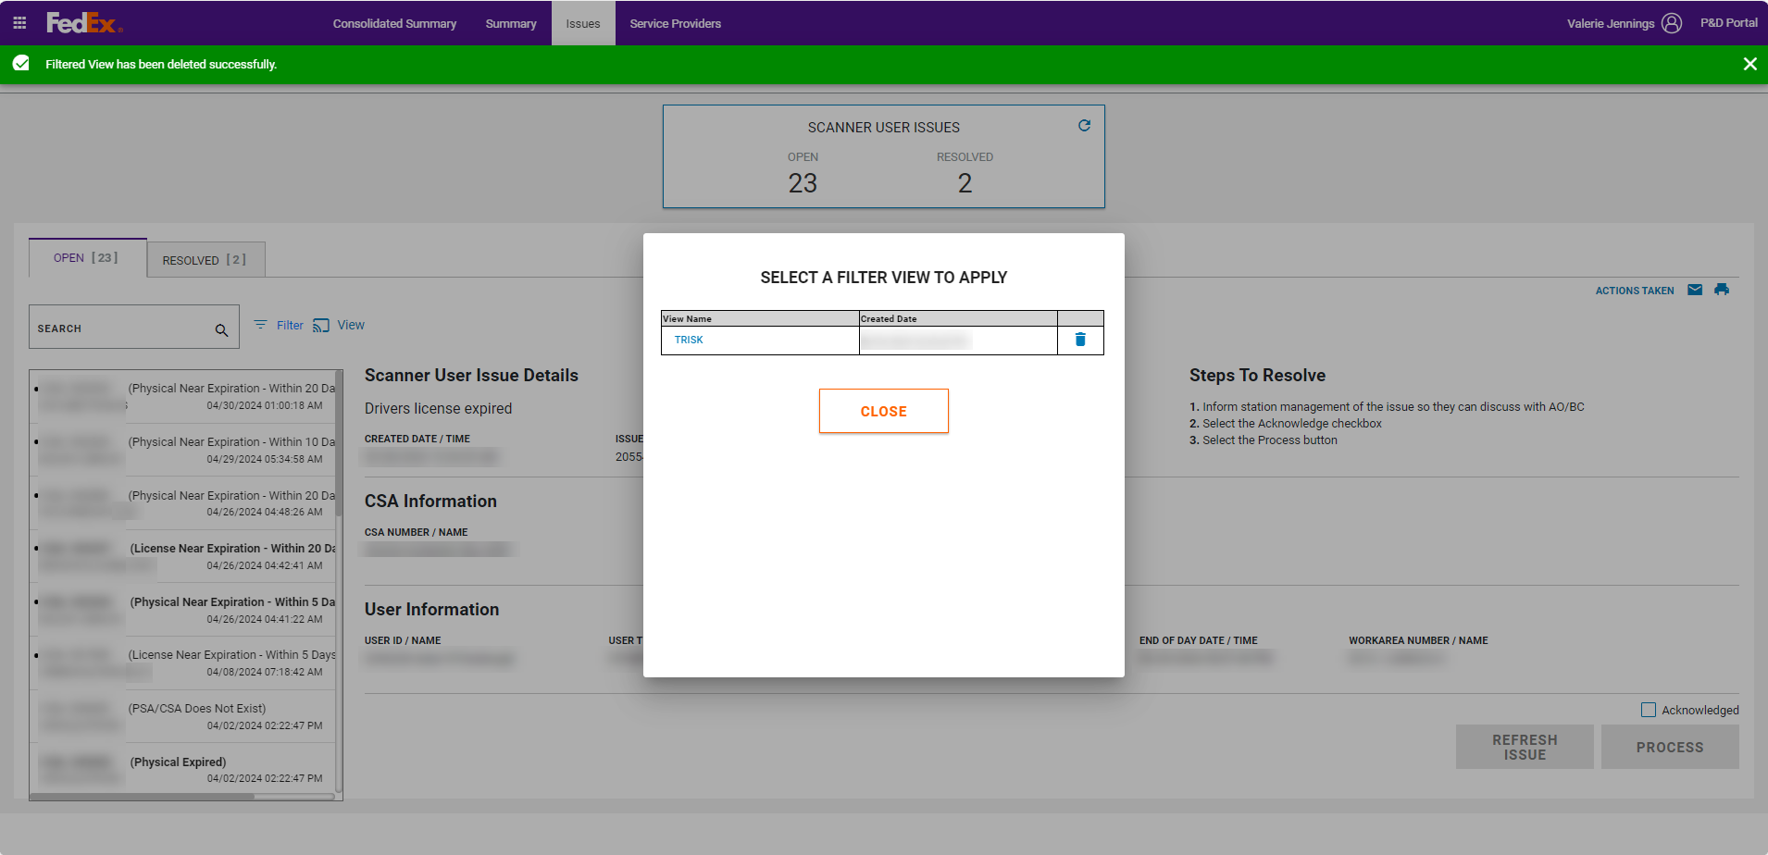

Resolving SCANNER User Issues on the Issues Tab
The below table outlines the steps that can be taken to resolve SCANNER User issues. Note that CSA number, User ID, and User Type issues have multiple options in the Steps to Resolve. It is important to review each scenario carefully for the corresponding issue and follow the appropriate steps as outlined in the table below.
Some issues will auto-resolve if the conditions that generated the issue no longer exist. For example, if CSA or User IDs are updated in CDAS so that they are active/valid, or if CSAs and User IDs are made eligible in CDAS at the station. In these scenarios, a green snack bar displays when the issue is selected indicating that the conditions that generated the issue no longer exist and the issue just needs acknowledged and processed. The Other reason for edit is applied to these issues and Auto-Resolved displays as justification.
The Steps to Resolve appear as a scrollable list when viewing an issue on the Issues tab in the P&D Portal UI.
Important: An issue cannot be resolved until the end of the day is performed on the scanner.

Issues | Steps to Resolve (multiple options exist for some issues)
CSA Does Not Exist | If the CSA # entered in the scanner is accurate:  - Do not change the CSA #.  - Ask station management to update the CSA # in CDAS so that it exists.  - Once station management confirms that the CSA # exists in CDAS, select Refresh Issue.  - A green confirmation message displays at the top of the screen indicating that the conditions that generated the issue no longer exist.  - Select the Acknowledged checkbox.  - Select Process.  If the CSA # entered in the scanner is not accurate:  - Select the correct CSA # from the CSA #/Name dropdown.  - Select the Acknowledged checkbox.  - Select a Reason for Edit. If Other is selected, enter justification.  - Select Ok on Reason for Edit pop-up.  - Select Process.
CSA is Inactive | If the CSA # entered in the scanner is accurate:  - Do not change the CSA #.  - Ask station management to update the CSA # in CDAS so that it is active.  - Once station management confirms that the CSA # is active in CDAS, select Refresh Issue.  - A green confirmation message displays at the top of the screen indicating that the conditions that generated the issue no longer exist.  - Select the Acknowledged checkbox.  - Select Process.  If the CSA # entered in the scanner is not accurate:  - Select the correct CSA # from the CSA #/Name dropdown.  - Select the Acknowledged checkbox.  - Select a Reason for Edit. If Other is selected, enter a justification.  - Select Ok on Reason for Edit pop-up.  - Select Process.
CSA Not on Active Contract | If the CSA # entered in the scanner is accurate:  - Do not change the CSA #.  - Ask station management to update the CSA # in CDAS so that it is associated with an active contract.  - Once station management confirms that the CSA # is associated with an active contract in CDAS, select Refresh Issue.  - A green confirmation message displays at the top of the screen indicating that the conditions that generated the issue no longer exist.  - Select the Acknowledged checkbox.  - Select Process.  If the CSA # entered in the scanner is not accurate:  - Select the correct CSA # from the CSA #/Name dropdown.  - Select the Acknowledged checkbox.  - Select a Reason for Edit. If Other is selected, enter a justification.  - Select Ok on Reason for Edit pop-up.  - Select Process.
CSA is Not Eligible at Station | If the CSA # entered in the scanner is accurate:  - Do not change the CSA #.  - Ask station management to work with First & Last Mile Engineering to get the CSA made eligible in CDAS at the station.  - Once station management confirms that the CSA # was made eligible in CDAS, select Refresh Issue.  - A green confirmation message displays at the top of the screen indicating that the conditions that generated the issue no longer exist.  - Select the Acknowledged checkbox.  - Select Process.  If the CSA # entered in the scanner is not accurate:  - Select the correct CSA # from the CSA #/Name dropdown.  - Select the Acknowledged checkbox.  - Select a Reason for Edit. If Other is selected, enter a justification.  - Select Ok on Reason for Edit pop-up.  - Select Process.
User ID Not Active/Not Valid | If the User ID entered in the scanner is accurate:  - Do not change the User ID.  - Ask station management to update the User ID # in CDAS so that it is active/valid.  - Once station management confirms that the User ID # is now active/valid in CDAS, select Refresh Issue.  - A green confirmation message displays at the top of the screen indicating that the conditions that generated the issue no longer exist.  - Select the Acknowledged checkbox.  - Select Process.  If the User ID entered in the scanner is not accurate:  - Select the correct User ID # from the User #/Name dropdown.  - Select the Acknowledged checkbox.  - Select a Reason for Edit. If Other is selected, enter a justification.  - Select Ok on Reason for Edit pop-up.  - Select Process.
User ID Not Eligible at Station | If the User ID entered in the scanner is accurate:  - Do not change the User ID.  - Ask station management to make the User ID eligible at the station in CDAS.  - Once station management confirms that the User ID # is now eligible at the station in CDAS, select Refresh Issue.  - A green confirmation message displays at the top of the screen indicating that the conditions that generated the issue no longer exist.  - Select the Acknowledged checkbox.  - Select Process.  If the User ID entered in the scanner is not accurate:  - Select the correct User ID # from the User #/Name dropdown.  - Select the Acknowledged checkbox.  - Select a Reason for Edit. If Other is selected, enter a justification.  - Select Ok on Reason for Edit pop-up.  - Select Process.
User Type Invalid for CSA | If the CSA # entered in the scanner is not accurate:  - Select the correct CSA # from the CSA #/Name dropdown that matches the User Type.  - Select the Acknowledged checkbox.  - Select a Reason for Edit. If Other is selected, enter a justification.  - Select Ok on Reason for Edit pop-up.  - Select Process.  If the CSA # entered in the scanner is accurate:  - Select the correct User Type from the User Type dropdown.  - Select the Acknowledged checkbox.  - Select a Reason for Edit. If Other is selected, enter a justification.  - Select Ok on Reason for Edit pop-up.  - Select Process.
User Type Invalid For User ID | If the User ID # entered in the scanner is not accurate:  - Select the correct User ID # from the User #/Name dropdown that matches the User Type.  - Select the Acknowledged checkbox.  - Select a Reason for Edit. If Other is selected, enter a justification.  - Select Ok on Reason for Edit pop-up.  - Select Process.
Driver’s License near expiration - within 20 days (## days left) | - Inform station management of the issue so they can discuss with AO/BC.  - Select the Acknowledged checkbox.  - Select Process.
Physical Expired | - Inform station management of the issue so they can discuss with AO/BC.  - Select the Acknowledged checkbox.  Select Process.
Temp User - Hours must be entered in CDAS (displays only when a manual route has been entered in the P&D Portal for the TEMP PSA) | - Ensure the total hours worked for the temp user have been entered in CDAS.  - Select the Acknowledged checkbox.  - Select Process.

Service Providers Tab

Purpose
As scanner data is received in the P&D Portal, information begins to populate on the Service Providers tab for each work area that dispatched.
The Service Providers tab has a calendar concept. The tab default displays to the current date. If a user wants to view a past date, the calendar tool can be used to change the date. For additional information on the calendar tool, see the calendar tool section below.

Layout and Functionality
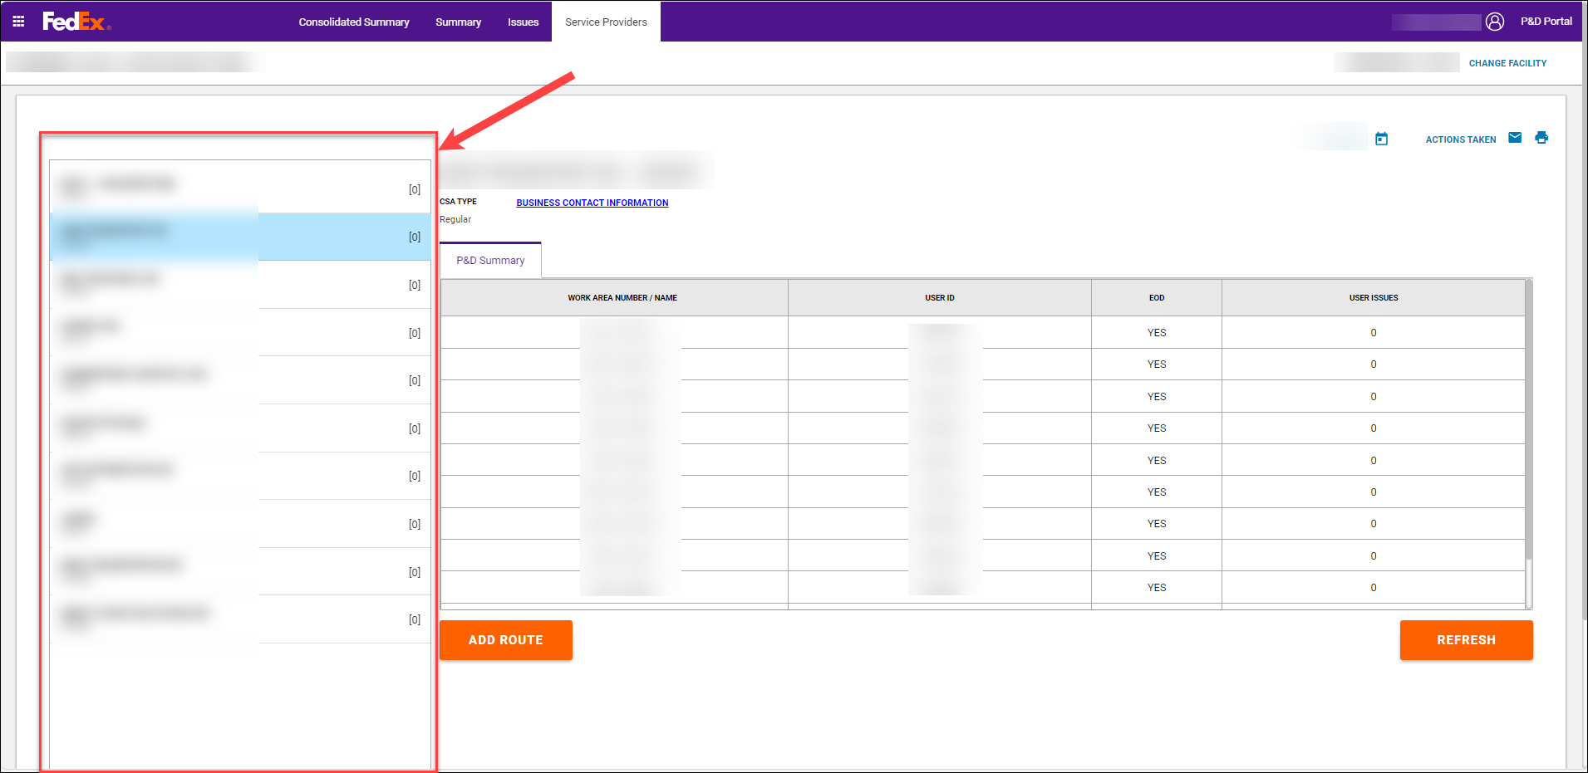

CSA List
- Displays a list of every CSA that had work areas dispatch for the selected date.
- The CSA list displays:
- CSA name
- CSA number
- The total number of open issues in parenthesis that need to be worked on the Issues tab for the CSA.
- The list displays in alphabetical order by CSA name.
- The first CSA is selected by default and is highlighted blue.
- When a different CSA is selected from the list, it will be highlighted blue.
- The CSA list is scrollable when there are more CSAs than can be viewed on the page.
- The details and work area information for the selected CSA displays to the right of the CSA list.

CSA Details (to the right of the CSA list)
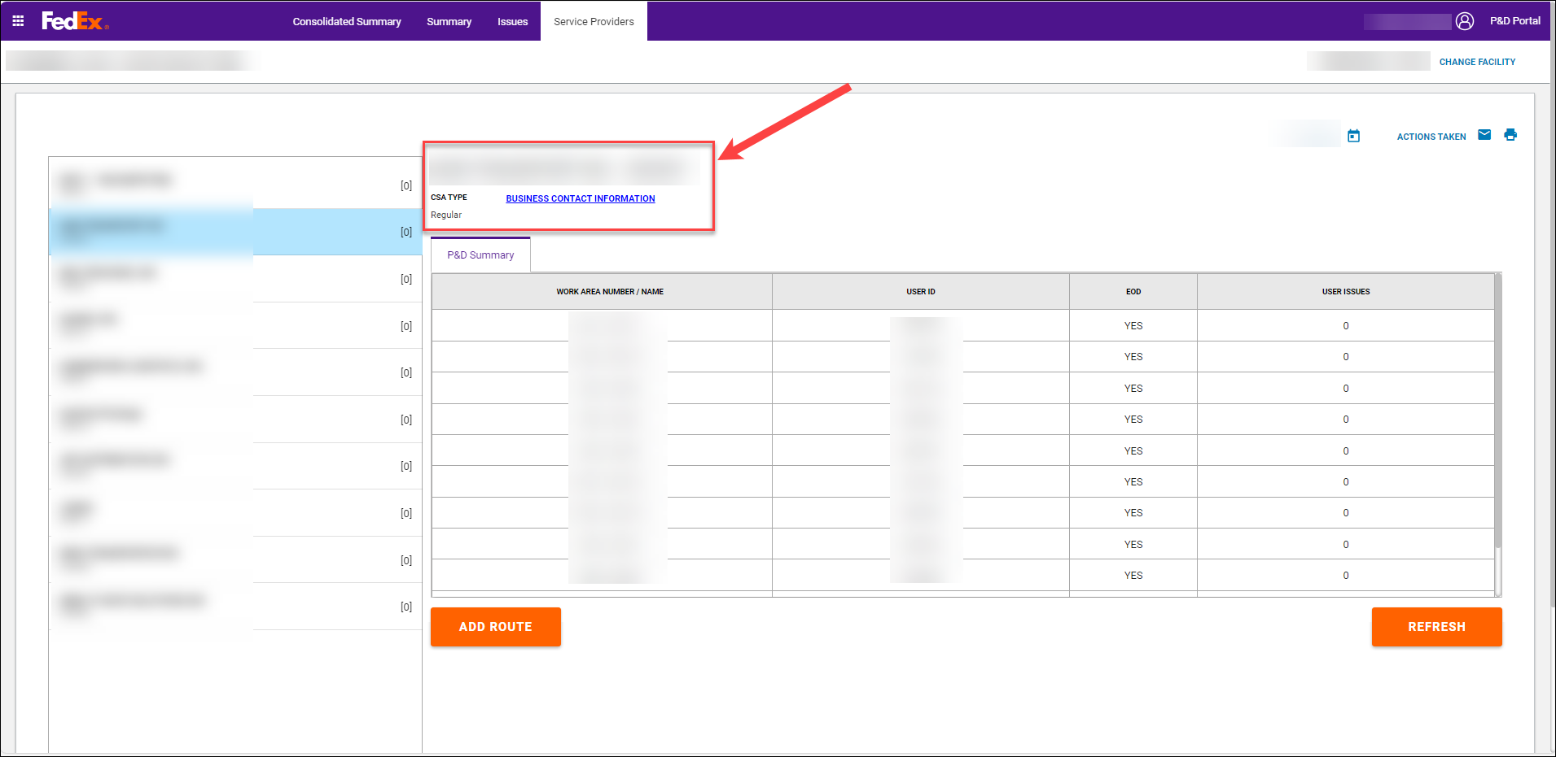
- The CSA information section provides details retrieved from CDAS for the selected CSA:
- CSA Name/Number: Displays the CSA name and number associated with the activity.
- CSA Type: Provides the description of the CSA # such as Regular, Agency, Management.
- Select the Business Contact Information link to display a pop-up box with the following CSA business contact information as maintained in CDAS:
- Contact Name
- Phone Number
- Email Address
Note: If multiple business contacts are listed, the same phone number and email address may display for all contact names based on how the entity has maintained this information in CDAS.

P&D Summary
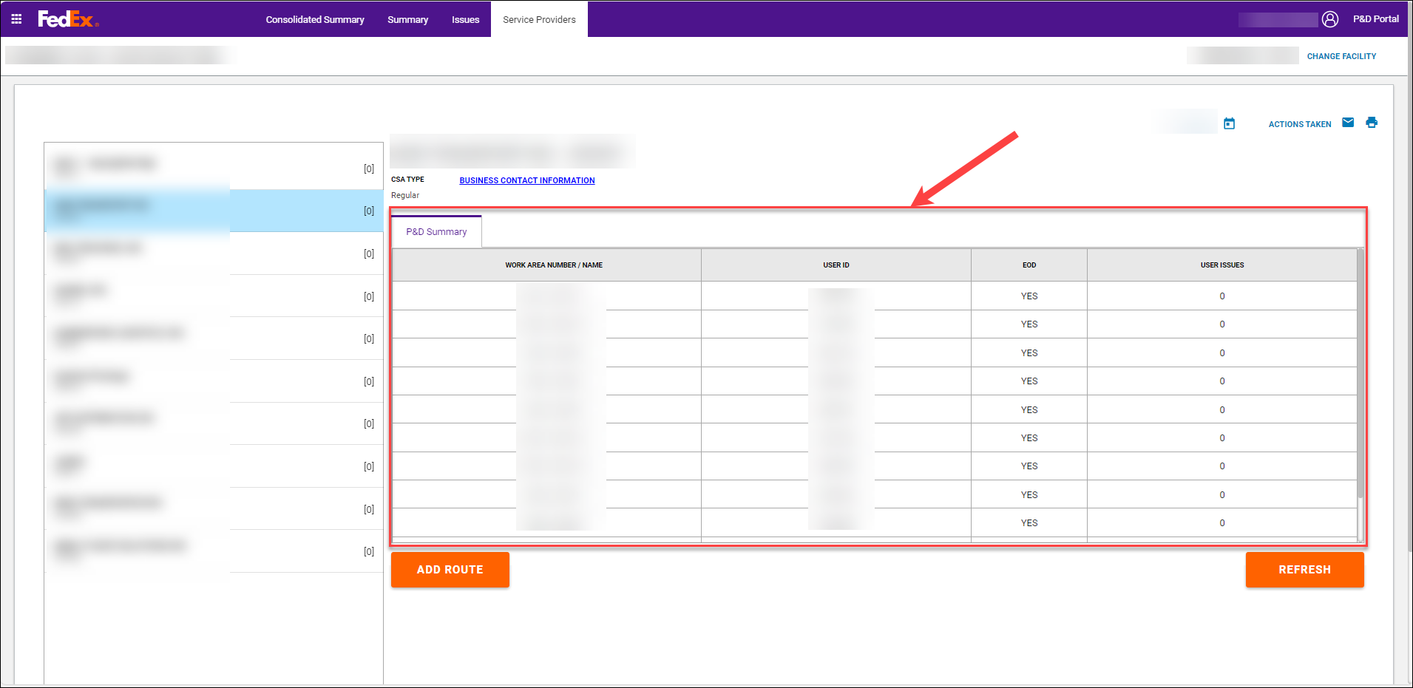
- The P&D Summary sections displays a list of work areas that dispatched either with a scanner or work areas that were manually added in the P&D Portal for a given date.
- Work areas begin to populate on the P&D Summary tab once the first stop is received from the scanner or when the manual route is created in the P&D Portal.
- The information displayed on the P&D Summary tab includes:
- Work Area Number/Name: sorted in work area number order.
- User ID: The user ID associated with the activity.
- User Issues: The total number of open issues for the user that need to be worked on the Issues tab.
- Selecting a work area on the P&D Summary tab opens a new tab to view work area details (see Work Area Detail Tab section in this document for additional information on the work area tab).
- The P&D Summary tab contains two buttons:
- Add Route: Can be used to add a route that dispatched without a scanner. For additional information regarding adding a route, see the Adding a Manual Route on the Service Providers Tab section of this document.
- Refresh: Can be used to refresh the Service Providers tab. If additional CSA and work area information was received since the tab was accessed, the tab refreshes and displays any new activity received.

Work Area Detail Tab
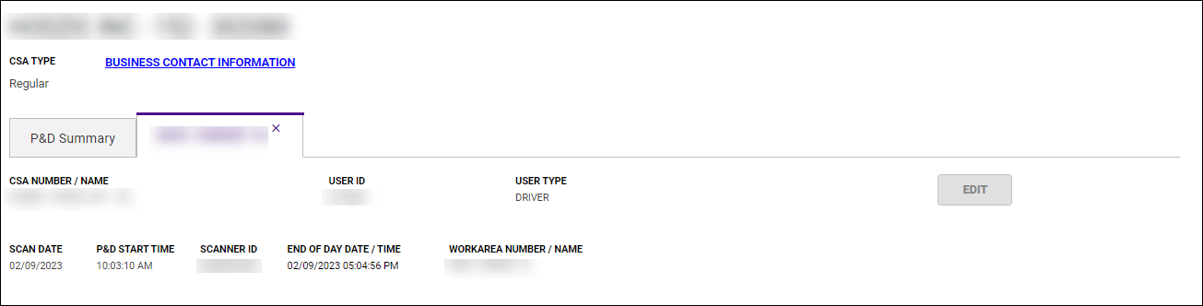
- The tab name displays the work area number/name selected.
- The following work area information is displayed on the page:
- CSA Number/Name: Displays the CSAnumber entered in either the scanner or in the P&D Portal for a manual route along with the associated name as listed in CDAS.
- User ID: Displays the User number entered in either the scanner or in the P&D Portal for a manual route along with the associated name as listed in CDAS.
- User Type: Displays the user type entered in either the scanner or in the P&D Portal for a manual route.
- Scan Date: displays the activity date.
- P&D Start Time: displays the P&D start time.
- Scanner ID: displays the scanner serial number. If the work area is a manual route created in the Portal, the scanner ID begins with *MAN.
- End of Day Date/Time: Displays the end of day date and time.
- Since work areas display as soon as the first stop is performed, this field is blank until the end of day is received.
Important: Work area information cannot be edited until the end of day is received. This means Edit is disabled until the end of day is received.
- If the end of day is received after midnight of the activity date (late upload), the end of day displays in red font.
- Work Area Number/Name: displays the work area number/name.
- Edit button: The button provides a way to edit PSA/CSA, User ID, and User Type if they were entered incorrectly in the scanner or in the P&D Portal for a manual route.
- When Edit is selected, an edit pop-up displays. For additional information on editing a route, see the Editing a Route on the Service Providers Tab section of this document.
- The Edit button is disabled until:
- The end of day has been received.
- All open issue for the work area/user have been resolved.
  - Any edits made in the P&D Portal are sent to EASE to ensure that both applications are in sync and to ensure accurate CSP compensation.
- After an edit has been successfully processed and the Edit pop-up is closed, the UI refreshes to display the work area information that was edited. An asterisk (*) displays next to any field that was changed.
Image of disabled EDIT button (end of day received but outstanding open issues exist):
Image of enabled EDIT button (no outstanding open issues exist, and the end of day has been received):
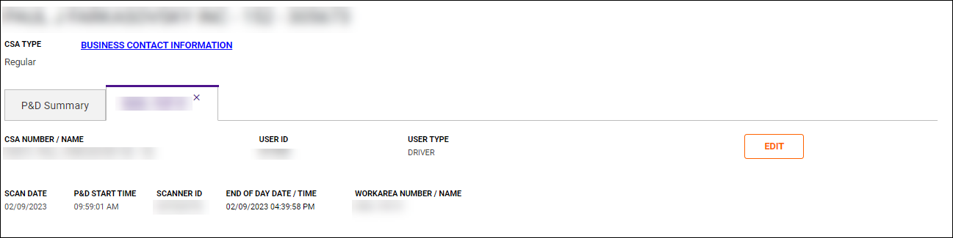

Calendar Tool
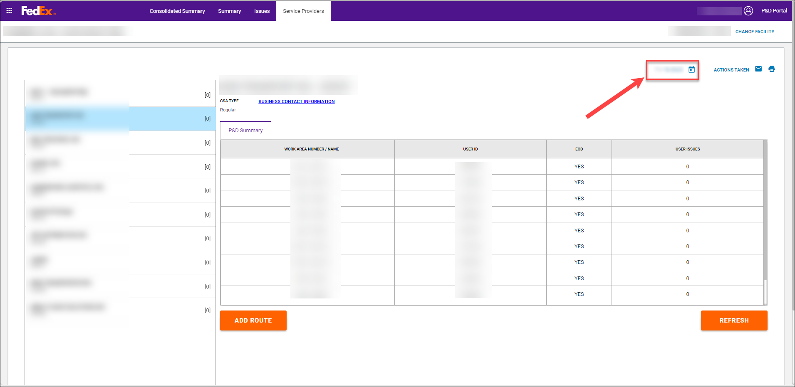
- The Service Providers tab initially loads the current day’s activity.
- Selecting the calendar icon provides a calendar tool to be able to select a previous activity date.
- When a different date is selected, the Service Providers tab refreshes to display the information for the selected date.
- The calendar is available to view information/activity back one year.
- Edits can only be made in the P&D Portal for current day and the past 71 days (72 days total).
- Any edits required for dates beyond 72 days must be performed in CDAS.
- The information/activity for dates beyond 72 days displays in read only mode.

Email Icon
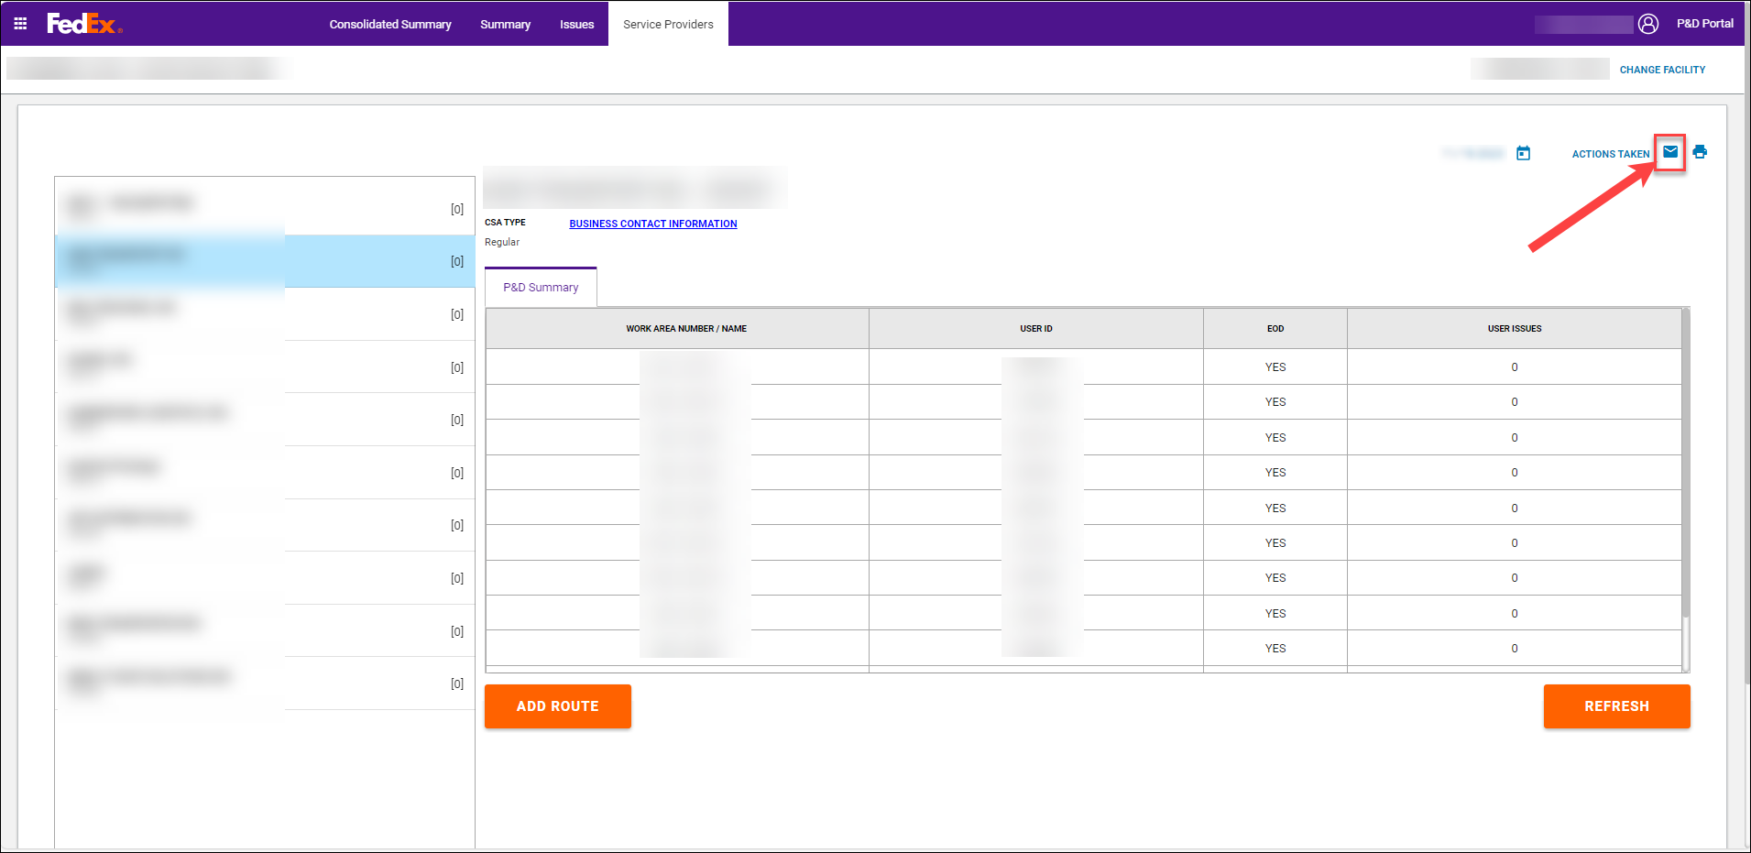
- This icon provides users with the ability to email the information being viewed/displayed on the screen.
- The Email icon is located in the upper right-hand corner near the calendar tool and print icon.
- When the icon is selected on the P&D Summary tab, an “Are you sure” pop-up message displays notifying the user that the information is confidential to FedEx Ground and the particular service provider.
- The pop-up contains Ok and Cancel buttons.
- If Cancel is selected, the “are you sure” pop-up closes.
- If Ok is selected:
  - A “Select Business Contact” pop-up displays with a list of business contact names, phone numbers, and email addresses as maintained by the service provider on MyGroundBizAccount.
  - Check the box in the Select column next to the desired contact.
  - Select Send. The email is sent to the selected business contact and the pop-up closes.
  - Select Cancel to close the pop-up. An email is not sent if Cancel is selected.

Print Icon
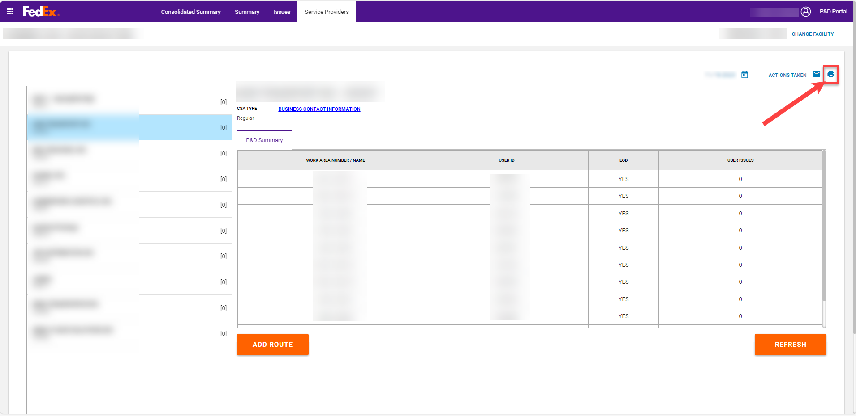
- This icon provides users with the ability to print the information being viewed/displayed on the screen.
- The print icon is located in the upper right-hand corner near the calendar tool.
- When the icon is selected on the P&D Summary tab, an “Are you sure” pop-up message displays notifying the user that the information is confidential to FedEx Ground and the particular service provider.
- The pop-up contains Ok and Cancel buttons.
- If Ok is selected, the print preview screen displays. The user has the option to print or save a copy locally. If print is selected, the issue information prints to the default laser printer.
- If Cancel is selected, the confirmation pop-up closes.
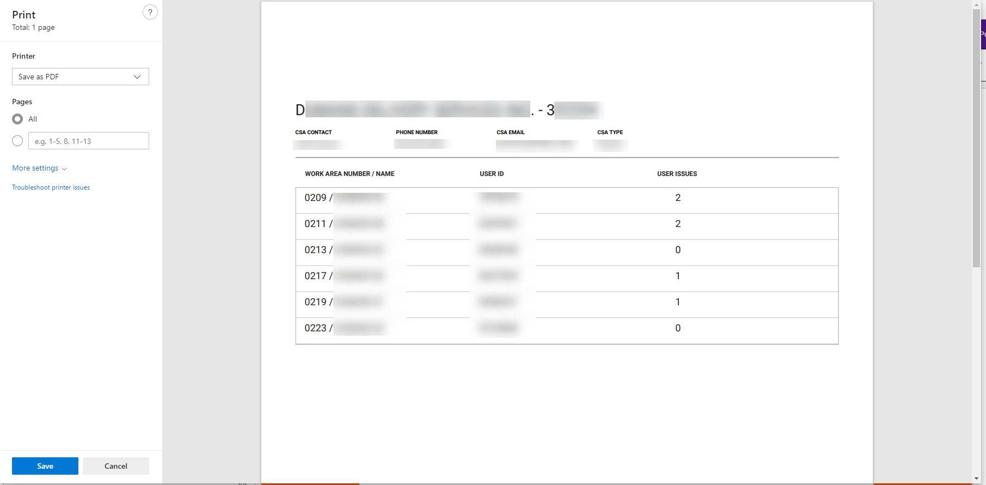

Actions Taken Link
- The Actions Taken link provides visibility to who may have printed or emailed information on the Service Providers tab.
- When selected, an ‘ACTIONS TAKEN’ pop-up displays and provides visibility to the following information:
- Action: Displays either Print or Email.
- Date and Time: Displays the date and time the action was taken.
- Employee ID: Displays the employee ID who took the action.
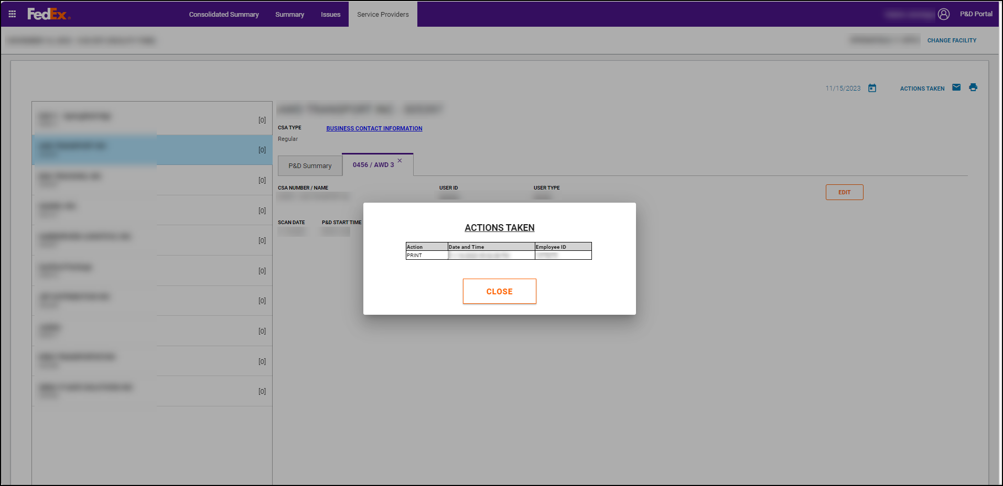

Editing a Route on the Service Provider Tab
If a user entered incorrect information in the device during scanner log-in or a manual route was created with incorrect information in the P&D Portal, the information can be edited in the P&D Portal. Once the edit is successfully processed in the P&D Portal, the updated route information is systematically sent to EASE to ensure both applications are in sync.

Follow the below steps to edit a route on the Service Providers tab.
- On the Service Providers tab, select the appropriate activity date from the calendar tool.
Important: The Service Providers tab default displays to the current date. Ensure the correct date has been selected prior to any edit being made.
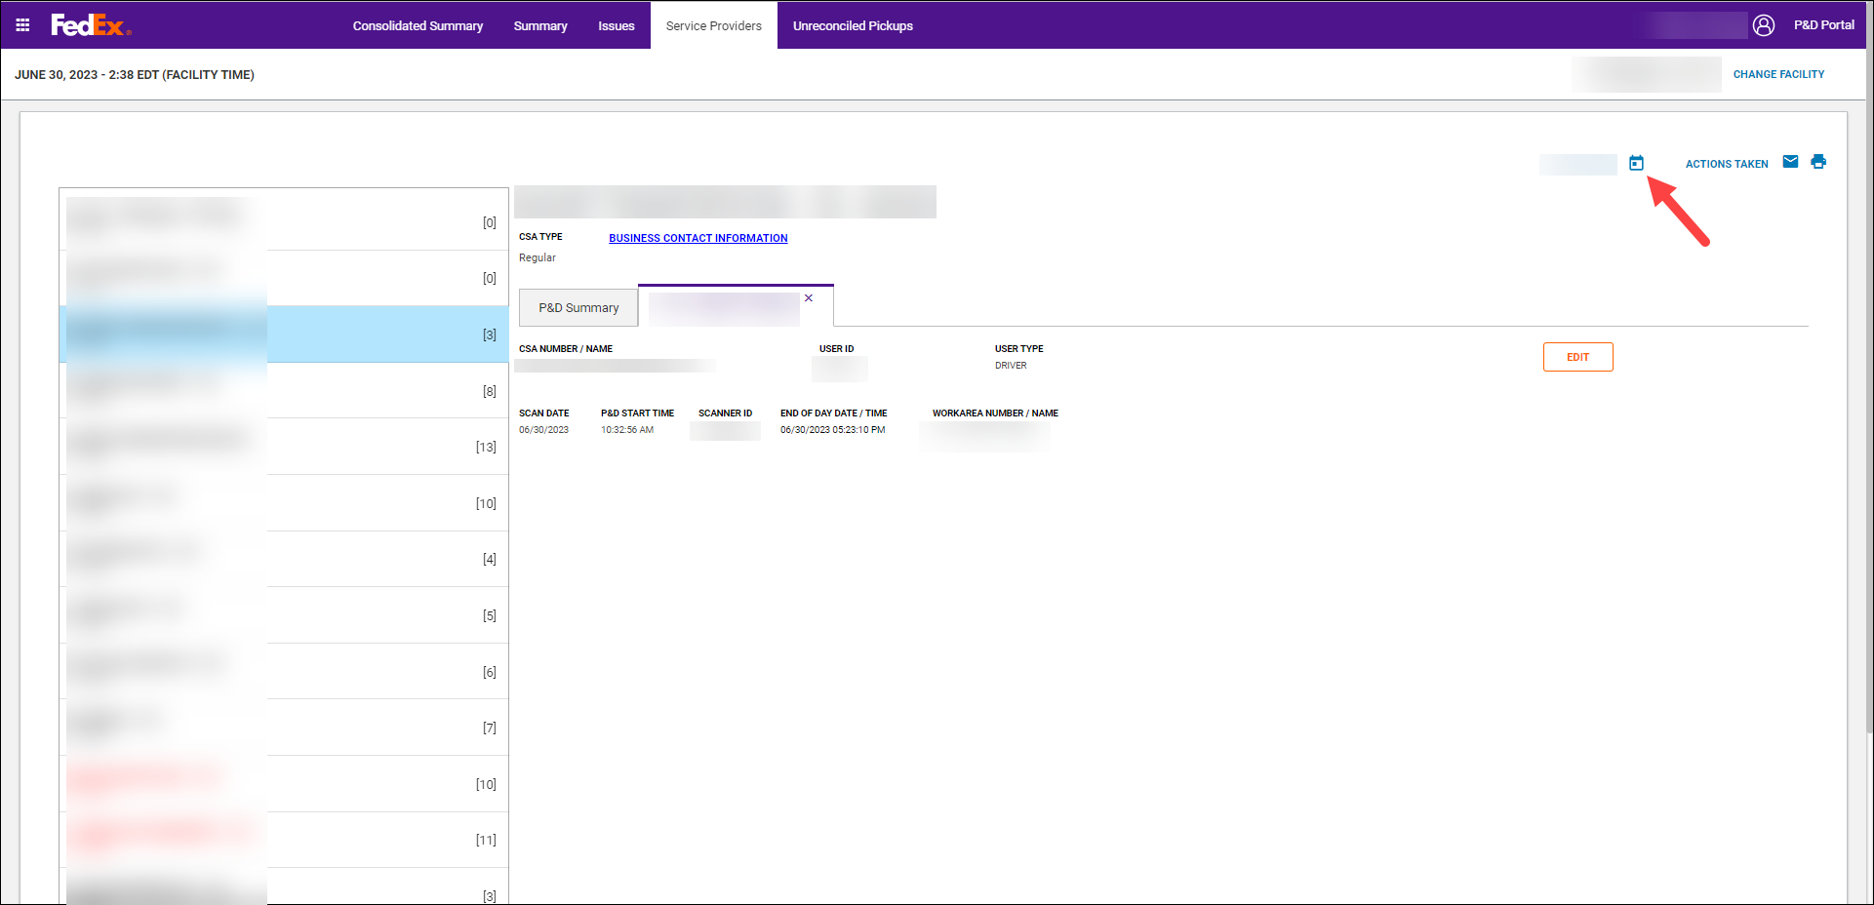
- Once the correct date has been selected, select the CSA that needs updated from the CSA list.
- On the P&D Summary tab, select the work area that needs updated.
- On the Work Area tab, select Edit.
Note: The Edit button is disabled if:
- The scanner end of day had not been received yet.
- Open issues still exist that need to be resolved on the Issues tab for the work area.
- On the edit pop-up, make a selection in the Edit CSA section if that field needs changed:
- CSA Number/Name dropdown:
- This field defaults to the original entry from the scanner or entered in the P&D Portal for a manual route.
- Select a different CSA # from a list of CSA’s eligible at the station or search the list by keying values in the field.
Important: If the CSA # is not listed, it must be made eligible at the station in CDAS. Inform station management so that they can work with a First & Last Mile engineer at PGH to make the CSA eligible at the station in CDAS. Once the CSA # is made eligible at the station in CDAS, try the entry again.
The CSA Number/Name list displays in alphabetical order by the entity name.
Additional CSA information displays based on the new CSA # selected:
- CSA Type: Provides the description of the selected CSA # such as Regular, Agency, Management.
- CSA Contact: Displays the contact’s name associated with the selected entity.
- Phone Number: Provides the phone number associated with the contact’s name.
- CSA Email: Provides the email information associated with the entity.
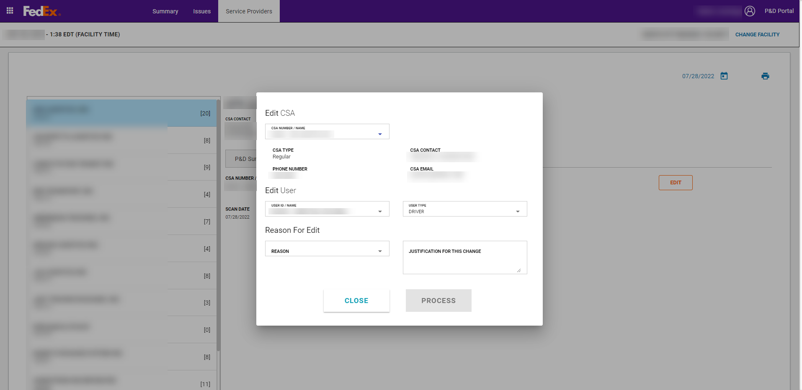
- Make a selection in the Edit User section if either of these fields need changed:
- User ID/Name dropdown:
- This field defaults to the original entry from the scanner or entered in the P&D Portal for a manual route.
- Select a different user from a list of users eligible at the station. For stations in Alaska, Hawaii, and Canada this is a keyable field to enter the employee driver ID.
Important: If the user is not listed, it must be made eligible at the station in CDAS. Inform station management so that they can make the user eligible in CDAS. Once the user is eligible at the station in CDAS, try the entry again. This does not apply to stations in Alaska, Hawaii, and Canada.
- The list displays in alphabetical order by the users first name.
- User Type dropdown:
- This field defaults to the original entry from the scanner or entered in the P&D Portal for a manual route.
- Select a different user type from a list of available user types.
- When a CSA # is selected that changes the available user types, the User Type field blanks out and a selection is required.
- If the field blanks out, select the corresponding user type (for example, Contractor, Driver, Helper, Key Contact, Supplemental, etc.).
- The list displays in alphabetical order.
- Make a selection in the Reason for Edit section:
- Reason dropdown:
- Select the appropriate reason for edit from a list of available reasons.
- The list displays in alphabetical order.
Note: The Reason for Edit field may show a value when the pop-up loads if the route has been previously edited or added. A new/different reason can be selected.
- Justification For This Change:
- If Other is selected as the Reason for Edit, justification must be entered in the Justification for this Change field.
- An entry can be made in this field for any reason selected but is required for Other.
Note: If the route has been previously edited or added and justification was entered, this field may show information when the pop-up loads. A new justification can be entered, if applicable.
- Select Process.
- If the route has been successfully processed, a green confirmation message displays at the top of the screen.
- If the route cannot be processed successfully, yellow or red messages display at the top of the screen. For additional information on error messages displayed in the P&D Portal, see P&D Portal Snack Bar Messages section of this document.
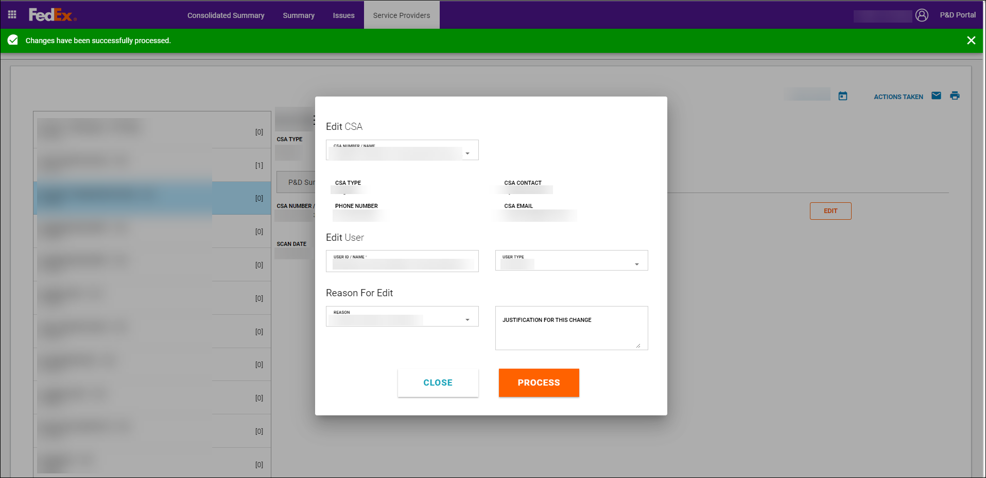
- Select Close.
- The add pop-up closes.
- The screen returns to the P&D Summary tab.
- The page refreshes to display the edited information.
- An asterisk (*) displays next to any field that was changed.
- The edited information is sent to EASE to ensure the two applications are in sync and so that the activity can be added in EASE as needed.
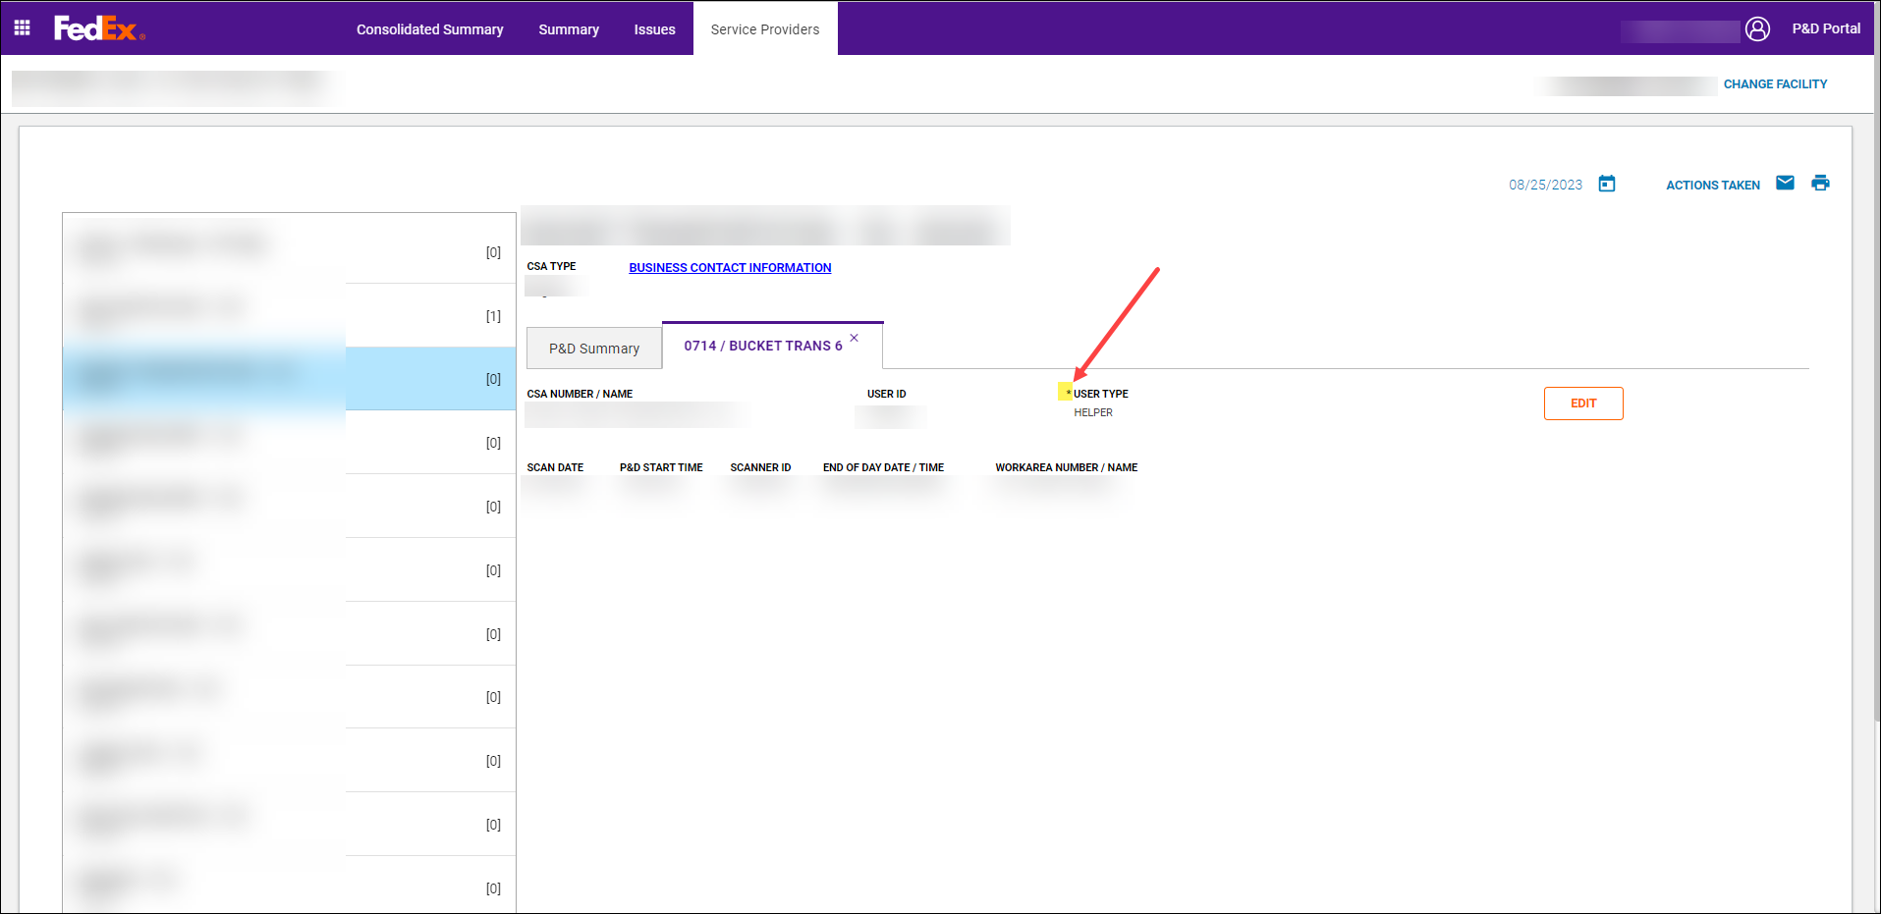
- Additional information on Close button:
- The Close button toggles between Close and Cancel depending on if a change was made on the Edit pop-up.
- Close:
- Close Initially displays when the Edit pop-up loads.
- Close toggles to Cancel once a change is made to any of the dropdown boxes.
- Cancel changes back to Close once a change is successfully processed.
- Selecting Close closes the pop-up box.
- Cancel:
- Select Cancel to display an ‘Are you sure’ pop-up with Yes and No buttons:
- Selecting Yes:
- Closes the ‘Are you sure’ pop-up box.
- User is returned to the Work Area tab where Edit was selected and unsaved changes are lost.
- Selecting No:
- Closes the ‘Are you sure’ pop-up.
- User is returned to the Edit pop-up with changes made still persisted.

Adding a Manual Route on the Service Providers Tab
If a user dispatched without a scanner, a manual route can be created in the P&D Portal. Once successfully processed in the P&D Portal, the route information is sent to EASE so that the activity can be added.
Follow the below steps to add a manual route on the Service Providers tab.
- On the Service Providers tab, select the appropriate date from the calendar tool.
Important: The Service Providers tab default displays to the current date. Ensure the correct date is selected prior to adding a route.
- Select the ADD ROUTE button on the P&D Summary tab and an add pop-up displays.
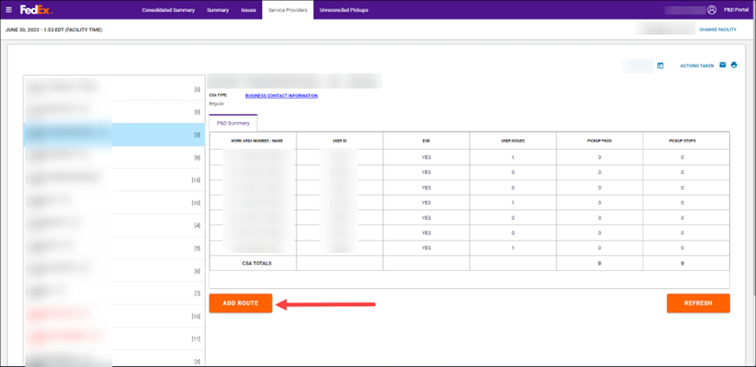
- On the add pop-up, select a CSA in the Add CSA section:
- CSA Number/Name dropdown:
- Select the CSA number associated with the activity from a list of CSAs eligible at the station or key in information in the field.
Important: If the CSA number is not listed, it must be made eligible at the station in CDAS. Inform station management so that they can work with a First & Last Mile engineer at PGH to make the CSA eligible at the station in CDAS. Once the CSA number is made eligible at the station in CDAS, try the entry again.
The CSA Number/Name list displays in alphabetical order by the entity name.
Additional CSA information displays based on the CSA # selected:
- CSA Type: Provides the description of the selected CSA # such as Regular, Agency, Management.
- CSA Contact: displays the contact’s name associated with the selected entity.
- Phone Number: Provides the phone number associated with the contact’s name.
- CSA Email: Provides the email information associated with the entity.
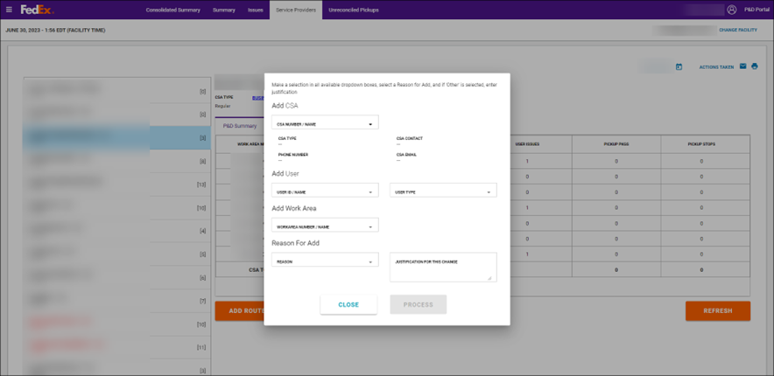
- Select a user in the Add User section:
- User ID/Name dropdown:
Select the user associated with the activity from a list of users eligible at the station. For stations in Alaska, Hawaii, and Canada this is a keyable field to enter the employee driver ID.
Important: If the user is not listed, it must be made eligible at the station in CDAS. Inform station management so that they can make the user eligible in CDAS. Once the user is made eligible at the station in CDAS, try the entry again. This does not apply to stations in Alaska, Hawaii, and Canada.
- The list displays in alphabetical order by the users first name.
- User Type dropdown:
- Select the corresponding user type (for example, Contractor, Driver, Helper, Key Contact, Supplemental, etc.).
- The list displays in alphabetical order.
- Select a work area in the Add Work Area section:
- Work Area Number/Name dropdown:
- Select the work area number / name from a list of work area associated with the CSA # selected.
Important: If the work area is not listed, it must be added in the Work Area Master Table (WAMT). Once the work area is added to the WAMT, try the entry again.
- The list displays in work area number order.
- Select a reason in the Reason for Add section:
- Reason dropdown:
- Select the appropriate reason for edit from a list of available reasons.
- The list displays in alphabetical order.
- Justification for this Change:
- If Other is selected as the Reason for Add, a justification must be entered in the Justification for this Change field.
- An entry can be made in this field for any reason selected but is required for Other.
- Select Process.
Note: The Process button only enables once a selection is made in all available dropdown boxes.
- If the route was successfully processed, a green confirmation message displays at the top of the screen.
- If the route cannot be processed successfully, yellow, or red messages display at the top of the screen. For additional information on error messages displayed in the P&D Portal, see P&D Portal Snack Bar Messages section of this document.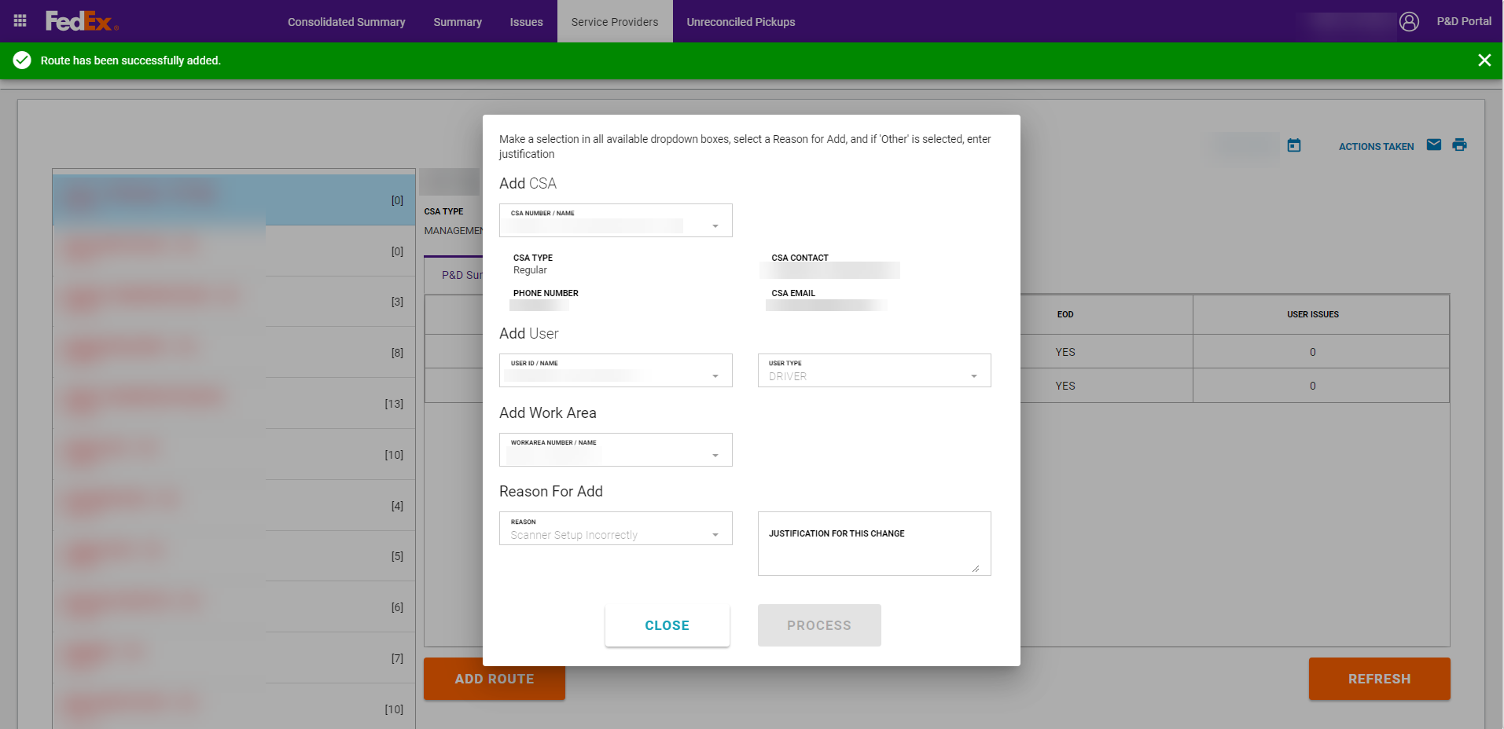
- Select the CLOSE button.
- The add pop-up closes.
- The screen returns to the P&D Summary tab:
- The CSA for the newly added route is selected by default in the CSA list.
- The work area detail tab for the route just added displays.
- The scanner ID is systematically generated and begins with *MAN to indicate it is a manual route.
- The manual route information is systematically sent to EASE to ensure the two applications are in sync.
- The route can be accessed as normal in EASE for further processing.
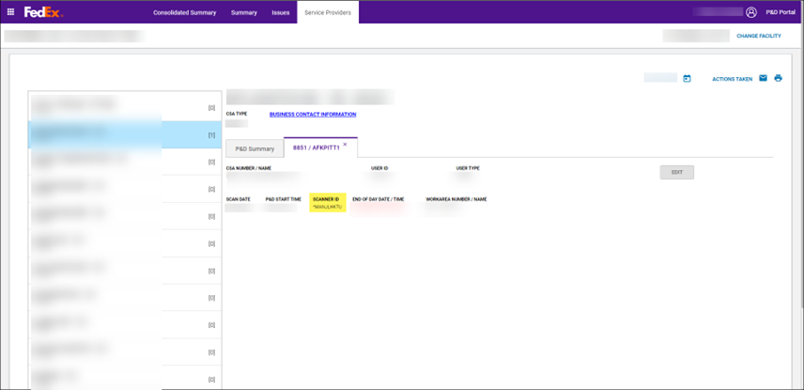
Additional information on Close:
The Close button toggles between Close and Cancel depending on if a change was made on the Add pop-up.
- Close:
- Close Initially displays when the Add pop-up loads.
- Close toggles to Cancel once a change is made to any of the dropdown boxes.
- Cancel changes back to Close once a change is successfully processed.
- Select Close to close the Add pop-up box.
- Cancel:
- Select Cancel to display an ‘Are you sure’ pop-up with Yes and No buttons:
- Selecting Yes:
- Closes the ‘Are you sure’ pop-up box.
- User is returned to the work area tab where the ADD ROUTE button was selected and unsaved changes are lost.
- Selecting No:
- Closes the ‘Are you sure’ pop-up.
- User is returned to the Add pop-up with changes made still persisted.

Read Only View of Pickup Activity
As scanner data is received in the P&D Portal, pickup activity will populate on the Service Providers tab for each work area.
This release provides a read only view of pickup activity in the P&D Portal. All pickup reconciliation, edits to pickup detail information, and pickup summary adjustments must still be performed in EASE as normal. Any adjustments made in EASE will NOT be fed back to the P&D Portal.

Layout and Functionality

Work Area Detail Tab – Pickup & Delivery Stop Table
The work area detail tab now contains a table that displays the pickup stops (in stop # order) performed for the selected work area.
For now, only pickup stops are displayed. If the pickup stop also contains a delivery (combo stop), a DELIVERY stop type displays however, the delivery details are not currently provided. Delivery stop information will be added later.
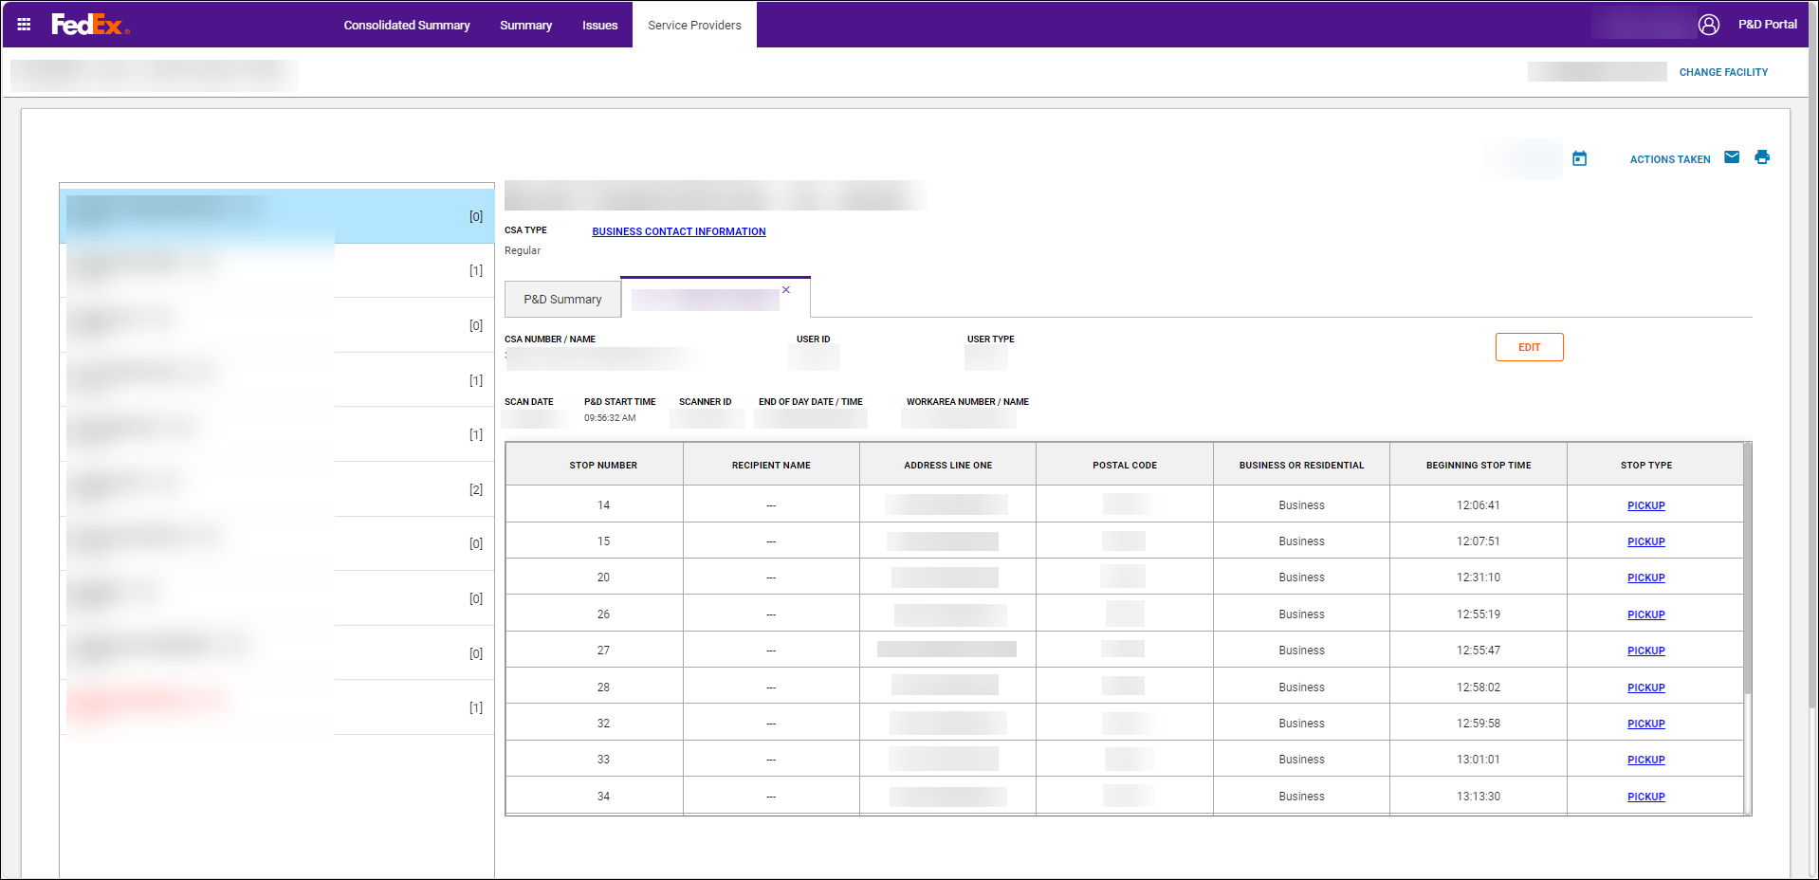
- The table contains the following information:
- STOP NUMBER: displays the pickup stop number as performed on the FORGE scanner.
- RECIPIENT NAME: this field is blank for pickup stops. If the stop is a combo stop, the recipient name displays for the delivery activity.
- ADDRESS LINE ONE: displays the street address for the stop.
- POSTAL CODE: displays the postal code for the stop.
- BEGINNING STOP TIME: displays the time the stop was started on the FORGE scanner.
- STOP TYPE: displays the word PICKUP for pickup stops and DELIVERY for delivery stops. When the PICKUP link is selected, a PICKUP DETAILS pop-up opens to view the details for the selected pickup stop. A DELIVERY DETAILS pop-up will be available later.

Pickup Details Pop-up
The PICKUP DETAILS pop-up displays detailed information for the selected pickup stop. The pop-up, for now, is read only. Edit capabilities will be enabled later.
Important: All pickup reconciliation, edits to pickup detail information, and edits to pickup summary totals must still be performed in EASE as normal.
The pop-up contains the following buttons:
- CLOSE: when selected, the PICKUP DETAILS pop-up closes.
- PROCESS: this button is currently disabled. It will be enabled when edit functionality is released later.
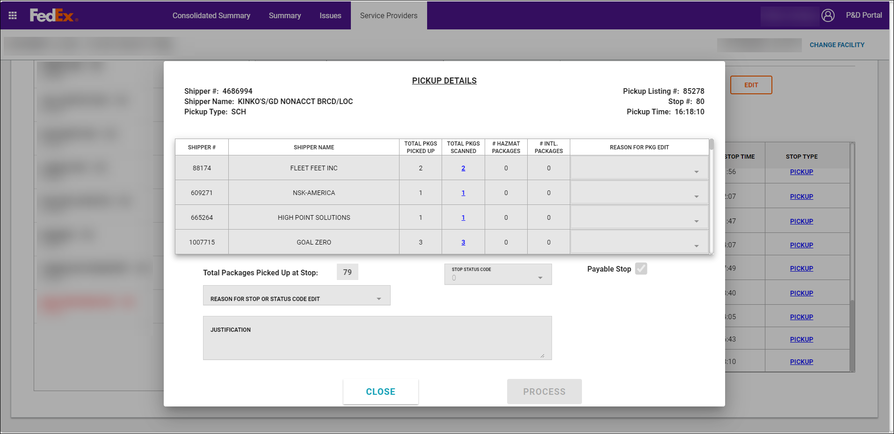

Pickup Details Pop-up: Planned Shipper Section
- The top section of the PICKUP DETAILS pop-up contains the following information:
Shipper #: displays the scheduled/planned shipper number. If the pickup did not match back to a scheduled/planned shipper number, this field will display with a zero.
Shipper Name: displays the corresponding shipper name for the listed shipper #. If the pickup is not matched to a planned pickup, this field will display with the text “Unknown”.
Pickup Type: displays the type of pickup stop such as SCH, CSM, NAP, PRP, etc. This field will be blank if the pickup type cannot be determined.
Pickup Listing #: displays the pickup listing number associated with the work area that performed the pickup. If the work area does not have an associated pickup listing, this field will be blank.
Stop #: displays the stop number as performed on the FORGE scanner.
Pickup Time: Displays the pickup time which matches the stop begin time.

Pickup Details Pop-up: Actual Package Section by Shipper Number

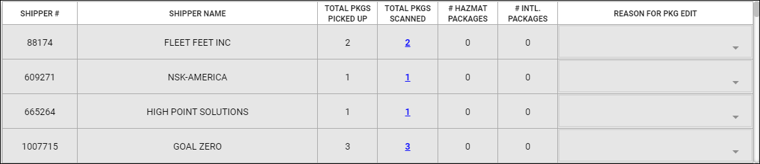

- The table displays the following information:
- SHIPPER #: displays the actual shipper numbers scanned at the stop. If no packages were picked up at the stop, the planned shipper number will display with zero packages.
- SHIPPER NAME: displays the corresponding shipper name for the scanned shipper numbers.
- TOTAL PKGS PICKED UP: displays the total number of packages picked up for the shipper number. This field is disabled for read only view. It will be enabled later when package edit capability is released.
- TOTAL PKGS SCANNED: displays the total number of packages scanned for the shipper number in blue font. This number could be the same as the TOTAL PKGS PICKED UP or it could be different in the case of scan all exempt pickup stops. When the number is clicked, a Scanned Tracking ID Information pop-up displays. For additional information regarding this pop-up, see the Scanned Tracking ID Information section in this document.
- # HAZMAT PACKAGES: displays the total number of hazardous material packages scanned for the corresponding shipper number.
- # INTL. PACKAGES: displays the total number of international packages scanned for the corresponding shipper number.
- REASON FOR PKG EDIT: this field is disabled for read only view. It will be enabled later when package edit capability is released.

Pickup Details Pop-up: Actual Stop Section
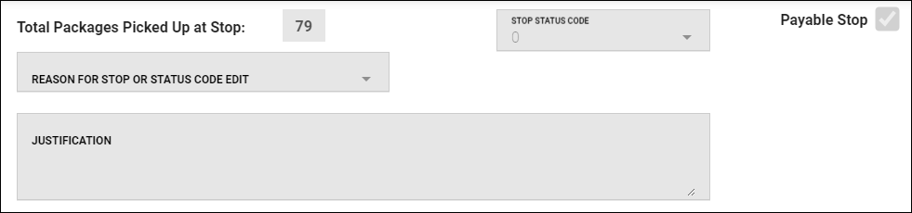

- The bottom section provides information regarding the stop:
- Total Packages Picked Up at Stop: displays the total packages picked up for all shippers. If the total is greater than 1,000 packages, a message displays near this field highlighted in yellow.
STOP STATUS CODE: displays the status code applied to the stop if applicable. This field is disabled for read only view. It will be enabled later in certain scenarios when status code edit capability is released.
Payable Stop: this field is systematically determined and designates whether the stop is payable. A checkmark in the box reflects the stop is payable. If the stop is not payable, the field will be blank (no checkmark displays). This field is disabled for read only view. It will be enabled later when payable stop edit capability is released.
REASON FOR STOP OR STATUS CODE EDIT: this field is disabled for read only view. It will be enabled later when stop and status code edit capability is released.
JUSTIFICATION: this field is disabled for read only view. It will be enabled later when stop and status code edit capability is released.

Scanned Tracking ID Information Pop-up
- When the blue total in the TOTAL PKGS SCANNED column is clicked, the Scanned Tracking ID Information pop-up displays.
- The shipper number corresponding to the blue scanned total that was clicked displays at the top of the table.
- Only the tracking ID’s that were scanned for that shipper number display in the table.
- The blue tracking ID’s are links and when clicked, an FTRACK window opens displaying information for the selected tracking ID.
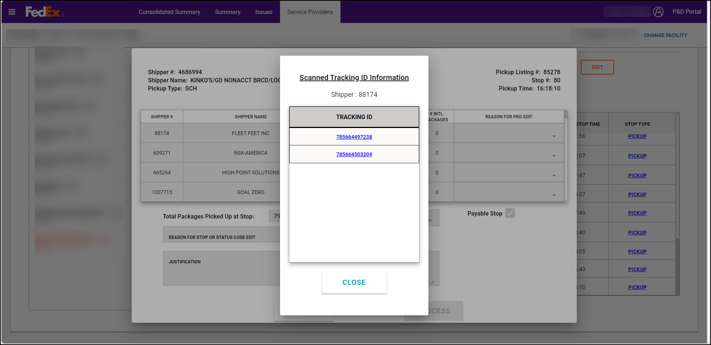

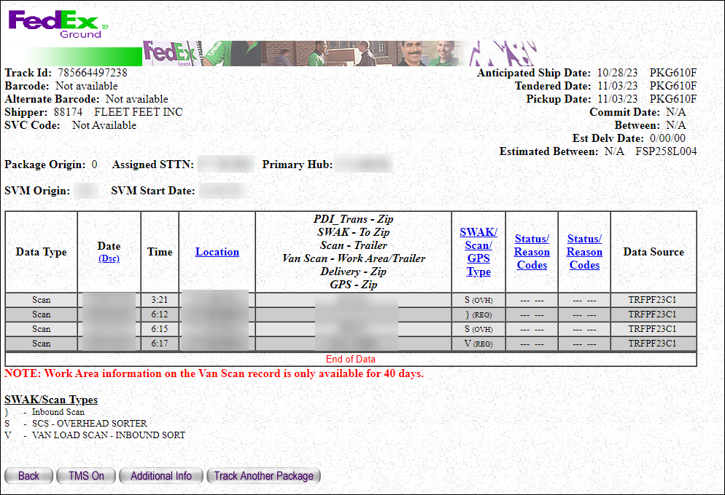

P&D Portal Snack Bar Messages
The table below provides information on common green, yellow, and red snack bar messages that could display in the P&D Portal UI and actions that can be taken to resolve the issue.

Facility Search Pop-Up
Snack bar Message  Snack Bar Color | Scenario That caused the snack bar to display | Resolution
List of eligible stations cannot be retrieved at this time. Please try to log in again. If issue persists, call in a help ticket with error code ##### (with unique error code).  Red | The system is unable to retrieve the list of eligible stations the user has access to. | - Select Logout button.  - Try logging back into the P&D Portal application again.  - If the red snack bar persists, call in a help ticket and reference the unique error code displayed in the message.
P&D Portal Application is not available at this time. Please try to log in again. If issue persists, call in a help ticket with error code: SYS-00001.  Red | System issues are being encountered and the P&D Portal application is not available. | - Select Logout.  - Try logging back into the P&D Portal application again.  - If the red snack bar persists, call in a help ticket and reference the unique error code displayed in the message.  - Try logging back into the P&D Portal once the system issue is resolved.
Document is obsolete. Please refer to Added Capacity Carrier STAR Application Access, SET-500 | The system is unable to retrieve the station details for the station selected. | - Select Logout.  - Try logging back into the P&D Portal application again.  - If the red snack bar persists, call in a help ticket and reference the unique error code displayed in the message.

Summary Tab
Snack Bar Message  Snack Bar Color | Scenario that caused he snack bar to display | Resolution
P&D Portal Application is not available at this time. Try to log in again. If issue persists, call in a help ticket with error code: SYS-00001.  Red | System issues are being encountered and the P&D Portal application is not available. | - Select Logout.  - Try logging back into the P&D Portal application again.  - If the red snack bar persists, call in a help ticket and reference the unique error code displayed in the message.  - Try logging back into the P&D Portal once the system issue is resolved.
Unable to retrieve weekly issue data. Try to refresh your screen. If issue persists, call in a help ticket with error code ##### (with unique error code).  Red | The system is unable to retrieve the issue counts to display in the different sections on the Summary tab. | - Select the browser refresh button to reload / refresh the page.  - If the red snack bar persists, call in a help ticket and reference the unique error code displayed in the message.

Issues Tab
Snack Bar Message  Snack Bar Color | Scenario that caused the snack bar to display | Resolution
The conditions that generated this issue no longer exist. Select the Acknowledge checkbox and Process to resolve the issue.  Green | The data in CDAS was updated after the issue was created and now the issue no longer exists (i.e., a CSA # or user ID was made eligible at the station in CDAS). | - Select the Acknowledged checkbox.  - Select PROCESS to resolve the issue.
Unable to mark selected issue as read. If issue persists, call in a help ticket with error code ##### (with unique error code).  Yellow | The system is unable to mark the selected issue as “read” by the user. The issue continues to show in bold font. | - Select a different issue to see if the system can mark it as “read.”  - If the yellow snack bar persists, call in a help ticket and reference the unique error code displayed in the message.  - Proceed to resolve the issue even though it could not be marked as “read.”
Changes were successfully processed however edits have failed to run. Call in a help ticket with error code ##### (unique error code).  Yellow | An error occurred during the Edits processing so the system could not create any new issues, if issues exist, based on the updated information. | - The issue moved to the resolved tab: however. edits did not run on the changed to information (i.e., if the driver’s license or physical is expired for a user ID change, an issue will not be created).  - No further action is required for this yellow snack bar message.  - Select another issue to resolve.

Snack Bar Message  Snack Bar Color | Scenario that caused the snack bar to display | Resolution
Unable to retrieve eligible user types. If issue persists, call in a help ticket.  Red | The system is unable to pull the list of eligible user types to display in the USER TYPE dropdown. | - Select Refresh Issue to refresh the issue being viewed or select the SCANNER User Issues card to refresh the page.  - If the red snack bar persists, call in a help ticket and reference the unique error code displayed in the message.
Unable to retrieve Issue Details for the selected Issue. If issue persists, call in a help ticket with error code ##### (unique error code).  Red | The system is unable to retrieve the details for the issue selected. | - Select Refresh Issue to refresh the issue being viewed or select the SCANNER User Issues card to refresh the page.  - If the red snack bar persists, call in a help ticket and reference the unique error code displayed in the message.
Unable to retrieve selected issue from list.  Red | The system is unable to pull the selected issue from the list to display the issue details. | - Select the SCANNER User Issues card to refresh the page.  - If the red snack bar persists, call in a help ticket.
Unable to resolve Issue. If issue persists, call in a help ticket with error code ##### (unique error code).  Red | The system is unable to mark the issue as resolved. | - Select PROCESS again.  - If the red snack bar persists, call in a help ticket and reference the unique error code displayed in the message.  - Try resolving the issue later once the system issue is resolved.

Snack Bar Message  Snack Bar Color | Scenario that caused the snack bar to display | Resolution
P&D Portal Application is not available at this time. Try to log in again. If issue persists, call in a help ticket with error code: SYS-00001.  Red | System issues are being encountered and the P&D Portal application is not available. | - Select Logout.  - Try logging back into the P&D Portal application again.  - If the red snack bar persists, call in a help ticket and reference the unique error code displayed in the message.  - Try logging back into the P&D Portal once the system issue is resolved.
Changes are unable to be processed at this time. Try again. If issue persists, call in a help ticket with error code ##### (with unique error code).  Red | The system experienced an error while processing the issue. | - Select Process again.  - If the red snack bar persists, call in a help ticket and reference the unique error code displayed in the message.  - Try processing the issue again once the system issue is resolved.
User Type cannot be empty. Select a User Type value.  Red | The User Type field is blank or empty and the Acknowledge checkbox was selected prior to selecting a valid user type in the User Type dropdown. | - Select the appropriate user type from the User Type dropdown.  - Select the Acknowledged checkbox.  - Select a Reason for Edit.  - Enter a Justification for This Change if Other was selected.  - Select Ok.  - Select Process.

Service Providers Tab
Snack Bar Message  Snack Bar Color | Scenario that caused the snack bar to display | Resolution
Unable to retrieve issue count. Try to refresh your screen. If issue persists, call in a help ticket with error code ##### (with unique error code).  Yellow | The system is unable to retrieve the issue counts to display on the Service Providers tab for either the CSA list or for the work area list on the P&D Summary tab or both. | - Select Refresh to reload / refresh the Service Providers tab.  - If the yellow snack bar persists, call in a help ticket and reference the unique error code displayed in the message.  - Try accessing the Service Providers tab again once the system issue is resolved.
Service provider details could not be retrieved. If issue persists, call in a help ticket with error code ##### (with unique error code).  Yellow | The system is unable to retrieve the Service Provider details for the CSA selected. | - Select Refresh to reload / refresh the Service Providers tab.  - If the yellow snack bar persists, call in a help ticket and reference the unique error code displayed in the message.  - Try accessing the Service Providers tab again once the system issue is resolved.
Unable to retrieve Service Provider information. Try to refresh your screen. If issue persists, call in a help ticket with error code ##### (with unique error code).  Red | The system is unable to retrieve the Service Provider information. | - Select Refresh to reload / refresh the Service Providers tab.  - If the red snack bar persists, call in a help ticket and reference the unique error code displayed in the message.  - Try to access the Service Providers tab once the system issue is resolved.
P&D Portal Application is not available at this time. Try to log in again. If issue persists, call in a help ticket with error code: SYS-00001.  Red | System issues are being encountered and the P&D Portal application is not available. | - Select Logout.  - Try logging back into the P&D Portal application again.  - If the red snack bar persists, call in a help ticket and reference the unique error code displayed in the message.  - Try logging back into the P&D Portal once the system issue is resolved.

Edit Pop-Up
Snack Bar Message  Snack Bar Color | Scenario that caused the snack bar to display | Resolution
Changes were successfully processed.  Green | The changes made on the Edit pop-up were successfully processed. | - Select Close to close the Edit pop-up.  - The UI refreshes to display the updated information.
Changes were successfully processed however edits failed to run. Call in a help ticket with error code ##### (with unique error code).  Yellow | An error occurred during the Edits processing so the system could not create any new issues, if issues exist, based on the updated information. | - The changes were successfully processed.  - New issues were not created, if they exist, on the updated information (i.e., if the driver’s license or physical is expired for a user ID change, new issues were not created).  - Select Close to close the Edit pop-up.  - The Service Providers tab refreshes to display the updated information.  - No further action is required for this snack bar message.
Unable to retrieve the necessary information to display on this screen. Close this screen and try again. If issue persists, call in a help ticket with error code ##### (with unique error code).  Red | The system is unable to retrieve the necessary information to display in the CSA and User dropdowns on the Edit pop-up. | - Select the CLOSE button on the Edit pop-up.  - Try selecting the EDIT button again.  - If the red snack bar persists, call in a help ticket and reference the unique error code displayed in the message.  - Try making the changes later once the system issue is resolved.
Changes are unable to be processed at this time. Try again. If issue persists, call in a help ticket with error code ##### (with unique error code).  Red | The system is unable to process the changes made on the Edit pop-up. | - Select Process again. If the issue persists, call in a help ticket and reference the unique error code displayed in the message.  - Select Cancel on the Edit pop-up.  - Select Ok on the ‘Are you sure’ pop-up.  - The Edit pop-up closes and changes made are lost.  - Try making the changes later once the system issue is resolved.
P&D Portal Application is not available at this time. Try to log in again. If issue persists, call in a help ticket with error code: SYS-00001.  Red | System issues are being encountered and the P&D Portal application is not available. | - Select Logout.  - Try logging back into the P&D Portal application again.  - If the red snack bar persists, call in a help ticket and reference the unique error code displayed in the message.  - Try logging back into the P&D Portal once the system issue has been resolved.

Add Route Pop-Up
Snack Bar Message  Snack Bar Color | Scenario that caused the snack bar to display | Resolution
Route was successfully added.  Green | The manual route created on the Add pop-up was successfully processed. | - Select Close to close the Edit pop-up.  - The UI refreshes to display the manual route created.  - No further action is required for this snack bar message.
Changes successfully processed however edits have failed to run. Call in a help ticket with error code ##### (with unique error code).  Yellow | An error occurred during the Edits processing so the system could not create any new issues, if issues exist, based on the information entered. | - The changes were successfully processed.  - New issues were not created, if they exist, on the updated information (i.e., if the driver’s license or physical is expired for the user ID entered, new issues were not created).  - Select Close to close the Add pop-up.  - The Service Providers tab refreshes to display the manual route created.  - No further action is required for this snack bar message.
Unable to retrieve the necessary information to display on this screen. Close this screen and try again. If issue persists, call in a help ticket with error code ##### (with unique error code).  Red | The system is unable to retrieve the necessary information to display in the CSA, User, and Work Area dropdowns on the Add pop-up. | - Select Close on the Add pop-up.  - Try selecting the ADD ROUE button again.  - If the red snack bar persists, call in a help ticket and reference the unique error code displayed in the message.  - Try making the changes later once the system issue is resolved.
PnD Portal Application is not available at this time. Try to log in again. If issue persists, call in a help ticket with error code: SYS-00001.  Red | System issues are being encountered and the P&D Portal application is not available. | - Log out of the P&D Portal application.  - Try to log back into the P&D Portal application again.  - If the red snack bar persists, call in a help ticket and reference the unique error code displayed in the message.
A record already exists for the selected user ID and work area. Manual route not created. Select the user and work area from the P&D Summary tab.  Red | The system did not create the manual route entered on the Add Route pop-up because a route for the CSA, user, and work area already exists. | - Select Close on the Add pop-up.  - Select the work area that already exists on the P&D Summary tab.  - If changes are required on the information for that work area, select Edit.
Changes are unable to be processed at this time. Try again. If issue persists, call in a help ticket with error code ##### (with unique error code).  Red | The system is unable to process the changes made on the Add pop-up. | - Select Process again. If the issue persists, call in a help ticket and reference the unique error code displayed in the message.  - Select Cancel on the Add pop-up.  - Select Ok on the ‘Are you sure’ pop-up.  - The Add pop-up closes and changes made are lost.  - Try creating the route later once the system issue is resolved.

Related Documents

Policies:
Field Operations, POLICY-013 (governing policy)

Online Manuals and Forms Materials:
- N/A

Required Training:
- N/A

Other Materials:
- N/A

