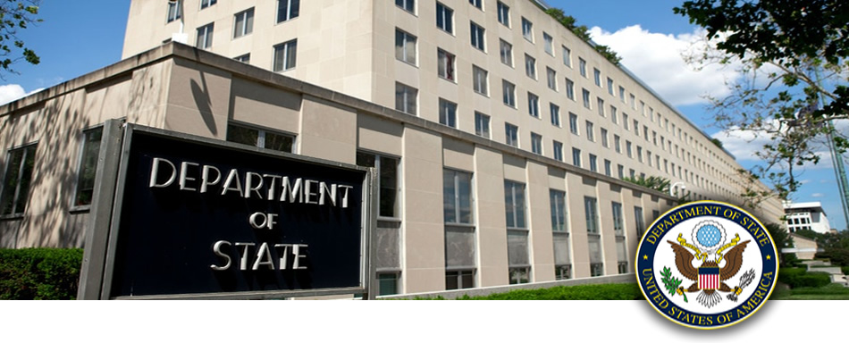
Briefing Report for:
[cp:scripting key='DataSource' dataId='cb94032c-3eb9-4d48-a6eb-299cb925f498’/]
[cp:scripting key='DataSource' dataId=’c05c0173-1fdb-4a0a-94d7-e8db03d81cf3’/]

Past U.S. Presidential Visits
[cp:scripting key='DataSource' dataId='c5042a65-5ef0-4d77-993a-f7183d80493d' /]

Talking Points
[cp:scripting key='DataSource' dataId='321b3e53-4c6a-47d9-84b1-50e4bf4b3929' /]

Tasks
[cp:scripting key='DataSource' dataId='1f67498f-b1bf-4af5-b818-5c8c2ab76221' /]

Past Secretary’s Visits
[cp:scripting key='DataSource' dataId='8dafb60c-3e6b-4a28-8281-634a5067fd70' /]
Press Guidance
[cp:scripting key='DataSource' dataId='424421c7-51b0-42b1-99a3-bcba5cec92c8' /]

Heads of State
[cp:scripting key='DataSource' dataId=’15554072-ece1-460e-83ef-ee0875d3038a’ /]

Heads of State
[cp:scripting key='DataSource' dataId=’15554072-ece1-460e-83ef-ee0875d3038a’ /]

Secretary’s Remarks
[cp:scripting key='DataSource' dataId='9a7c7731-7b0e-450e-85e6-7baa017e559c' /]

Priority Issues
[cp:scripting key='DataSource' dataId='2d6dc84e-c23a-4e23-a845-76447eed43b0' /]

Past Visits to U.S. from this Region
[cp:scripting key='DataSource' dataId='17c41d7e-72be-4d31-abe4-af25bd7f1133' /]
Charts, Graphs, Research Data
[cp:scripting key='DataSource' dataId='ff1b7945-b551-4a37-9028-de059815db7a' /]

Test Module 01
[cp:scripting key='DataSource' dataId=’ 1d20af22-9a6b-42e2-b7e6-58f99b1f28e3' /]
Test Module 02
[cp:scripting key='DataSource' dataId=' 08c8b43c-d9cb-4f31-8654-569731f8d09e' /]
Test Module 03
[cp:scripting key='DataSource' dataId='1c6a8c39-9205-4df1-b2f2-088fa2c65a44' /]
Test Module 04
[cp:scripting key='DataSource' dataId=’597aa434-26ec-4e46-82eb-f9706dea85c3' /]
Test Module 05
[cp:scripting key='DataSource' dataId=’73c9f921-0319-4b4e-aa5e-a0819a9e3aa9' /]
Tableau Charts & Data
[cp:scripting key='DataSource' dataId='ff1b7945-b551-4a37-9028-de059815db7a' /]

