Market Trends: Unification of the User
Experience Platform Marketplace
Published: 31 March 2016
Analyst(s): Fabrizio Biscotti, Gene Phifer
The user experience platform is key to acquire and retain new customers,
and strategic planners should provide guidance to help customers move
from a purely technology-led to a strategically business-driven
implementation of the UXP.
Key Findings
■
Enterprises now see the user experience platform (UXP) as critical to their success, and
commitment to the UXP extends beyond IT departments to be of primary concern for CMOs'
communication and brand management strategies.
■
As UXP products become more popular and attractive for businesses, during the next five
years, we will continue to see the market for UXP suites slowly absorbing some of the stand-
alone offerings.
■
■
Total software revenue of all UXP ecosystem components is presently estimated at about $32
billion, of which about $3.0 billion is for holistic UXPs.
Demand is coming from not only well-established corporations with large budgets, but also
smaller organizations.
Recommendations
Vendor strategic planners should:
■
■
Target the key buyers as the buying centers are changing, and be ready to talk to the marketing
and line-of-business people within an enterprise rather than to CTOs and CIOs.
Take a vertical market approach as several industries are seeing the greatest benefit from
purchasing UXPs and will be very active in this space. Pay particular attention to financial
services, healthcare, public sector and other heavily regulated industries, as they will be among
the top adopters.
■
Create a UXP that can address a variety of audiences, allowing clients to manage content and
interactions with as many players in their value chains as needed.


■
Go beyond mere customer-centric UXPs, and expand the "ethos" to adjacent areas to fulfill the
needs of the investor, customer, employee, partner and supplier audiences.
Table ofContents
Introduction...........................................................................................................................................2
Technological Innovation. ...............................................................................................................3
Market Trend. ...................................................................................................................................................5
Changing Marketplace for User Experience. ..................................................................................5
UXPs Are Experiencing Solid Traction..................................................................................................5
Capitalizing on User Experience Platform Demand. .......................................................................6
Market Trend: Supply and Demand Structures for UXP..................................................................7
Market Size. ..............................................................................................................................7
Supply Side...............................................................................................................................9
Demand Side. .........................................................................................................................10
Technology Trend: Moving to Digital by Default. ...........................................................................13
Contrarian View. .................................................................................................................................14
User Experience Trends May Be Derailed by User Preferences...................................................14
Vendors to Watch. ..............................................................................................................................15
Gartner Recommended Reading........................................................................................................17
List of Tables
Table 1. UXP Deployment Options.......................................................................................................11
Table 2. Examples of UXP Vendors and Products................................................................................16
List of Figures
Figure 1. Key Functions of a UXP.........................................................................................................4
Figure 2. UXP Technology Functional Evolution...................................................................................8
Figure 3. Market Segments in the UXP Ecosystem..............................................................................9
Introduction
The traditional approach to deploying websites, portals and mobile applications has seen
enterprises adopt an ad hoc strategy when designing their digital footprint. Multiple developers are
Page 2 of 19


often involved in building a company's various Web and mobile initiatives, and frequently use their
personally preferred tools among a large collection of one-off, nonintegrated products.
These solutions cause enterprises to suffer mismatches and maintenance issues, as well as make
the deployment of a consistent user experience (UX) across devices more difficult. As organizations
increasingly turn to digital businesses, and consumers become more aware of technology and more
involved in online interactions, the importance of building a successful user experience cannot be
overstated.
New IT paradigms, as well as new tools and methodologies, are replacing present technologies as
we approach the age of smart machines. As a result of this changing scenario, vendors and IT
leaders are focused on a customer-experience-centric value chain when designing their customer
journey, or even revisiting their business processes and operations.
Technological Innovation
A UXP is an integrated collection of technologies and methodologies that provide the ability to
design and deliver user interface and presentation capabilities for a wide variety of interaction
channels.
This rationalized and integrated platform approach has a profound impact on the UX strategies and
efficiency of UXP adopters, due to a better and more centralized and consistently organized
deployment of tools. Time to market is reduced, quality is improved and the overall UX is enhanced
with the use of a UXP matched to the organization's needs.
The set of functionalities delivered via UXPs emerged from the ranks for traditional portal products.
They grew to include content management, collaboration and social capabilities, mobile and
context technologies, search engines, and integration and API services, as well as orchestration and
personalization abilities (see Figure1).
Page 3 of 19

Figure 1. Key Functions of a UXP
Legend: Inner circles = Required; Outer circles = Optional; Overlapping circles = Some features required, some optional
UCC = universal communication and collaboration
Source: Gartner (March 2016)
Although UXPs are, by definition, built to be horizontal frameworks, many UXPs are intended for a
specific type of audience — that is, the audience has a narrower focus, also referred to as ethos.
UXPs can be designed in a way that targets customers, consumers, employees, suppliers, business
partners and citizens; they can also support specific industry segments that determine the
applications, templates and workflows offered as complements to their portal products (see
"Emerging Technology Analysis: User Experience Platforms").
Page 4 of 19
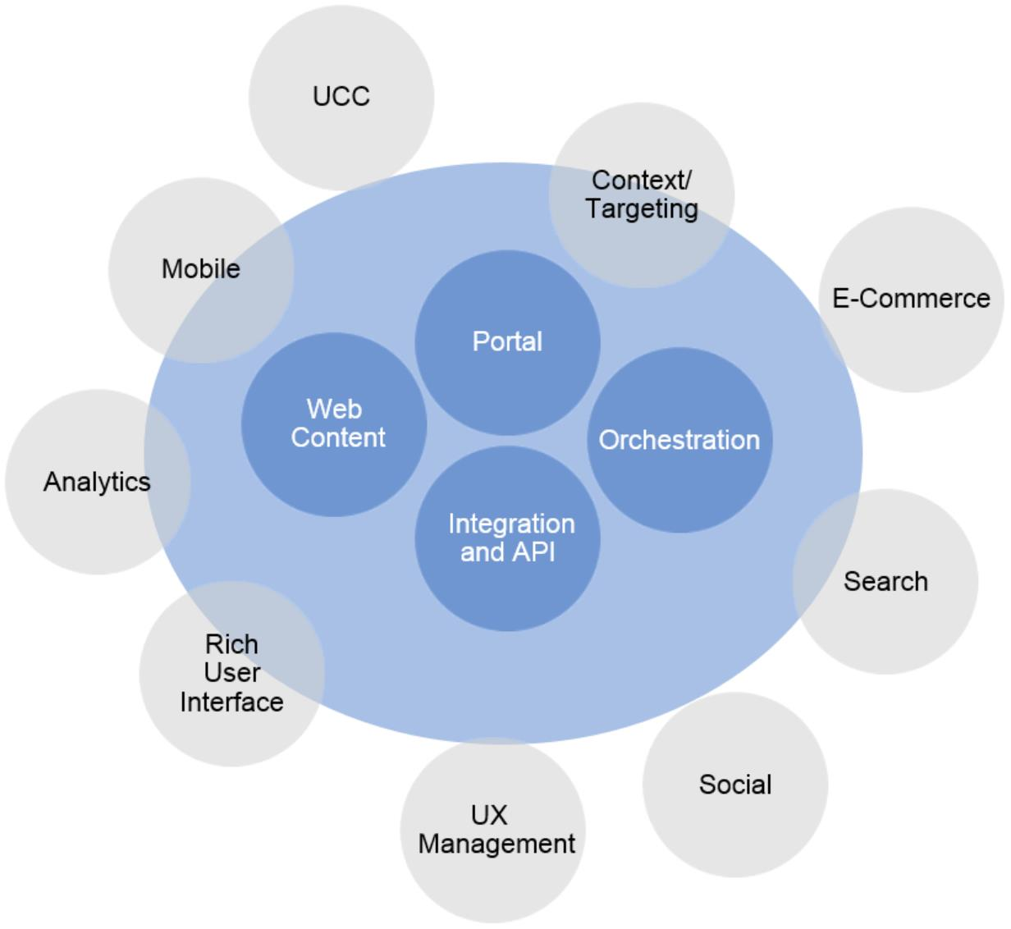

Market Trend
Changing Marketplace for User Experience
The widespread diffusion of consumer-driven IT, the exponential growth of mobile platforms and the
emergence of new technological innovations such as wearables and smart machines are changing
user demands and software vendor behavior.
Current trends indicate a shift in the technologies used to deliver user experiences, especially as the
ability to create a successful UX strategy has become an increasingly important business strategy
differentiator.
Comprehensive suites and platforms that encompass critical infrastructure capabilities, as well as
design-oriented solutions, are seen as effective solutions to create a seamless UX at the
presentation and user interface level.
Moreover, the proliferation of client devices and growing demand from end users for simple and
usable, yet powerful, sites such as Google have raised awareness among enterprises of the
importance of adopting a customer experience (CX)-centric value chain and developing new IT
paradigms, chief among them agile development and bimodal IT.
Many enterprises now see UXP as critical to their success to be able to build a good experience for
users. Commitment to the UXP, therefore, extends beyond IT departments and is a primary concern
for CMOs' communication and brand management strategies. CEOs are also keen on the benefits
of adopting a UXP approach. Customer engagement technology was the No. 1 investment
technology from 2015 through 2019, according to a Gartner CEO survey delivered in early 2015.
Changes in companies' internal governance see them adapting structure and operations around the
customer journey. As a reflection of the observed market trends, enterprises are setting up VP
positions for customer experience, as well as focusing on website optimization and design-driven
thinking.
Marketing and communication executives are also understanding that faster customer support is
not necessarily the optimal strategy since companies are competing on different levels of services
and many customers show more concern for quality and CX.
UXPs Are Experiencing Solid Traction
Buyers of portal products have complained for years about the multitude of technologies and tools
that they must use to deliver the variety of solutions necessary to their digital businesses.
Modernizing and upgrading that digital presence is a key issue for enterprises needing to improve
their efficiency, and to help acquire and retain customers by increasing their satisfaction and loyalty
levels.
As traditional technologies prove inadequate to deliver the desired user engagement, enterprises
now demand easy-to-use solutions to simplify development of their websites and applications, and
to increase the level of user engagement and improving usability.
Page 5 of 19

The opportunity to link enterprise online services in a coherent and consistent way under the
umbrella of a UXP can provide an effective solution that tackles this demand and helps customers
to support their businesses in the digital world.
In many instances, customers report that within only 12 months after adopting a UXP, they can
already measure the benefits provided by improved efficiency. Customers react positively and are
satisfied with the UXP solution, and the platform approach is becoming increasingly popular.
The UXP competitive advantage is not only in the number of services that it can deliver, but
especially in the off-the-shelf integration of such features. This fundamental characteristic of UXPs
allows for minimized redundancies and a common framework for Web and mobile development,
eliminating the need for further deployment consulting and integration efforts.
While it is true that innovations improving UX are becoming an essential differentiator for mature
products and product categories, at the same time, the emergence of new technologies and new
modes of interfacing with old devices will also facilitate growth of the UXP market. The Internet of
Things (IoT), wearables and smart machines, among others, constitute a "blank slate" for UX
designers, and will require companies to make an effort to provide seamless consistency across
multiple channels and devices.
Such proliferation of interconnected technologies and consumers' awareness about the digital
world are raising expectations about functionality and personalization. A well-thought brand
management, design-driven strategy and integration among devices and channels will generate
further opportunities and demand for UXPs.
Capitalizing on User Experience Platform Demand
The recurrence of words such as simplicity and usability in the UXP market landscape suggests that
integration is the most critical issue that UXP products should focus on. Ease of deployment is one
of the primary needs that drives users' interest toward UXP products, and it is a concern that
vendors should not underestimate.
Rather than concentrate on developing more features to include in their UXP offerings, vendors
should instead deploy resources to make sure the integration of all the parts, whether developed in-
house or obtained through partnerships or acquisitions, is fully complete.
When designing their UXP product line and planning their product strategies, strategic planners
should have an open and flexible mind for the future; as new technologies are emerging quickly, it is
important to keep an eye on the evolution of the market and to track the development of the most
disruptive innovations. These are likely to bring new access and information models, as well as an
increase in the variety of data, which will require a consistent adaptation of current information
architecture and analytics.
At the same time, strategic planners need to keep in mind that the UXP market is still taking shape,
and a general lack of education still exists among enterprises about the necessary operational and
managerial changes involved in adoption. In fact, while there is overreaching consensus on the
importance of investing on UX-centered design and technologies, many still fail to understand the
correct approach to implement a successful UXP strategy.
Page 6 of 19

Guidance has to be provided to customers to advise them on how to best extract value from this
new platform approach. Companies that will adopt a UXP purely as another piece of technological
investment without fully including it in their business strategy and development might miss out on
the growth opportunities that the UXP offers.
The vision behind the UXP as a product is more complex to explain to customers than traditional
component technologies such as Web content management (WCM) or mobile. Strategic planners,
therefore, need to be able to communicate to their clients the value that a UXP will generate for their
digital businesses if implemented strategically.
To spur interest toward their offering and acquire and retain new customers, strategic planners
should provide guidance to help customers move from a purely technology-led, to a strategically
driven, implementation of the UXP.
External partner consulting firms and digital agencies should also be leveraged as a way to educate
clients and lead them through the process of UXP strategic planning.
Market Trend: Supply and Demand Structures for UXP
Market Size
UXP market has passed the introduction phase and is in its initial growth phase. A UXP competes
with the existing software products it's composed of and integrates (see Figure 2). The nature of the
UXP as a mix of different, but complementary, technologies integrated into a single product (or
suite) suggests that the UXP market can be looked at as an aggregate, or partial aggregate, of all its
components' markets.
Page 7 of 19

Figure 2. UXP Technology Functional Evolution
BPM = business process management; IoT = Internet of Things; WCM = Web content management
Source: Gartner (March 2016)
To make an educated estimate of the market size for UXPs, we first looked at the total revenue for
the relevant stand-alone components' markets, and, secondly, we tried to determine how much of
each segment belongs potentially to integration solutions/suites and to holistic UXP platforms to
form the entire UXP ecosystem.
We based our assessment on the features of the UXP products available in the marketplace, as well
as on the vendor market shares for individual components (see "Market Share: All Software
Markets, Worldwide, 2014").
The combined market size of all the components of the user experience platforms ecosystem is
presently estimated to be $32 billion, of which about $3.0 billion are for holistic UXP platforms.
Figure 3 shows the UXP ecosystem market segments.
Page 8 of 19
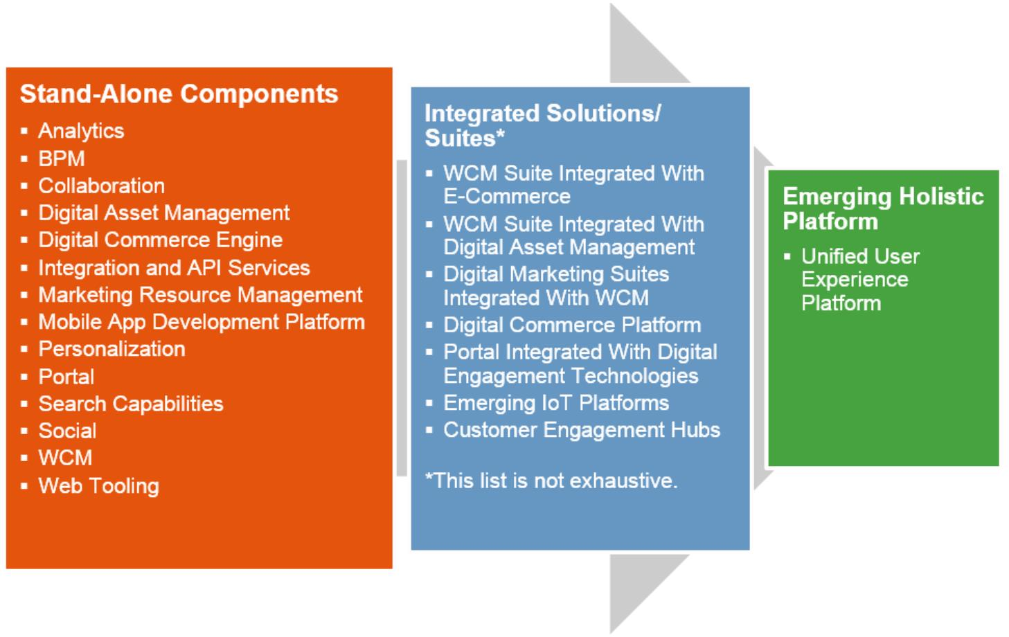

Figure 3. Market Segments in the UXP Ecosystem
CAGR = compound annual growth rate; ECM = enterprise content management
Source: Gartner (March 2016)
During the next five years, we will continue to see the market for suites and holistic UXP platforms
slowly subsuming entirely some of the stand-alone markets and absorbing at least part of the
demand for other segments (see "Forecast: Enterprise Software Markets, Worldwide, 2012-2019,
4Q15 Update" and the following quarterly updates). The appeal and benefits of an integrated and
easily deployable set of technologies under the UXP umbrella is likely to stimulate new demand and
generate extra revenue streams.
Supply Side
The UXP market has grown from a market for traditional portal products, to which vendors have
been making efforts to add progressively a set of complementary technologies through off-the-shelf
integration.
As UXP products become more popular and attractive for customers, the UXP market is likely to
subsume the market for portal products. It is possible that this will extend to incorporate the
markets for other complementary technologies such as WCM and collaboration segments; however,
at this point, it appears that the markets for these complementary technologies will continue intact
for years.
As a composite market, the value and supply chains for the UXP market are similar to other
application platform suites and middleware technologies. Upstream, vendors engage in
Page 9 of 19
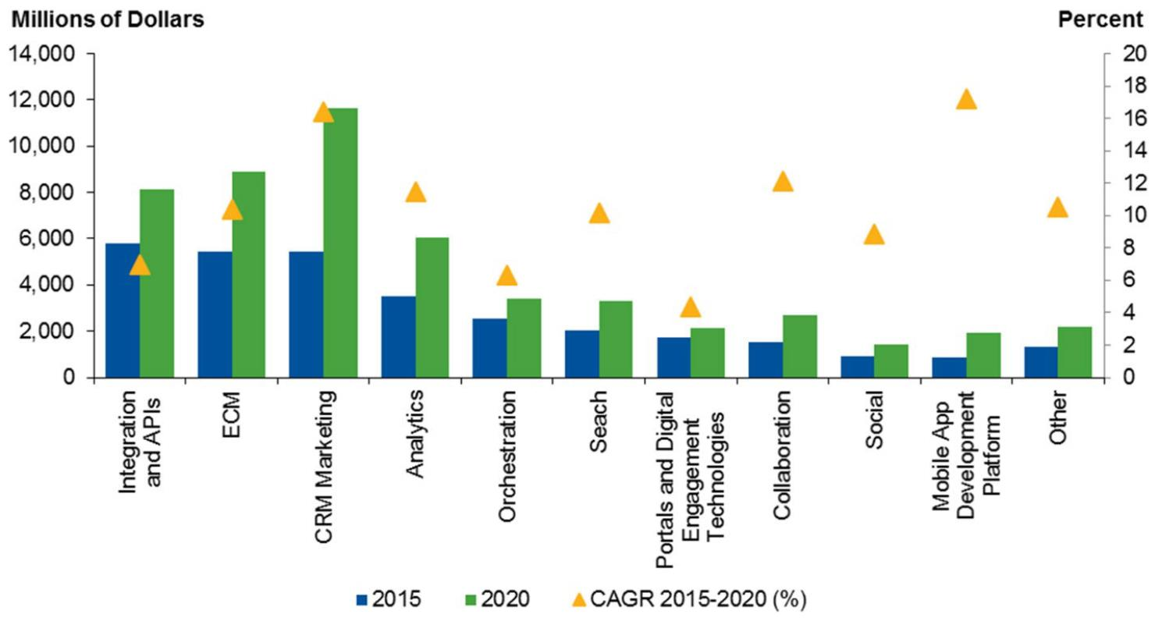

partnerships with other components providers, while the downstream layer of the market relies on
implementation partners, internal or external consulting groups and digital agencies involved in the
marketing process.
However, the structure of the UXP marketplace is likely to differ from comparable technologies,
mainly because of the large amount of components required to deploy a UXP. As a matter of fact,
the effort and difficulty involved in assembling and integrating all the necessary tools and
technologies have important implications for vendors.
Initially, large vendors will find it easier to enter the UXP market as they possess all the
competences required to deliver UXP core functionalities in-house and have a solid presence in all
the UXP components markets.
Also, players in this market will have to rely more heavily on partnerships, mergers and acquisitions,
and open-source communities than they would for the development of other technologies. This is
especially true for smaller firms wanting to become UXP vendors; they must consider all available
options to close the gaps in their portfolios in terms of UXP components.
For an IT provider wanting to enter the UXP market, a conspicuous commitment in UXP vision and
resource allocation is required, which may be seen by some as a barrier to entry. However, the UXP
market is young and fragmented, leaving space and opportunities for new vendors to succeed and
grow.
Larger vendors are expanding (not confusing) the definition of UXP. This is positive in the way that it
creates differentiation; however, there is confusion among customers about the scope and value of
UXPs. This could lead toward smaller companies with a clearer vision and well-structured offerings,
or toward more expensive and complex solutions from bigger vendors. Complexity is scary for end
users and difficult to deploy.
Because business customers still have to reach a full understanding of the value of a UXP or do not
yet have the technical skills to change their existing IT systems, some more time is needed before
demand switches altogether from a best-of-breed to a platform approach.
Consequently, competition in this market is likely to come from not only other UXP vendors, but also
vendors offering targeted digital experience suites of products. Vendors of portal, WCM and e-
commerce are also investing in different customer engagement features, from analytics to social
platforms, and are likely erode the share for pure UXPs in the enterprise software market.
It is, therefore, up to strategic planners to define a strong line of product innovation and solid vision
for their UXP offerings that can be communicated effectively to existing and new customers. They
should also be working alongside company's executives and marketing officers to gear
management toward a more aggressive and clean-cut UXP strategy.
Demand Side
The popularity of UXP products is growing, along with the satisfaction of those who have already
adopted this type of platform solution. Although customers have significantly lagged behind
Page 10 of 19

vendors' offerings due to a lack of education and understanding, as well as inertia and hesitation,
demand is growing, and it is expected to catch up with supply by 2017.
Table 1 shows several ways to deploy UXP.
Table 1. UXP Deployment Options
Roll-Your-Own Stand-Alone
Components
Integrated Solutions/Suites*
Suite: Holistic UXP Platform
UXP assembled from a set of best-of-
breed products and open-source
components. The UXP market is
perceived only as a source for
components.
UXP is built by buying all or part of a
UXP solution. The rest is
supplemented with existing
technologies or technologies from
other vendors.
UXP is obtained as a single
product or a suite from a single
vendor, replacing any or all
existing tools.
Source: Gartner (March 2016)
Demand is currently coming from not only well-established corporations with availability of large
budgets, but also smaller companies that have been observed as among the drivers for UXP
adoption. This is because there are several ways of deploying UXP capabilities (as shown in Table
1), and internal corporate governance and legacy products are often factors inhibiting the adoption
of a holistic UXP. In this respect, companies that don't have the baggage of organization and are
more agile in putting in place management changes will also be more likely to adopt and adapt their
structure to disruptive technologies.
Finally, it appears that many business customers still have an unclear view about product offerings
for UXP. They are talking to many vendors at the same time to better understand how the different
functionalities best fit their needs, and what added value will derive from adoption.
At the same time, successful implementation of the UXP depends on the structural and digital
maturity of companies.
Some smaller enterprises may readily embrace the concept of a single platform approach while not
yet having the organizational and infrastructural maturity to do so, and will need guidance and
external consulting to carry out the deployment of their UX vision.
Strategic planners should, therefore, consider the size and maturity of companies when seeking
new customers, although still watch for other discriminators. In particular, a company's "new"
versus "traditional" business approach, whether in terms of type of organization or business model,
also accounts for a positive, rather than risk-averse, adoption behavior.
Native digital companies, for example, find it generally easier to switch to a new technology, and will
be more prone to implementing a UXP vision than enterprises that are still taking the first steps in
the world of digital business.
This is also true of new digital initiatives set in place by existing companies that may decide to
adopt a full-on UXP approach for their online services or transactions, while maintaining more
Page 11 of 19


traditional technologies for their mature business. This falls perfectly in line with bimodal IT
strategies.
In general, deployment of a UXP is a priority for companies that understand the strategic
importance of innovating their product line or services around the customer journey. And as
digitalization becomes a vital requirement for companies that want to grow and keep competitive
into the next generation, adoption of a UXP will be a necessary step forwards for many enterprises.
In this respect, it is also important to consider who, within enterprises, is interested in buying UXP.
The buying centers are changing with respect to the traditional division of tasks that saw IT
departments responsible for the purchase and delivery of enterprise software technologies.
Strategic planners should now be able and be ready to talk to the marketing and line-of-business
people within an enterprise, rather than solely to CTOs and CIOs.
IT will still be very much involved in implementing UXP, but more in the role of trusted partner,
supporting CMOs in achieving their digital UX vision.
It must be noted that budgets remain largely fragmented across departments and different projects;
this constitutes a major issue in the creation of a seamless customer journey, which requires a
broader internal reorganization. Nevertheless, changes are indeed happening within organizations,
as marketing is becoming more involved in the strategic management of technology and data
science, and IT and business units are working more closely to achieve better UX. Strategic
planners will also often find themselves dealing directly with companies' CEOs, whom are becoming
increasingly engaged in customer engagement and customer experience strategies.
As it was mentioned above, it is primarily the maturity and the modernity of organizations that
determine demand for the UXP, together with the horizontal pressure on companies to devise digital
and mobile strategies. Hence, vendors should make an effort to guide and educate existing and
potential customers about the added value of the UXPs versus more traditional piecemeal
approaches.
However, some trends have emerged in the past few years, suggesting that certain industries are
being more responsive than others to adoption of this technology.
In general, highly decentralized and vertical industries see the greatest benefit from purchasing
UXPs, in particular, franchise networks, trade associations, healthcare, public sector and heavily
regulated industries.
Banking and financial services firms, as well as insurance and wealth management companies, are
also among the top clients that strategic planners should look for. Within this sector are included
new disruptive competitors creating alternative financial solutions to the more traditional companies
in the industry.
Governments feature as predominant users of UXPs, having the need to centralize and standardize
many different websites and applications across the citizen life cycle. A similar attitude is shown by
higher education institutions and universities, as well as the healthcare sector. As a matter of fact,
centralization allows these institutions not only to improve the quality of their users' engagement
Page 12 of 19

and experiences, but also to rationalize internal resources, simplify employees' training and reduce
inefficiencies caused by previous solutions.
The media and telecommunications industries also show an interest in UXP. The next big customer
target has been identified, with large manufacturing companies wanting to engage with direct
customers through digital channels.
Technology Trend: Moving to Digital by Default
Strategic planners should consider updating their UXP offerings according to the most recent trends
that can be observed in the marketplace, and respond to new technological demands as they
emerge.
Although the concept of "digital by default" and the concern about seamless experiences in an
omnichannel world are, by now, axiomatic, strategic planners need to keep watching upcoming
trends and new potential applications to extend the reach of their UXPs.
As portals and content management products become increasingly tangled with digital commerce
and digital experiences, efforts to develop UXP should focus on contextualization and personalized
engagements, as well as cross-channel data gathering.
The impact on UXP from the IoT will be demonstrated by sensors and beacon technology as an
example of disruption to customers' interactions in digital marketing use cases.
The IoT, with new machines and categories of software, will disrupt the marketplace and will impact
the way people interact with each other and with services, content, processes and applications, and
how enterprises manage the interactions with their customers. Although not all audiences have yet
grasped the extent and direction of these changes, it is essential that vendors develop platforms
suited to a multitude of interactions, channels or devices.
Overall, it is important to create a UXP that can address a variety of audiences, allowing clients to
manage content and interactions with as many players in their value chains as needed. Investors,
customers, employees, partners and suppliers are the main audiences, which then need to be able
to interact with individual consumers and individual departments.
Therefore, vendors whose offerings are limited to customer-centric UXPs have an opportunity to
expand their UXP's ethos. In this respect, employee-facing use cases are particularly attractive to
vendors, especially as CEOs are growing more concerned about hiring and retaining qualified
personnel, as well as improving employees' efficiency in the workplace.
However, most UXPs currently focus on customer-centric use cases, and this segment of the UXP
market is flourishing more rapidly than others.
Among the solutions offered as part of these particular use cases, e-commerce and marketing
functionalities, in particular, are sought by both B2B and B2C clients. These clients are learning the
strategic importance of content marketing and a more direct interaction with customers for business
growth.
Page 13 of 19

In this respect, customer-centric UXPs prove to be a special case in the UXP landscape, adding
extra features and add-ons that are very specific to their use cases. For this reason, Gartner is
developing a new concept and definition that may best fit these types of platforms under the name
of customer experience platforms, defined as integrated sets of tools that follow a single and logical
line to customer profiling and have a consistent way of creating audience segments.
In general, UXPs can be delivered as cloud software or on-premises. Although many vendors still
offer some UXP components as on-premises solutions, the market is moving toward a 100% cloud
dimension. There are pros and cons to developing a fully on-cloud strategy. However, cloud
solutions are often considered a driver for the growth of the UXP, and big companies that are more
risk-averse often prefer the on-premises deployment method.
The idea of hosting their operations on the public cloud still triggers customers' concerns about
security and data privacy, while for vendors developing a pure cloud, software as a service may
prove too expensive and lengthy of a solution. Strategic planners should, therefore, consider the
benefits of running their functions on an infrastructure-as-a-service model, but need to keep in mind
the shortcomings of a purely cloud offering. In addition, since customers expect a UXP to work well
on both the cloud and on-premises, a hybrid cloud strategy seems to be the most beneficial and
opportune for vendors and clients.
Contrarian View
User Experience Trends May Be Derailed by User Preferences
While market growth for UXPs is predicted to continue on an upward trend, the possibility should be
considered that widespread adoption of a UXP strategy by companies might be hindered by
customer inertia or eventual shortcomings of UXP solutions perceived by customers.
Overall, it must be said that vendor innovations in UX are still ahead of demand, which signals that
the market is not yet mature enough and guidance is needed to foster adoption.
Some inhibiting factors that strategic planners should take a careful look at and consider in their
assumptions about the UXP market are:
■
■
■
■
Large enterprises that have most of the UXP components already deployed in some fashion are
likely to be hesitant to walk away from their investments in these technologies.
Organizations may lack the level of specific technology knowledge skill sets required to put in
place the UXP and run it successfully.
Inertia within corporate politics, in particular, is making it difficult for companies to assign the
execution of the UXP strategy to one department or the other.
Customers may be reluctant to adopt a UXP as a single product because of fear of vendor lock-
in.
Page 14 of 19

■
■
Developers are likely to oppose the new platform approach since they prefer to use their
favorite tools to develop websites, portals or applications.
From a vendor perspective, developing a complete UXP requires a lot of componentry, which
may be prove difficult to collect and integrate together.
Vendors to Watch
The vendors in Table 2 demonstrate how UXP vendors are positioning their products and
differentiating their messaging.
Page 15 of 19

Table 2. Examples of UXP Vendors and Products
Vendor
Product
Capabilities
Acquia
Acquia Platform
Identity management, social publishing, collaboration, integration,
multisite configuration, contextual database, targeting,
internationalization and accessibility support; e-commerce and vertical
application add-ons
Adobe
Adobe Marketing Cloud
Industry-leading suites. Acquisition of best-of-breed components and
internal development. Cemented in the digital marketing ecosystem.
Backbase
Backbase Customer
Experience Platform
Mobile, content management, forms, website optimization and customer
experience management, on top of original rich Internet applications and
mashup capabilities
Episerver
Digital Experience Cloud
Customer-facing capabilities
eZSystems eZ Publish Platform
Real-time analytics, WCM, e-commerce and marketing automation,
search engine, optimization and personalization, general-purpose
components for authentication, multilingual translation and emailing
e-Spirit
HPE
FirstSpirit
Analytics and personalization, and partnership with IBM, Salesforce and
Google
Web Experience
Management
WCM, DAM, analytics, search, data and information platform, mobility
and social capabilities, and digital commerce from in-house products
IBM
Digital Experience Platform:
Customer Experience Suite
and Employee Experience
Suite
Based on industry-leading portal technology WebSphere aggregated with
other in-house capabilities, from social to human capital management
Jahia
Digital Industrialization In
Action
Open source, based on document management and portal capabilities,
forms, application development, collaboration, composition and
integration, digital commerce and in-house apps and components
Liferay
Liferay Portal
Content management, analytics, social capabilities and other open-
source products, such as digital commerce
Microsoft
OpenText
SharePoint
Portal, WCM, search and collaboration; complements Office 365
OpenText Experience Suite
Portal, Web experience management, social, analytics, mobile, WCM,
search and DAM
Oracle
CX Suite
Portal, WCM, marketing automation, mobile, search, analytics, identity
management, business process management and service-oriented
architecture, plus a variety of CRM applications
Oxcyon
Centralpoint
Customizable through pluggable modules from various UXP horizontal
capabilities and vertical functionalities
Page 16 of 19


Vendor
Product
Capabilities
Salesforce
App Cloud
Salesforce automation and CRM, marketing and business functions,
social, collaboration, analytics, and customer-facing and employee-
facing apps
SAP
Fiori UX, Hana Cloud
Portal, Hybris
Portal capabilities, social, WCM, analytics, digital commerce and product
information management, all developed around a set of UX design
principles, along with a powerful digital commerce platform.
SDL
Customer Experience
Cloud Suite
Digital experience, knowledge management, language and customer
analytics, e-commerce optimization, and experience optimization
Sitecore
Squiz
Sitecore Experience
Platform
Mainly content management, marketing automation and digital
commerce
Squiz Suite
WCM, search, social, external analytics and other add-ons from partners
DAM = digital asset management; WCM = Web content management
Source: Gartner (March 2016)
Additional contribution to this research was made by Irene Milani.
Gartner Recommended Reading
Some documents may not be available as part of your current Gartner subscription.
"Emerging Technology Analysis: User Experience Platforms"
"Market Guide for User Experience Platforms"
"The Roles and Synergies of Horizontal Portal Software and Web Content Management"
"Hype Cycle for Digital Commerce, 2015"
"Hype Cycle for Human-Machine Interface, 2015"
"Hype Cycle for Web Computing, 2015"
"How User Experience Can Make or Break Your Customer Experience"
"Predicts 2015: The Impact of Digital Business on Web and Portal Technologies"
"Magic Quadrant for Integrated Marketing Management"
"Magic Quadrant for Horizontal Portals"
Page 17 of 19


Evidence
This report required data collection and preparation of market statistics information. Prevailing
market conditions and political and economic events that affect vendor performance, such as
regulations, merger and acquisitions, a slowed worldwide economic recovery and new-version
migration, have been taken into account. Gartner uses public sources of information and works with
software vendors to establish estimates for the market. Information from Gartner's secondary
research and internal community meetings has also been used to arrive at certain conclusions. The
data in this research report is published as Gartner estimates/opinion, not as facts that vendors
have reported.
The research positions in this document are supported by Gartner's primary research of IT
managers conducted in 3Q15, interviews with select vendors, vendor contract reviews and analysis
conducted by the Gartner Knowledge Center.
This document is published in the following Market Insights:
Software Applications Worldwide
Software Asia/Pacific
Software Europe
Software Infrastructure Worldwide
Page 18 of 19

GARTNER HEADQUARTERS
Corporate Headquarters
56 Top Gallant Road
Stamford, CT 06902-7700
USA
+1 203 964 0096
Regional Headquarters
AUSTRALIA
BRAZIL
JAPAN
UNITED KINGDOM
For a complete list of worldwide locations,
visit http://www.gartner.com/technology/about.jsp
© 2016 Gartner, Inc. and/or its affiliates. All rights reserved. Gartner is a registered trademark of Gartner, Inc. or its affiliates. This
publication may not be reproduced or distributed in any form without Gartner’s prior written permission. If you are authorized to access
this publication, your use of it is subject to the Usage Guidelines for Gartner Services posted on gartner.com. The information contained
in this publication has been obtained from sources believed to be reliable. Gartner disclaims all warranties as to the accuracy,
completeness or adequacy of such information and shall have no liability for errors, omissions or inadequacies in such information. This
publication consists of the opinions of Gartner’s research organization and should not be construed as statements of fact. The opinions
expressed herein are subject to change without notice. Although Gartner research may include a discussion of related legal issues,
Gartner does not provide legal advice or services and its research should not be construed or used as such. Gartner is a public company,
and its shareholders may include firms and funds that have financial interests in entities covered in Gartner research. Gartner’s Board of
Directors may include senior managers of these firms or funds. Gartner research is produced independently by its research organization
without input or influence from these firms, funds or their managers. For further information on the independence and integrity of Gartner
research, see “Guiding Principles on Independence and Objectivity.”
Page 19 of 19

