
GDC64 Tablet Aircraft Interface Unit (TAIU)
• 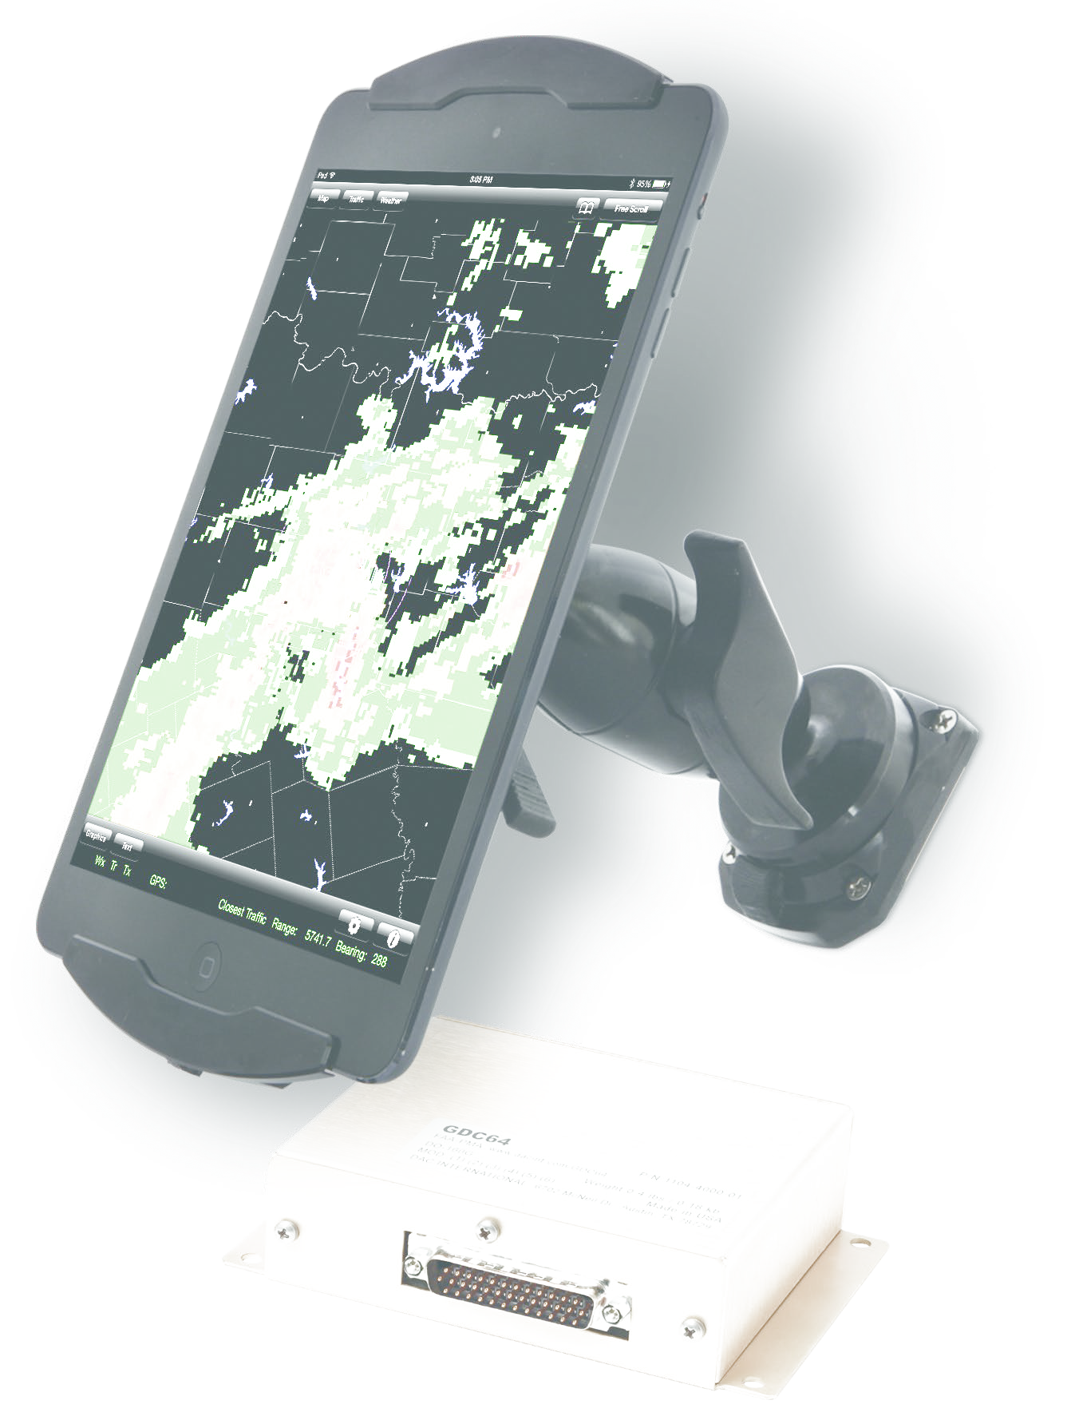
- Appr
- F
•
- Pr •
•
even mor
•
the iPad.
- W
air
•

DAC International
6702 McNeil Drive, Austin, Texas 78729 P. 800.527.2531 (U.S. only) | 512.331.5323 F: 512.331.4516 dacinfo@dacint.com | www.dacint.com
Typical features of GDC64:
- • • •
Operational aspects 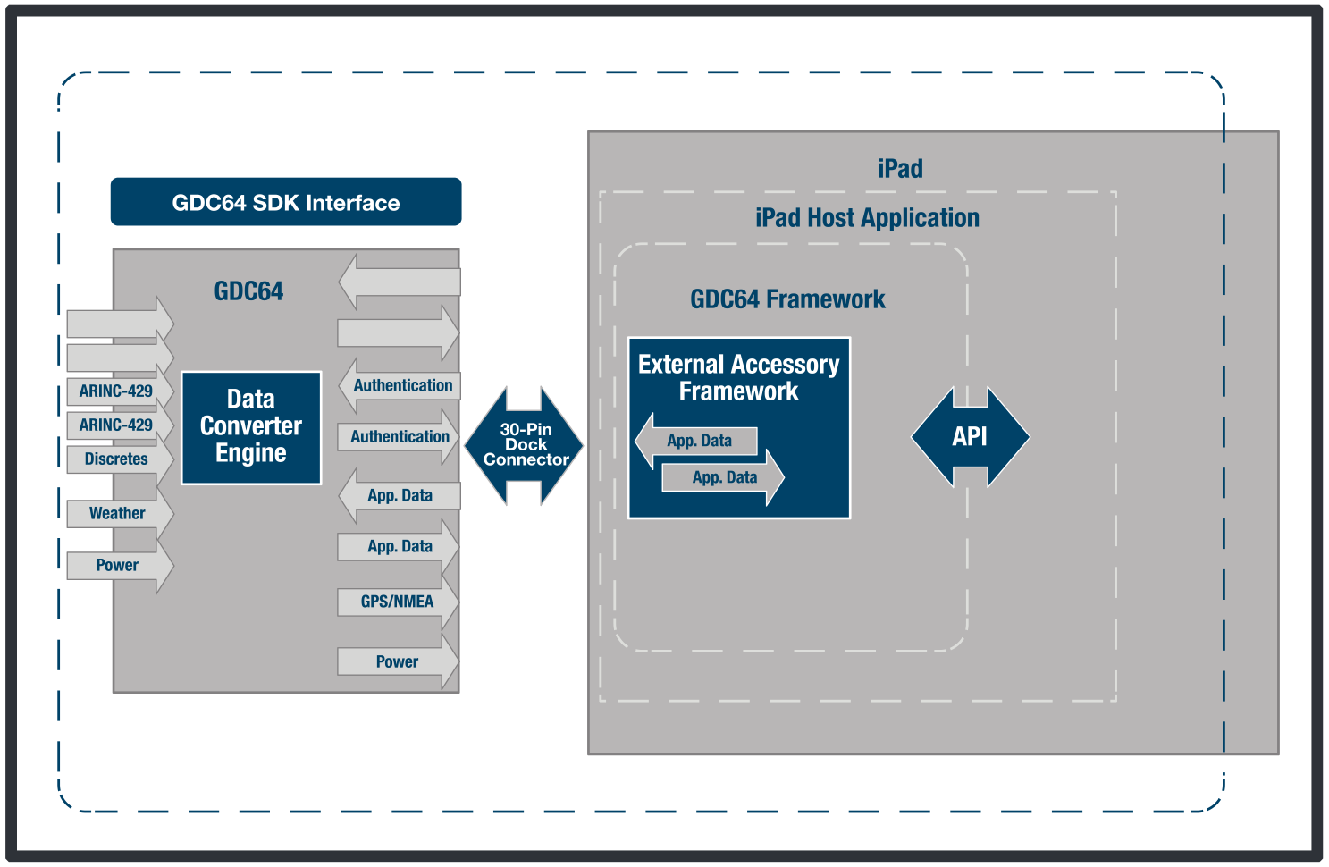•

Software Development Kit

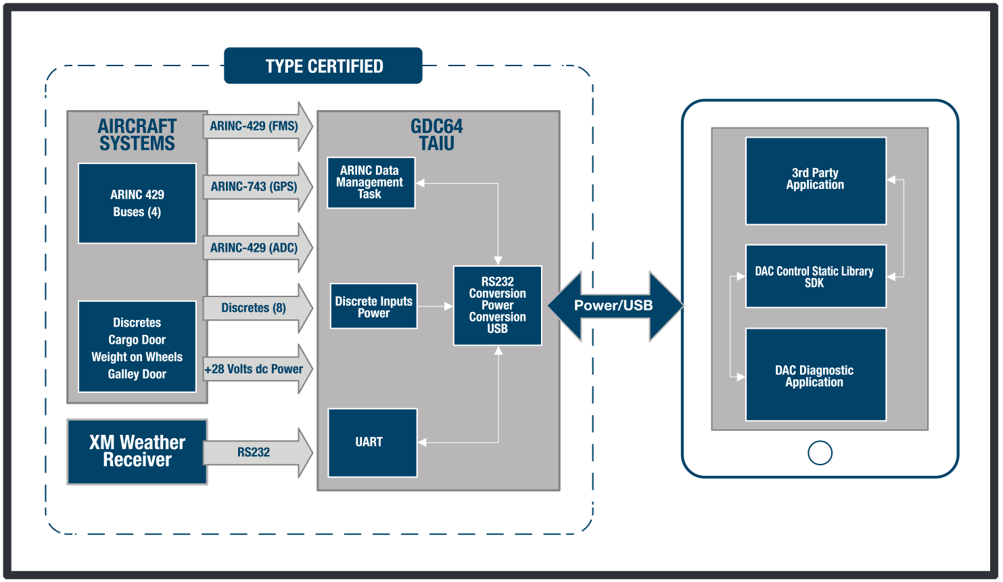

Apple MFi licensee

FOR IMMEDIATE RELEASE
Contact:
Carole Mackay FltPlan.com 203-262-8942 Carole@FltPlan.com
Support for DAC International GDC64 Added to FltPlan Go
Southbury, CT – February 27, 2017. FltPlan Go, FltPlan.com’s free EFB app for iPad, now supports DAC International’s GDC64 Tablet Aircraft Interface Unit (TAIU). FltPlan Go users can transfer a wealth of information, including GPS position, heading, altitude, speed, and track information as well as onboard XM Satellite weather from the panel into the FltPlan Go app.
The GDC64 connects directly to the aircraft’s power bus and is Part 25-approved. The unit features four ARINC 429 ports allowing for seamless transfer of this complex, real-time data to the FltPlan Go app. The wired connection of the GDC64 offers the added benefit of serving as a safe and approved power supply.
“We are very excited to offer FltPlan Go users access to mission-critical radar and weather information through the GDC64. We believe that the GDC64 offers is a great choice for panel to tablet connectivity,“ said Sarah Wilson, FltPlan.com principal. “Our objective is to offer as many connectivity options to our users as possible and the GDC64 is unique in its combination of power supply and data transfer capabilities.”
The free FltPlan Go app, featuring GDC64 support, is currently available for download from the Apple App Store.
About DAC International Inc. DAC International, a subsidiary of Aero Precision Holdings LP is a worldwide distributor of avionics, test equipment, data converters and aviation supplies. The company has an FAA approved manufacturing and development facility, holding several STC’s, PMA’s and TSO’s. Products are compliant with DO-160, MIL-STD-810C and MIL-STD-461F, containing software that meets the objectives of DO-178B, Levels A thru E.
For more information on DAC or its products and service offerings, including Esterline products, visit www.dacint.com.
(continued)
About FltPlan. FltPlan was established in 1991 and has grown into the largest flight planning company in North America. FltPlan’s 158,000-plus active, registered users file more than 55% of all N#-registered flight plans and more than 70% of all N#-registered flight plans for jets and turboprops. The FltPlan System includes free, web-based flight planning and filing integrated with the free FltPlan Go mobile apps for iOS, Android and Windows devices, along with a full range of premium services including SMS, Pre-Departure Clearances (PDCs), eAPIS and APIS for Mexico, Canada and the Caribbean, Premium Flight Tracking, a DCM Call Sign Program, Handling Services, and Runway Analysis. FltPlan recently introduced FltLogic, an integrated flight scheduling program, and FltPlan Manager, an administrative-level program that allows for streamlined management of multiple FltPlan user/aircraft accounts. With more than 24 years of flight planning and filing experience, FltPlan strives to make planning simple and cost effective while providing outstanding 24/7/365 customer support.
For additional information about FltPlan, contact Support@FltPlan.com.
(End)

